Youth Music NextGen Fund Application Guidance

August 2026
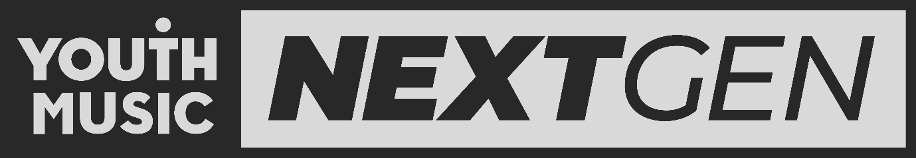
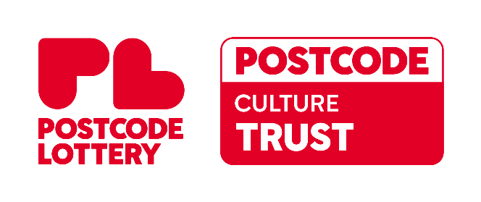

Table of Contents

About the Youth Music NextGen Fund 2
Deadline 2
Support 3
Access support 3
Contact 5
Points to note 6
New Grants Portal 6
Working with collaborators 6
Use of Artificial Intelligence (AI) in applications 6
Living Wage 7
Section one: NextGen Fund overview 8
Aim 8
Who is the fund for? 8
Amount 8
Length 8
Section two: Am I eligible? 9
Who can apply? 9
Who cannot apply? 10
Section three: Project fit 11
What we want to fund 11
What we can’t fund 12
Section four: Budget 14
Budget guidance 14
Personal Access Costs 16
Section five: How to apply 17
Section six: How we make decisions 18

About the Youth Music NextGen Fund

The Youth Music NextGen Fund offers early-stage creatives grants of up to £3,000 to make their ideas happen.

The Youth Music NextGen Fund is for early-stage musicians and wider music adjacent creatives, who face significant barriers to further their careers and make their ideas happen.

The fund is open to 18–25-year-olds (and up to 30 if you identify as d/Deaf, Disabled or Neurodivergent) who are in early career stages. Successful applicants will use the money to launch a creative project, idea or business.

We want to support the future of the music industries. This includes:
Singers, Rappers, Songwriters, Producers, DJs, A&Rs, Managers, Agents, and all other music-adjacent creatives.

Deadline

Upcoming application deadlines for NextGen Fund can be found on our website.

All application deadlines are 5pm.

Support

Access support

Youth Music is committed to offering a clear and accessible grant-making process that is open to everyone.

What is an access cost?

If you identify as d/Deaf, Disabled, neurodivergent or have a long-term health condition, access costs help remove barriers to being able to apply for your grant or deliver your project.

What support does Youth Music offer?

Support to make NextGen Fund application

If you identify as d/Deaf, Disabled, neurodivergent or have a long-term health condition and need further support to make an application to Youth Music, you can apply to our Application Access Fund.

This provides up to £350 to help you with putting your application together. For example, hiring a support worker to help you with writing your application or planning your project.

Please submit your Application Access Fund form before you start making your NextGen application.

You can apply for the Application Access Fund up to six weeks before a funding round opens. We can accept applications up to one week before the round closes.

- Support to deliver your NextGen Fund project
You can include your own access costs on top of the £3,000 maximum grant in your NextGen Fund application.

We call these personal access costs. We don’t currently cap personal access costs, and we don’t require any proof or paperwork with your application.

The amount of access costs you can include in your application should be proportionate to your project activities and access requirements. If your application is successful, and we need any more information about your access costs we may be in touch. Access costs have no bearing on the outcome of your application.

Examples of personal access costs that Youth Music could support:

- Assistive technologies: These should be specific to your project. Laptops are not considered assistive technology unless your current laptop will not allow the assistive technology you need to be installed.

We will only consider funding for the most cost-effective assisted technology that meets your needs for this project.

When a technology will be of use to you beyond the project duration, we may only be able to make a contribution to the total amount. This depends on its use within the project and affordability.
- Mental health: Mental health support can be considered if you experience sustained and disabling mental health barriers. The mental health support should directly enable you to deliver your project activities.

- Support workers and personal assistants: You should specify the tasks the support worker or PA will do, and how this relates to your access needs. You should break down in as much detail as possible the hours they will work across your project (e.g. month by month, or by project activity).

Where possible, please include the name / organisation of the person you plan to work with.

- Travel costs: Travel expenses incurred due to your access needs (for example, additional costs of using accessible transport.) General travel expenses should be included in your main project budget.

- Coaching or mentoring: We can consider coaching or mentoring where it specifically responds to your access requirements. The coaching or mentoring should directly enable you to deliver your project activities.

- Other access costs: We can consider other access costs on a case-by-case basis. We cannot fund medication or costs that are not directly related to your project.

Contact

You can book 1:1 calls during the application period with our grants team to discuss your project and ask us any questions. To book these or ask us any questions us email us on grants@youthmusic.org.uk or phone us on 020 7902 1060.

Points to note

New Grants Portal

We have updated the application portal. This means that you will ned to create an account to be able to submit your application. The URL for this new system is:
https://youthmusic.my.site.com/

Simply click on sign up and follow the instructions. You must use the same login email every time to retrieve your application so don’t forget to note down which email you’ve used.

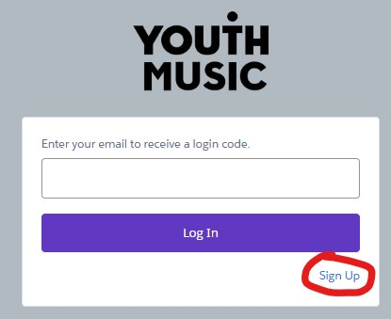

Working with collaborators

While you may collaborate with others as part of your project, the grant recipient must be a single person, and the primary focus must be on supporting that individual's artistic growth and ideas.

When working with collaborators, we encourage you to consider carefully who makes the application, and what you can put in place to support collaboration to take place fairly and smoothly. Our resources on safety and rights in the music industries may support with this.

Use of Artificial Intelligence (AI) in applications

We know that using AI can help with writing a funding application. Youth Music is not against applicants using AI to support them with this. However, if you do use AI to help you draft your application, please make sure it’s an honest reflection of your work and plans.

We often find AI answers are quite generic, with multiple applicants responding the same way. This can have a negative impact on your assessment so make sure the application reflects who you are.

Living Wage

Youth Music is a real Living Wage Funder – this means everyone employed on Youth Music-funded projects must be paid at least the real Living Wage (including anyone you are working with as part of your access requirements.)

Section one: NextGen Fund overview

Aim

Support early-stage musicians and music-adjacent creatives.

Help young people who face significant barriers to invest in themselves, develop their skills, and bring their creative ideas to life.

Who is the fund for?

- 18–25-year-olds or 18–30-year-olds (if you identify as d/Deaf, Disabled, or Neurodivergent).
- Those who have never received funding before.
- Those who face significant barriers to further their careers and make their ideas happen.
- Those who are in early career stages.

Amount

- Grant sizes are up to £3,000.

Length

- Projects last up to 12 months.

Section two: Am I eligible?

Who can apply?

You must be able to answer yes to all the statements in this section before you make an application. If you cannot answer yes to all the statements in this section, then you are not eligible.

- You’re aged 18 to 25 at the point of the application deadline. If you identify as d/Deaf, Disabled or Neurodivergent, you can be aged 18 to 30.

- You’re an emerging creative, and this fund will support you to take your first steps into the music industries.

- You’ve faced barriers to progress your career within the music industries.

- You don’t have the financial means to invest in this project yourself.

- You aren’t currently receiving or haven’t received significant financial backing. Youth Music considers significant financial backing to be around £10k or above. This is just a guide, not a strict rule, but we'd be unlikely to prioritise anyone who has already received significant financial backing.

- You aren’t signed to a record label, publisher or management company.

- You aren’t already employed full time in the music industries.

- You’re based in, and your project will take place in England, Scotland, Wales or Northern Ireland.

- You’re committed to completing your project in 12 months.

- You have a UK bank account in the exact name you are applying under.

- You’re able to start your project within three months of hearing your project has been funded.

- You’ve not previously had a NextGen Fund grant.

- You’re applying to the NextGen Fund as an individual, and not on behalf of a group or collective or a band.

Who cannot apply?

- Signed Artists. If you’re signed to a record label, publisher or management company, we won’t be able to support your project. We want to keep the fund open to people who aren’t at that stage yet.

- People in full-time employment in the music industries already. This specifically means working in the area of the industry you want to progress in. For example, we won’t exclude someone who works at a major music venue at the bar, but we would if you were already an A&R at a major record company.

- Groups, bands and collectives. This grant supports individual creatives and their career development. We do not fund bands, groups, or collectives.

- Existing businesses: Individuals can apply to start a new business idea, but we can’t accept applications from existing organisations or businesses. If you’re not sure whether that applies to you, please get in touch.

Section three: Project fit

What we want to fund

If you are eligible, the next step is to check if your idea is something that we will fund.

We are looking to support projects that are:

- Interesting, innovative, or original (for you or your audience)
- Realistic and deliverable within a year
- Well planned, timelined and clearly budgeted
- Delivered and run by mostly yourself

Here are some examples of ideas:

- A creative music project: this could be a single release, an EP, or a contribution towards an album campaign. Your music can already be finished or still in progress. While many applications we receive are for EPs (which is absolutely fine), we encourage you to think creatively about how you make, release, and promote your work. Please explain why you’ve chosen your format - whether it’s linked to your stage in your career or a personal creative challenge. It’s also helpful to share what you’ve released so far, so we can understand the next steps in your journey.

- A music-based business: this could include starting a record label or creating a music platform. Some online platform ideas we receive need significant capital and complex technical support, which can be expensive. If you’re applying to create an online platform, make sure you have the skills and knowledge to deliver it, that the project is realistic and will benefit the wider music community. If your idea relies heavily on complex technology, it may be better suited to funding from a dedicated tech funder.
- A platform that supports underrepresented voices and perspectives: supporting leaders that build communities and help facilitate others in pursuing their creative goals. For example, a music website championing underrepresented artists and talent.
- A series of events showcasing other emerging artists: we want to support new promoters and help new artists gain experience performing on stage.
In addition to funding your main idea, we can also cover related costs, such as:

- Career development – training, mentoring, and networking.
- Audience development – marketing and promotion.
- Equipment and software – tools you need to create or share your work.
- Business development – administrative costs like insurance and fees.

Funding conditions:

Please note that if you are successful you will need to comply to these conditions:

- All funded projects must be released or shared within one year of receiving the award.
- We can only fund ideas that are accessible to the general public. For example, we cannot fund a training course that has no public outcome.
- You must adhere to our editorial policy.

What we can’t fund

Youth Music is not able to fund the activities or items listed below. Please read this section carefully. Your application will be not be eligible if you include any of the following:

- Activities, goods, or services that have already been bought or taken place before your project begins.
- Activities that are not music or career development focused.
- Individuals can apply to start a new business idea, but we can’t accept applications from existing organisations or businesses.
- Activities that promote a political or religious view.
- Applicants who are looking to work with children (under 18 years old). For example, we cannot fund the delivery of music-making sessions or training with children. This is because this fund is not designed to assess whether you have the necessary safeguarding measures in place to protect everyone involved.
- Activities where there could be significant risk to the safety and wellbeing of those involved. This could involve work with at risk groups of people where additional safeguarding measures are needed, work in high-risk environments, or dangerous working practices.

Section four: Budget

Budget guidance

Your total budget must be between £1,000 and £3,000.

We've organised the budget into seven categories to help you. You don't need to use every category, and if something doesn't fit, use the "Other" section.

There are spending limits on certain items because we want most of your grant to go toward creating and delivering your project, not just buying equipment. If you go above these limits you will not be able to submit your application.

Budget Categories

Time to Create (£500 minimum) - This is your wage that you pay yourself for working on the project. You don’t need to itemise your time to create in your application. We think it’s important to be able to pay yourself during your project. We have therefore already included £500 in this category. We encourage you to add additional budget lines in this section.

Project costs (no limit) - Direct costs for making your work:
- Studio time, recording, production
- Mixing and mastering
- Session musicians
- Manufacturing

Equipment (£700 maximum) - Hardware and software essential for your project that you'll use for future work too, for example a microphone.

Training (£200 maximum) - Skills development like courses, conferences, or workshops that help with this project and/or your career.

Marketing (£500 maximum) - We encourage people to avoid spending a lot of money on marketing or advertising through major agencies or social media companies. We have funded many successful projects that have used resourceful, creative marketing efforts. The more of the project you can deliver yourself, even if it's something you are doing for the first time, the stronger your application will be.

Travel (£200 maximum) – travel within the UK only. We don’t fund international travel.

Other - Anything else related to your project, including contingency for unexpected costs.

Budget Requirements

- Categorise your costs (like in the example) to break you budget down in an understandable way.
- When entering your budget, please round up to the nearest pound. For example; use £100 not £99.9.
- The budget example below is the minimum of what we want to see.

Budget tips

- Try to think of the details of the budget, as this will also help with the overall planning of the project.
- Research your costs. The Musicians’ Union helps set appropriate rates of pay across all areas of musicians’ work. Get multiple quotes for services in order to seek best value.
- Consider your network and reaching out to individuals that could support you in sourcing these costs.
- Be creative and resourceful! We would rather spend the money on you instead of on PR agencies or advertising. The more of the project you can deliver yourself, even if it's something you are doing for the first time, the stronger your application will be and the more you will learn.
- Youth Music is a real Living Wage Funder – this means everyone employed on Youth Music-funded projects must be paid at least the real Living Wage (including anyone helping you with your access needs).

Budget Example

Category | Amount | Description
Time to create | £500 | Project Wage
Project | £480 | Studio time £60x8hours
Project | £450 | Mixing three tracks @£150 per track
Equipment | £250 | Mic Sony Model CXY23Z
Marketing | £200 | Social media advertising
Marketing | £250 | Artwork for album
Other | £200 | Contingency for unexpected costs
Personal access costs | £750 | Project support worker fee (£75 per hour x 10 hours)
TOTAL  (without personal access costs) | £2430

Personal Access Costs

If you identify as Disabled, you can include your own access costs on top of the £3,000 maximum grant. We call these your personal access costs. These are for access costs that enable you to deliver your project. You enter your personal access costs as a line in your main budget.

There is no set cap on the amount of personal access costs you can apply for. They should be proportionate to your project activities and access requirements. If you are not sure about what access costs are proportionate to your context, please contact Youth Music’s Grants and Learning Team.

We don’t require any proof or paperwork of your personal access costs at application stage. If your NextGen application is successful, and we need any more information about your personal access costs we may be in touch.

Personal access costs are reviewed separately to your project, once we have made the decision to award you a grant. So personal access costs will have no bearing on whether your NextGen application is successful or not.

More information about Youth Music’s access support is here.

Section five: How to apply

So you’re eligible and you think your project idea is a good match for NextGen Fund.

You should now:

- Look at the application form questions.
- Plan your project and gather the information you’ll need to complete your application form.
- Write and save your responses in a word document/on your phone. You can draft your answers offline, but you need to paste your answers into the online form once they are ready.
- Once you have written your answers, go to the NextGen Fund page and click on the ‘Apply Here’ button. This will take you to the portal where you complete and submit the online application form.

Click here to read our top tips for writing a strong application.

Section six: How we make decisions

We will only be able to fund a limited number of applications in each funding round. This means we will have to make some difficult decisions.

The strengths of your application will be assessed alongside the other applications we receive by a group of assessors. A final shortlist will then go through to an expert judging panel.

Your application will be assessed on the following criteria:

- Eligibility check: We will conduct an initial check to make sure your application is eligible. It will need to contain enough detail and information to make a full assessment. If you have not included supporting documents or links that you refer to, we will not be able to assess your application.
- The strength of your project: Strong applications will be focused on creating something new or making something happen. Projects should enable you to develop your skills and explore new ground. Strong project ideas should be interesting, exciting or innovative. But remember to make sure it is realistic and achievable too.
- The potential benefit to you and your career: We want you to have a clear idea about where you’re going in your career and how your project will help you get there. We also want to have confidence that you’ll be able to deliver the project to a high standard, and that it will enable you to take your career forwards.
- The strength of the project plan: Strong applications will be well planned. They’ll have an accurate and reasonable budget. They will be clear about what will happen and how. We need to know when things will take place and who will be involved. Timescales will be realistic and achievable in 12 months.
- Ensuring we fund fairly: We will fund a diverse range of applicants. To do this we will use data to help guide our decision making. This will enable us to invest across a variety of projects, genres, individuals and geographical areas.

In our funding decisions, we will also prioritise:

- People who do not have the financial means to invest in themselves to get their ideas started.
- People that are too early stage to be funded by larger grant programmes like Arts Council England and PRS Foundation.
- Those who might be discriminated against, for reasons that could include Gender, Race, Disability, location, or other characteristics.

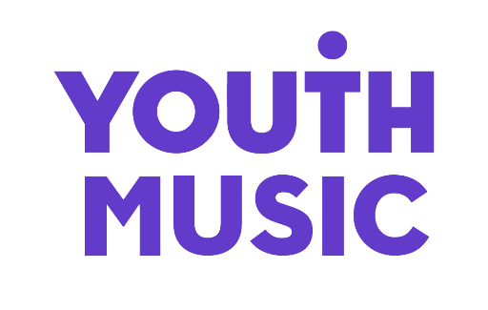
THE NATIONAL FOUNDATION FOR YOUTH MUSIC
STUDIO LG01, THE PRINT ROOMS
164-180 UNION STREET, LONDON, SE1 0LH
REGISTERED CHARITY NUMBER: 1075032
LIMITED COMPANY NUMBER: 03750674

