

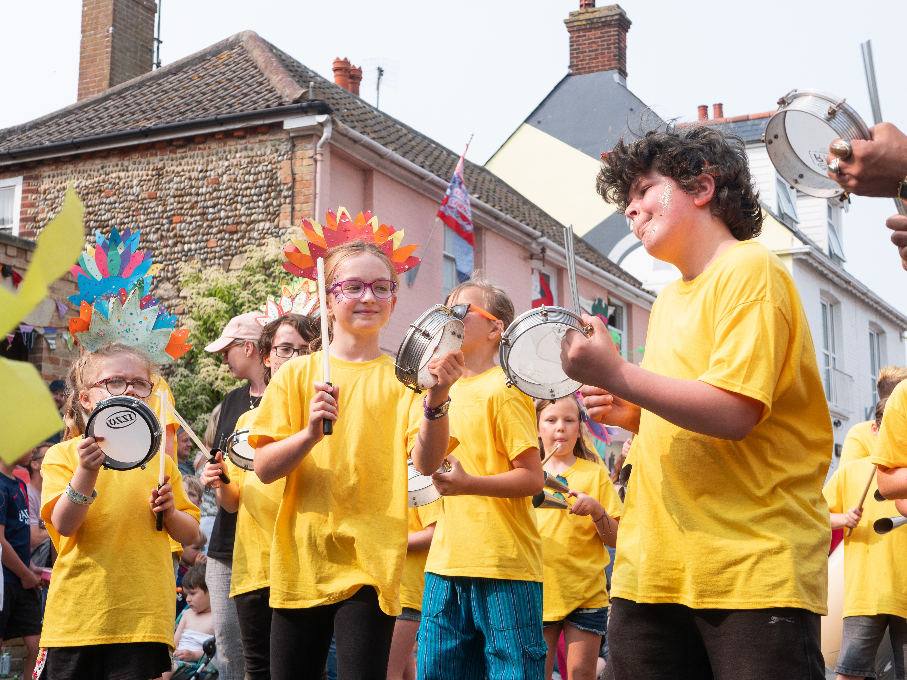

YOUTH MUSIC FEEDBACK SURVEY

2024

Photo by Angus Cooke

Contents

Introduction 2
Respondent Information 4
Executive Summary 5
Applying to Youth Music 6
Reporting to Youth Music 7
Youth Music Resources 8
Youth Music Impact 9
Artificial Intelligence 11
Climate Crisis 13
Youth Voice 14
Funding Principles 15

Introduction

The Youth Music Feedback Survey is an annual survey we undertake with our funded partners, as well as those who applied for a Youth Music grant in the last financial year. We conduct the survey to evaluate our performance as a funder and determine areas we can improve our performance. We also use it to gather insights about the grassroots organisations and young people we work with. A separate NextGen Feedback survey is conducted annually, too.

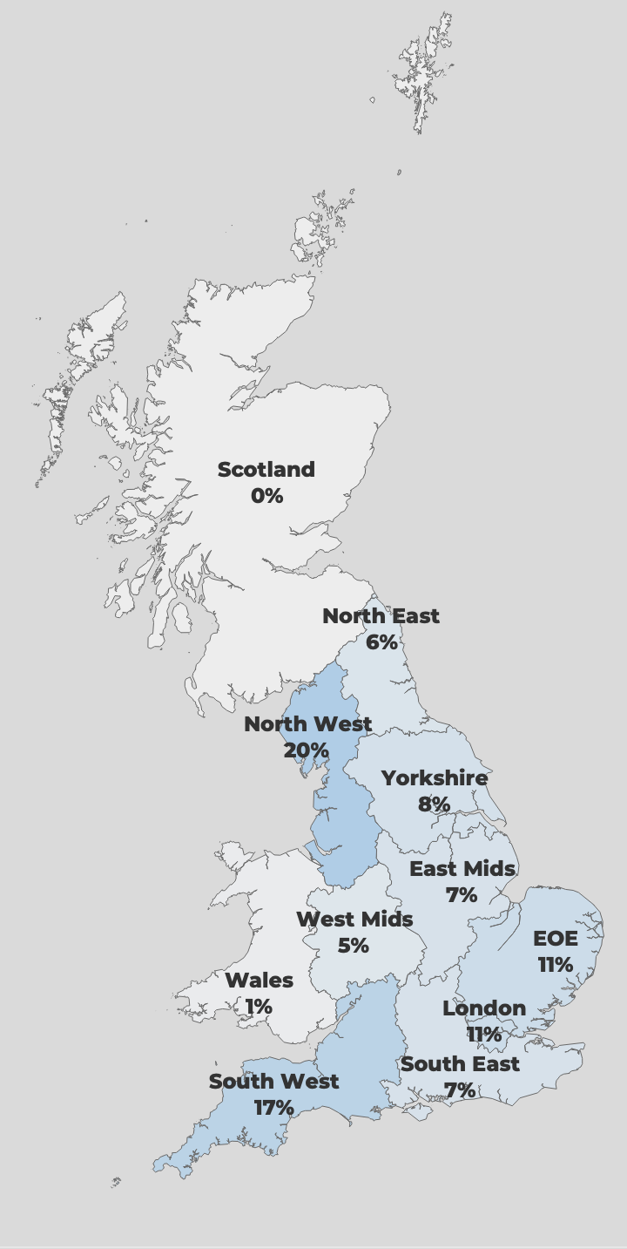

Respondent Information
84
Responses
(-34% from 2023)

10%
Response rate
(-5% from 2023)

Organisation size (84)

Sixty-nine percent (58) of respondents were current/previous funded partners. 25% were unsuccessful applicants and 6% were awaiting a response.

Region of operation (78)

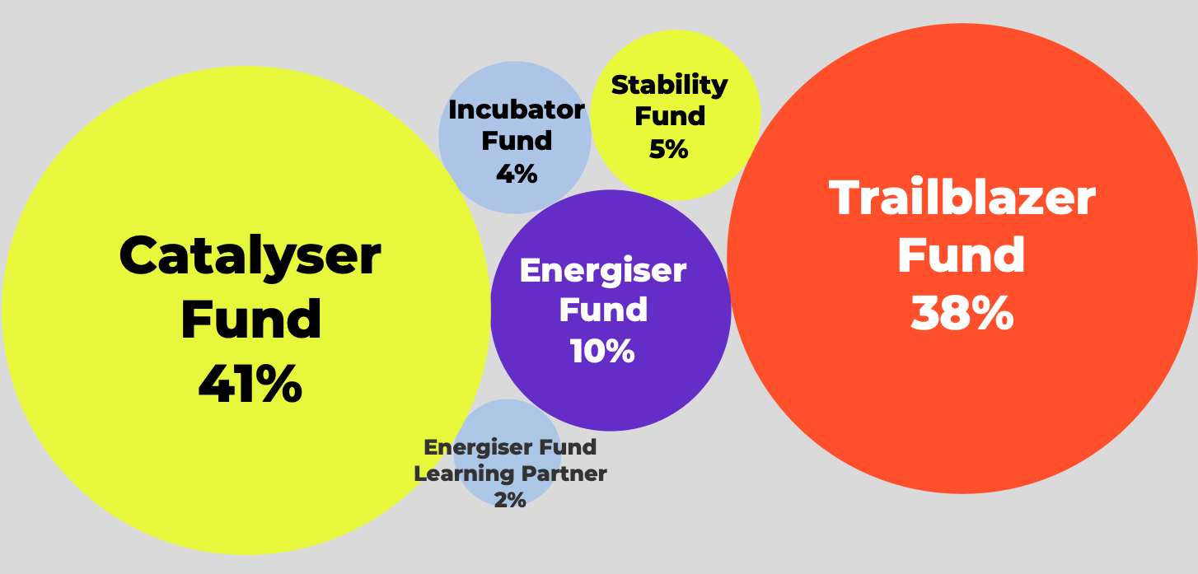

National
7%

Funds applied for (respondents could select multiple) (81)

Executive Summary

Methodology

- Data collected June-July 2024. We received a 34% decrease in responses compared to the previous year. 2023: 119; 2022: 106; 2021: 166; 2020: 116) Average completion time: 15 minutes.

Our grant making

- In 2024, being clear about our relationship and being accessible were the areas of highest satisfaction.

- 100% of respondents felt that the requirements of their grant were made clear to them from the outset.

Out impact

- 62% of respondents felt we have an above average/significant impact on their organisation's approach to IDEA, and 66% on their organisation’s sustainability.

- 84% rated us as above average/excellent as a funder.

- The most common single word to describe Youth Music was ‘supportive’, followed by ‘accessible’, ‘inclusive’ and ‘approachable’.

Applying to Youth Music
 | Was aware of this, but did not use | Was not aware of this | Very poor | Below average | Average | Above average | Excellent | Above average/  excellent | Difference from 2023
Information on Youth Music's current funding priorities and criteria | 1% | 1% | 0% | 0% | 12% | 36% | 49% | 85% | -4%
Applicant guidance notes | 1% | 0% | 0% | 0% | 14% | 36% | 49% | 85% | -9%
Phone/email support from Youth Music staff | 12% | 7% | 1% | 3% | 5% | 21% | 51% | 71% | -4%
Application questions and language | 1% | 0% | 3% | 1% | 19% | 35% | 40% | 75% | -8%
Application form format | 1% | 0% | 3% | 1% | 20% | 41% | 34% | 75% | -5%
Online grants portal (where you apply and manage grants) | 3% | 3% | 0% | 1% | 22% | 42% | 29% | 71% | -1%
Youth Music website | 0% | 1% | 0% | 1% | 21% | 49% | 27% | 77% | -9%
Youth Music Network website | 5% | 10% | 0% | 0% | 21% | 42% | 22% | 64% | -4%
Information on Youth Music's currently funded projects | 5% | 1% | 0% | 1% | 22% | 44% | 26% | 70% | +5%

How would you rate the following aspects of the application process? (2024: 73 / 2023: 111)

How would you rate the following aspects of the application process? (73)

Reporting to Youth Music
 | Strongly disagree | Disagree | Neither agree nor disagree | Agree | Strongly agree | Agree/  Strongly agree | Difference from 2023
Youth Music staff are often available to respond to my queries | 0% | 2% | 2% | 25% | 72% | 96% | 8%
Youth Music staff respond to my queries promptly | 0% | 0% | 2% | 25% | 73% | 98% | 6%
I feel comfortable approaching Youth Music staff with a problem | 0% | 0% | 4% | 21% | 75% | 96% | 1%
Youth Music staff are flexible with the requirements of my grant | 0% | 0% | 8% | 26% | 66% | 92% | -3%
The requirements of my grant were made clear to me from the outset | 0% | 0% | 0% | 28% | 72% | 100% | 5%

To what extent do you agree with the following statements about our relationship management? (2024: 53 / 2023: 87)

The comment section to the question was overwhelmingly positive, with the majority of respondents praising the relationship they have with their grant manager; this is consistent with 2023.

“I feel that the Youth Music are on my side. That they are on the side of engaging young people in making music and are not fixed in how that is achieved.”

“Our grant managers have been absolutely excellent”

“support I have received for my current grant has been perfect.”

Youth Music Resources

 | Yes | No | Not aware | Not useful | Somewhat useful | Very useful | #
IDEA (Inclusion, Diversity, Equity and Access) hub | 58% | 27% | 15% | 0% | 45% | 55% | 38
Safeguarding hub | 52% | 33% | 14% | 0% | 44% | 56% | 36
#ShareTheMic Youth Voice hub | 31% | 38% | 31% | 0% | 20% | 80% | 20
Finance and fundraising hub | 30% | 45% | 25% | 0% | 35% | 65% | 20

Have you used any of the following resources for applicants and grantholders? (102)
If ‘Yes’, how useful was the resource?

We also additionally asked about our Exchanging Notes learning and development sessions, including if people have attended and if they have any feedback. Thirty-eight percent of respondents said they have attended a session (n=68). We also asked those who have attended for feedback and suggestions for future session. The majority of responses gave positive feedback on their experience, but some suggestions for sessions were:

- Improving the diversity of trustee boards
- Safeguarding
- How to use lyric writing in youth work
- Fundraising

Youth Music Impact
 | No impact | Below average impact | Average impact | Above average impact | Significant impact | Above average/  significant impact | Difference from 2023
Your organisation | 7% | 10% | 4% | 7% | 71% | 78% | -2%
Your organisation's approach to IDEA | 13% | 4% | 21% | 41% | 21% | 62% | +5%
Your organisation's Safeguarding practices | 16% | 4% | 34% | 32% | 13% | 46% | +2%
Your wider field of work | 7% | 4% | 21% | 32% | 35% | 68% | -4%
Your organisation's sustainability | 10% | 7% | 16% | 25% | 41% | 66% | -4%

Overall, how would you rate Youth Music’s impact on the following? (2024: 68 / 2023: 104)

The majority of comments were positive, particularly highlighting out impact on organisation’s sustainability. Other comments noted our impact had been low in these areas due to not receiving funding from us or that their practises were already strong.

Above average/Excellent
Above average/Excellent

Overall, how would you rate Youth Music as a funder? (2024: 68 / 2023: 104)

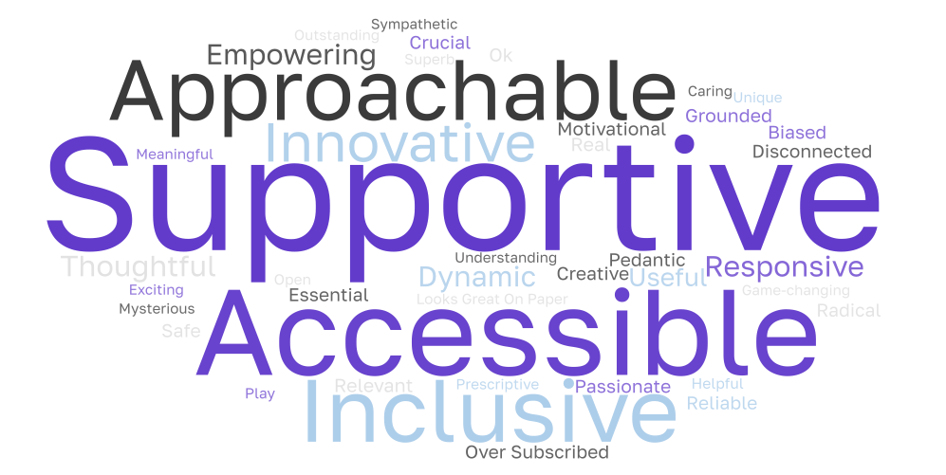

What is the one word you would use to describe Youth Music? (57)

Artificial Intelligence

After out thought leadership research (Generation AI) found that young people were embracing AI, we asked respondents to tell us about their thoughts on AI and if they’re currently using it in their work with young people.

Do you use AI tools for music composition, production or education in your work with children and young people? (66)

To what extent do you think AI tools can enhance music education? (65)

How likely are you to incorporate more AI tools in your music teaching or learning practices in the next year? (66)

Respondents were also asked what they as the benefits and challenges of AI for their work. The most common response was its usefulness for non-creative work, such as admin and writing applications, highlighting that this leaves more time for creative work. Other common responses included wanting to learn more about it before using it, while others said they had no intention of using AI.

“It is very helpful with administrative tasks e.g. policies”
“Our music activities don't involve much electronic work at present so there are limited benefits/challenges at the moment. AI may help behind the scenes with practical things, e.g. generating relevant materials and backing tracks etc. but that would be more supportive than anything else.”
“AI can benefit our work by enhancing data analysis, However, challenges could include maintaining a human touch in our interactions with young people.”
“You don't know what you don't know so it is easy to make an assumption - often a wrong one. It is important to learn about AI - the upsides and the downsides - and make a judgement on if and how you may want to use it. And how it can be used for good and bad by others.”
“Our work focuses on the therapeutic powers of music on children with additional needs. Sessions are led by a music therapist, so AI will not play a role in these services.”

Some respondents said they were using it for creative work, particularly for lyric generation:

“Impact on creativity - help young people and staff to come up with different techniques to tackle problems and create lyrics”
“encourages young people to develop lyrics that express how they feel. Help develop plans to move their music on, prepare posts to gain more exposure.”

We also asked if respondents discuss AI with the children and young people they work with, with 52% saying they do. They remaining was made up of 42% saying they don’t, and 6% saying it was not applicable to them.

Climate Crisis

Youth Music is committed to good practices around environmental sustainability. To learn more about climate impact on our funded partners, we asked about the ways the climate crisis is impacting their day-to-day work. The most common impact cited was rising expenses, such as increased energy costs:

“Energy bills and old inefficient buildings to work from”
“Energy bills have increased but ours are not as high as other organisations. When we got our own building (derelict) we installed underfloor heating: floors were rotten, cheapest alternative was concrete & underfloor heating was the most efficient way to heat an old building with high ceilings (concrete acts like a massive radiator!)”

Other impacts cited was an impact on mental health (for young people, families and staff) and changes in weather:

“We know it's a source of great concern for young people and for all of us more generally.”
“This is a feeling - not something evidenced, but we sense a collective anxiety, depression and hopelessness. On a practical note bad weather makes it much harder to get people out to events”
“Increased frequency of extreme weather events like heat waves, storms, floods, etc. This could lead to cancelled outdoor sessions and gigs, damaged equipment and attendance issues. It may require relocating events indoors.”
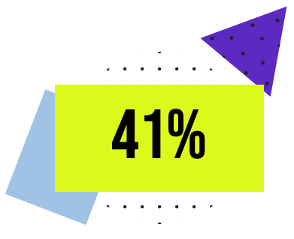
90%
We also asked what are the barriers to taking more organisational action in relation to the climate crisis. The most common barrier cited was a lack of funding:

“Organisational survival can take precedence over this, even though in the long run it is necessary for survival.”

A lack of resources and capacity was also a commonly cited reason.
of respondents embed environmental themes into their work with children and young people (59)
“Capacity and workload outside of the project team's specialisms (music making etc)”

Youth Voice

To inform how we better support organisations with Youth Voice, we asked organisations about any barriers they face in embedding youth voice and participation. The most common response was that they had no issues and have embedded Youth Voice into their programmes.

“We have an excellent track record of embedding youth voice and participation through setting up youth led project steering groups.”
“We have been very successful in embedding Youth Voice in our work. We have a team of young people who have control of part of the budget and actively are engaged in the direction of the charity. They used their fund to raise additional funds by getting Ed Sheeran to sign a guitar that they auctioned. Produced a CD sold at events and upgraded some of the equipment.”

The most common barriers cited was accessing the young people they want to work with or having a high turnover of young people coming through their project. Other barriers cited were funding, capacity, and working with non-verbal young people.

“We don't particularly have organisational barriers - we are proactive in supporting young people's engagement and participation (including in the decision-making of the Charity and the youth music project). However, there are always hurdles and difficulties to youth participation, including continuity and young people moving on/away.”
“We have struggled to attract female participants to our youth voice group”
“Adult gate keepers are usually the only barrier, e.g. a parent, a teacher making decisions on the young person's behalf
“Funding for staff to be able to do this work. We are a youth-led/voice organisation and weave this through our programmes to collect feedback and consultations however sourcing funding for our Youth Advisory board has been challenging”
“Age of group (babies, toddlers) but hopefully we are embedding child-led practice for the/their future.”

Funding Principles

 | Very poor | Below average | Average | Above average | Excellent | Above average/  Excellent | Difference from 2023
Principle 1. We will not waste your time. | 4% | 5% | 13% | 28% | 51% | 78% | -8%
Principle 2. We will only ask relevant questions. | 2% | 4% | 19% | 34% | 41% | 75% | -8%
Principle 3. We will accept our share of risk. | 1% | 4% | 22% | 38% | 35% | 73% | -5%
Principle 4. We will act with urgency. | 0% | 4% | 20% | 33% | 44% | 77% | -1%
Principle 5. We will be transparent about our decisions. | 1% | 8% | 16% | 33% | 42% | 75% | -1%
Principle 6. We will enable you to respond flexibly to changing priorities and needs. | 2% | 7% | 14% | 19% | 58% | 77% | -11%
Principle 7. We will be clear about our relationship from the start. | 2% | 0% | 16% | 23% | 58% | 81% | -10%
Principle 8. We will commit to light touch reporting. | 2% | 0% | 19% | 38% | 41% | 79% | +3%
Principle 9. We will be accessible. | 1% | 4% | 14% | 47% | 34% | 81% | -4%
Principle 10. We will involve people in our programme design and decision-making. | 2% | 0% | 23% | 36% | 38% | 74% | -3%

How would you rate us against this principle? (2024: 83 / 2023: 116)


THE NATIONAL FOUNDATION FOR YOUTH MUSIC
STUDIO LG01, THE PRINT ROOMS
164-180 UNION STREET, LONDON, SE1 0LH
REGISTERED CHARITY NUMBER: 1075032
LIMITED COMPANY NUMBER: 03750674

