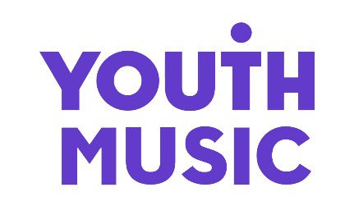

Just the way it is?
Young creatives demand safety and rights in music

Contents

Just the way it is? Young creatives demand safety and rights in music 1

Contents 2

About This Research 3

Our Approach 7

Report Summary 9

How Is Harm Experienced? 14

Strategies For Staying Safe 30

A Changing Landscape 32

Recommendations 33

Advice For Young Creatives 35

References 39

NOTE FOR READERS: This report shares personal stories from young people working in the music industries. Some of these accounts touch on sensitive topics, including alcohol and drug use, discrimination, sexual harassment, unsafe working conditions, exploitation, bullying, and the impact these experiences can have on mental health.

About This Research

The genesis of this research was a young creative seeking support from the Musicians’ Union following a bad experience on a music project. They wanted to speak out to help make sure that others didn’t suffer in the same way they did.

As a result, Youth Music, The Musicians’ Union, and Music Guardians came together to discuss ways we could work together to address this. We identified a gap in the knowledge, understanding and practices needed to keep young people safe in the music industries. So we embarked on this research. We hope it will help our industry partners to be more informed, and know how they can help. We hope it will help young creatives to feel seen and heard. To know ‘it’s not just me’. And we hope to create wider change for the next generation.

About Youth Music

Equalising access to music. We’re a national charity. We help marginalised young people to make and monetise music. Every year, we raise £10 million to fund inspirational grassroots music projects and support aspiring young creatives up and down the UK. We’re campaigning to break down barriers for young people facing inequity, exclusion and discrimination.

About Musicians’ Union

The Musicians’ Union is the UK trade union for all musicians representing over 36,000 musicians across the UK working in all sectors of the music business. As well as negotiating on behalf of members with all the major employers in the industry, we offer a range of support services for musicians.

About Music Guardians

Music Guardians works in partnership with the music industry to provide expert guidance, training, and support on best practices for safely integrating young people into professional music industry environments. Their mission is to help create an industry that is both inclusive and safe for young people as they begin or progress in their careers.

Foreword

“I have been a working musician for almost 10 years now, so this comprehensive report you’re about to read came as no shock to me.”

Victoria Canal, Musician.

“However, when I was 19, bright-eyed and bushy-tailed, desperate for any opportunity in the industry, I had no awareness of the normalised harm experienced by young people braving a working life in music. I was invited by a much older artist on Instagram to open on his US tour. “Oh my god! I’m going on tour!!” I thought, as I eagerly accepted the offer and dropped out of college to take the opportunity – of course, with no management, no professional experience in the industry, no reference point. What ensued was a gruelling and traumatising experience that, if I knew what I know now, I would never have tolerated. This experience included not being paid or provided accommodation as a band member, even when participating in all rehearsals and shows; getting sexually harassed, isolated, and ultimately groomed by the artist himself; getting discriminated against because of my disability, and treated particularly different because of being the only woman, and only young person (by 30 years) on the tour. And though everyone else on the tour knew exactly the position I was in – management, crew, band included – they’d signed NDA’s and were all afraid of losing their jobs if they were to look out for me. The message was – don’t speak up, you’ll ruin your career before it’s started.”

“Being young in the music industry… this is sadly just to be expected. That’s just the way it is.” This is a response I have heard too many times, but, I have to adamantly fight it as an absolute truth. This report by Youth Music might no longer come as a shock to me, but it certainly serves as an eye-opener, a reference point, and a call-to-action on how we can change the fabric of the music industry. It is incredibly important to acknowledge the web of normalised harm and dissect the ways we can move into a safer music industry for young, and all, people.”

Introduction

If discrimination, harassment and exploitation are pervasive in our industries, is that ‘just the way it is’? Outdated cultures are increasingly met with calls for much-needed change. This research is borne out of a desire to speed up progress towards a safer, fairer and more inclusive industry for all.

2025 is a time of welcome shifts in both the practices and understanding of worker safety and rights in the music industries and beyond. Several high profile reports, and a parliamentary enquiry, have increased visibility and discussion of exploitative industry practices. A new body, the Creative Industries Independent Standards Authority, has been established to tackle bullying and harassment. Sexual harassment laws have been tightened, and the Employment Rights Bill is making its way through parliament.

Meanwhile, increasing numbers of well-known musicians are using their platform to speak out about their negative experiences. Raye, Jade and Self-Esteem have all dealt with issues of industry exploitation in their work. Raye’s Ice Cream Man is about a sexual assault. When sung live, she tells the audience how she sings it for others in the same position, to know they are not alone. In industries where poor behaviour is silenced or normalised, the power of visibility and speaking out shouldn’t be underestimated. This research wouldn’t exist without people speaking out.

Missing from the conversation so far have been the voices of young creatives. At the start of their careers and in need of money, they’re on the wrong side of power imbalances. Many will take what they can get, in order to get on. Programmes that support their progression into the music industries often leave them in a grey area between participant and employee. Child safeguarding no longer protects them. All of this means they’re more open to exploitation.

Through sharing and analysing young people’s testimonies, this report seeks to better understand the structures that create conditions of harm. If we close the safety gaps for those most at risk, then everyone benefits as a result. We use this analysis to consider practical actions that can break some of those structures – whether you’re a freelance professional, grassroots organisation or large corporate entity.

NOTE: We use the term ‘music industries’ rather than ‘music industry’ to reflect the diverse ecosystem which generates employment, revenue and audiences through music. The singular ‘music industry’ indicates an industry that operates in a uniform style. The plural definition allows for the wide range of entities that make up the ecosystem, from multi-national corporates to small companies, charities, sole traders and collectives.

The Context

Research into discrimination and harassment in the music industries shows that the most marginalised people experience the worst harm – and those who face intersectional barriers are at greatest risk. Often, young creatives bear the brunt of these issues.

What is it about the music industries that create the conditions for harm? As the ‘Misogyny in Music’ report summarised:

“Abuse and discrimination are not unique to the industry but they are amplified in music by the high number of freelance workers in the sector – which gives rise to significant power imbalances in working relationships and precarious employment practices – and the informal nature of many workplaces which, together with late-night working, often in places where alcohol and drugs are available, can result in… working in environments that are unsafe”.

Despite recorded music and UK music export revenues both being at an all-time high, profits are not evenly distributed across the whole ecosystem. At entry level, a culture of low pay and hidden labour prevails. The music industries is a competitive industry to get into. The old narrative says that with limited space at the top of the ‘talent pipeline’, you need to do all you can to win success. Even if that means working for free.

There are good people in the music industries. But there’s also a grassroots funding crisis. For small organisations and freelancers, it can be hard to find the time and money to put policies and procedures in place that keep people safe.

In recent years there’s been a lot of work to diversify the workforce, especially since the murder of George Floyd. But inclusion isn’t always well-embedded:

“Agencies think they can just parachute different people into the same structures and don’t realise they have to change first… efforts around wellbeing and diversity are talked about more than they’re actioned. And when they’re actioned that action is often not thought through sufficiently” [1]. Where people are paid less and treated badly, their wellbeing suffers as a result. Low pay is the main reason people consider alternative careers beyond music. Unless things change, recent and steady progress on diversity risks being halted.

The Stats

Discrimination and harassment are rife in the music industries.
- 32% of women report being sexually harassed while working as a musician. [2]
- 47% of Black disabled music creators said they have been paid at a lower rate than other music makers working on the same event. [3]
- 88% of disabled musicians who’ve experienced disablism (disability discrimination) are open about their impairment or condition. [4]
- £4,000 is the disability pay gap, based on mean income for musicians earning 100% of their income from music. [4]
- 94% of Black, Black British, Caribbean, or African musicians experienced discrimination. [5]
- 43% of LGBTQ+ musicians report poor mental wellbeing (compared to 30% for all musicians). [6]
- 16.4m work days lost to stress, depression or anxiety in 2023/24. [7]

Find Out More:
- Musicians’ Census, including Insight Reports on Disabled Musicians, Women Musicians, LGBTQ+ Musicians and Global Majority Musicians (Musicians’ Union and partners)
- Dignity at work 2: Discrimination in the music sector (The Independent Society of Musicians)
- Unseen. Unheard. Race and disability – Black disabled experience in the UK’s Music Industry (Attitude is Everything and Black Lives in Music)
- Being Black in the Music Industry (Black Lives in Music)
- Misogyny in Music and Misogyny in Music: on repeat (Women and Equalities Committee)

Young people are overrepresented in the music industry workforce, but a culture of low and no pay is holding them back.
- 43% of the music industry workforce are aged 16-34. [8]
- 54% of music industry apprentices or interns are from ‘Black, Asian and ethnically diverse backgrounds’ [sic]. [8]
- 47% of under 30s in the creative industries have done an unpaid internship. [9]
- 66% of those who earn less than 50% of their income from music are aged 35 or under. [10]
- 70% of young people in the music industries cite insufficient earnings as the main barrier to pursuing a career in music. [11]
- 31% of young people in the music industries are considering careers elsewhere. [11]

Find Out More:
- A Blueprint for the Future (Youth Music)
- UK Music 2024 Diversity Report
- Job Quality in the Creative Industries (Creative Industries Policy & Evidence Centre)

Our Approach

We used a methodological approach that allowed us to gain rich experience-based insights from young creatives in a range of roles across the music industries. From performers to back-stage roles, managers, promoters, administrators and journalists.

We spoke with 19 young creatives aged 18-25 (up to 30 if they identify as d/Deaf, Disabled or neurodivergent) who’ve experienced issues to do with safety and rights in the music industry. We ensured that the young creatives we spoke to brought a range of backgrounds and perspectives. We spoke with people from different areas of the UK and at different stages of their careers, mainly in focus groups.

All the people we spoke with experienced some form of marginalisation because of things like gender, sexuality, ethnicity, disability or social class.

This report is about hearing from young people directly on their experiences and thoughts. We’ve tried to keep their words front and centre throughout.

Safety, Inclusion And Rights In The Focus Groups

We wanted to model good practice in the focus groups. They were facilitated by Music Guardians, who have experience of working directly with young people. We:
- Paid people for their time, told them what would happen beforehand, and offered support before, during and after.
- Recorded and made transcripts of the focus groups.
- Organised what the young creatives told us into themes. We analysed the themes, made links between them, and summarised what we learnt.
- Chose quotes that bring to life each theme.
- Checked with people that they were happy for their quotes to be used.

Who Took Part?

People who applied to be part of the research had all experienced issues around safety and rights. Compared to population levels, we were overrepresented by d/Deaf, Disabled and Neurodivergent people, women, working class people and LGBTQ+ people. Whilst not a representative sample, the stats corroborate the wider research that marginalised groups are more affected. Of those who applied:
- 79% identified as deaf, disabled or neurodivergent
- 73% used she/her pronouns
- 68% were from a working class background
- 58% were LGBTQ+
- 32% were from the global majority
- 32% were religious

Here’s some information about the people we spoke to. Names, locations and photographs have been changed to protect identities.
- KAYLA is an event organiser, promoter, content creator and music journalist from Hove.
- KAI from Leeds, is a singer, songwriter, producer, poet, multi-instrumentalist, youth worker and sound engineer.
- ALEX is a producer, vocalist, composer, mix engineer, music artist, performer and community musician from South London.
- GRACE is an indie artist from Derry. They also freelance as a sound engineer, session musician and music teacher.
- JAYDEN is a DJ and music producer from Swansea. They also run an event series.
- ETTA is a business owner, workshop leader, and access consultant from Dundee.

Report Summary

How Is Harm Experienced?

If we want to make our industries safer and more inclusive for all, then we need to know how harm is showing up, and what’s enabling it.

The young creatives we spoke to described their experiences of harm in many ways. Various enabling conditions kept emerging, which we’ve organised into five themes.

Within each theme there are certain types of situations, behaviours and cultures that feature persistently.
- Low and no pay
- Unsafe work environments
- Discrimination and harassment
- Informal and exploitative cultures
- Barriers to reporting

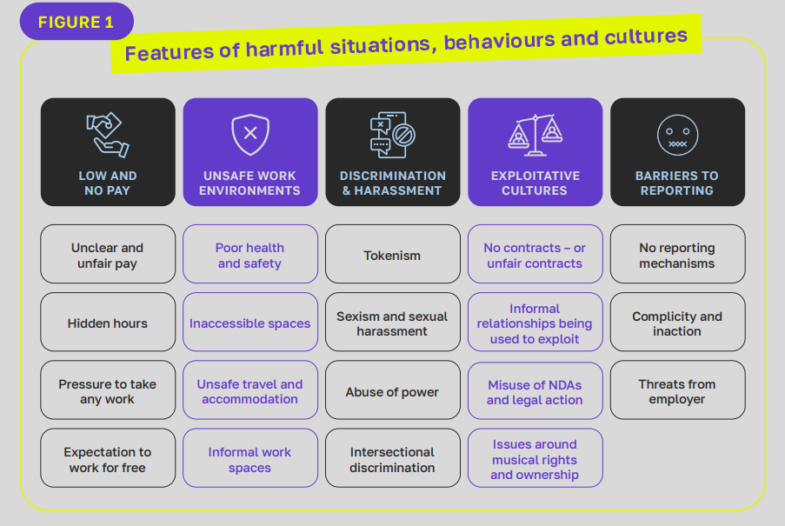

Figure 1: Features of harmful situations, behaviours and cultures
- Low and no pay – Unclear and unfair pay, hidden hours, pressure to take any work, expectation to work for free.
- Unsafe work environments – poor health and safety, inaccessible spaces, unsafe travel and accommodation, informal work spaces.
- Discrimination and harassment – tokenism, sexism and sexual harassment, abuse of power, intersectional discrimination.
- Exploitative cultures – no contracts or unfair contracts – informal relationships being used to exploit, misuse of NDAs and legal action, issues around musical rights and ownership.
- Barriers to reporting – No reporting mechanisms, complicity and inaction, threats from employer.

How Is Harm Amplified?

The more these issues are present together, the more likely it is that harm will occur. Those who already experience marginalisation are at greater risk.

The infrastructure, cultures and working practices within the music industries – for example high levels of freelancers, unequal distribution of power and money – means that these harms often go unchallenged and become normalised.

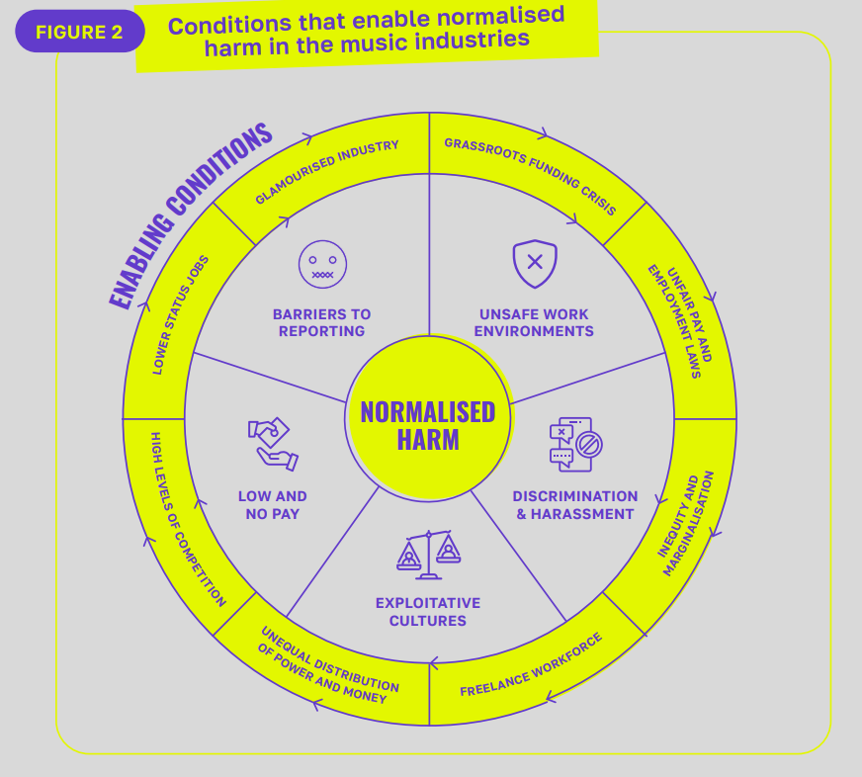

FIGURE 2 NEEDS ALT TEXT

Strategies For Staying Safe

Because harm, discrimination and exploitation have become normalised for young creatives, they’ve been forced to find ways to navigate the music industry while keeping themselves and others safe. Often this means relying on their gut instinct and experience. They are expected to ‘grow a thick skin’ and ‘get on with it’.

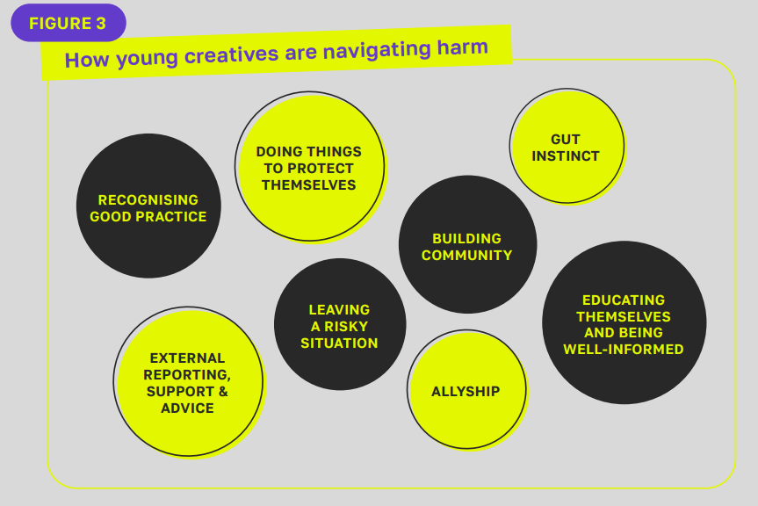

Figure 3: How young creatives are navigating harm
- Recognising good practice
- Doing things to protect themselves
- Gut instinct
- External reporting, support and advice
- Leaving a risky situation
- Allyship
- Educating themselves and being well informed

It’s vital to recognise the agency that young creatives have. But the emotional work and exhaustion that comes from always watching out for yourself is unsustainable. More protection should come from the music industries, government and other organisations.

Recommendations

If we want to change cultures, then we all need to act. Let’s work together to prioritise:
- Fair and transparent pay and contracts.
- Inclusive, diverse, equitable and accessible work environments.
- Eliminating discrimination and harassment.

To make this happen, everyone plays a part.

Government And Policymakers

Close the gap around safety, inclusion and rights of young adult creatives through policy and law.

Funders And Sector Support Organisations

Listen to what grassroots industry organisations and young creatives need to make things safer and fairer. Use your power and influence to promote accountability.

Industry Employers

Create open and accountable workplace cultures, with fair pay and contracts.

Industry Pathway Providers

Model, educate and partner in ways that promote safe, inclusive and fair practices.

Young Creatives

Know your rights, trust your gut, report bad behaviour, seek help from trusted organisations and prioritise your wellbeing.

How Is Harm Experienced?

Low And No Pay

“People listen to music every single day, and yet musicians are just not paid anything near to a living wage. It’s so hard to exist in the music industry and I think most people don’t consider music as a primary financial career.”

There is a culture of low or no pay for young creatives in the music industries. 70% cite insufficient earnings as the main barrier to pursuing a career in music. [11] Although there are fewer unpaid internships in the music industry than other creative sectors, there is a widespread culture of informal unpaid opportunities, hidden hours and underpayment. [9]

Unfair And Unclear Pay

Gigging musicians often bear the upfront costs of being a musician or promoter, while agents, venues and labels take a cut of any income. Gigging is commonly unpaid or reliant on ticket sales. There is also little return on streaming, where there are many barriers to creating a sustainable income including algorithmic biases.

“I’m trying to get bookings for the collective I’m part of. I’m reaching out to venues and they’re like ‘We only take ticket splits as a way of booking artists.’ And I’m like… ‘So I have to be the promoter, I have to be a musician, I have to be the booker’. And if I don’t fill up the space, I’m not getting paid.”

There is a lack of transparency around pay. Sometimes fees are not shared upfront, or are changed at the last minute.

“We were supposed to do a gig, and it got cancelled about three hours before, where we would have made £300. They haven’t sent it over yet, but they’ve said they’d pay us £100 because of the last minute cancellation.”

Combined with a lack of proper contracts or written agreements, people described waiting excessive lengths of time for payments to be made to them.

“I put a late fee on my invoice because it was a whole year late basically. They didn’t even send me their correct invoicing detail straight away as well.”

This includes organisations in receipt of funding. This is unacceptable when the common practice of funders is to release money before a project begins.

“I’ve had it where I’ve not been paid for a year by organisations. I’ve had it where organisations will spend the money that they’ve put in as me as a facilitator for a project, and not tell me until after I’ve worked two weeks for them, and then they’ll be like, ‘Oh, we’ll pay you in a couple months when we find that the money elsewhere’.”

Class And The Cost-Of-Living Crisis

The cost-of-living crisis and concentration of opportunities in expensive cities is also an issue, especially for young creatives from working class and lower economic backgrounds. Yet, because low and no pay is so normalised, many young creatives feel they have no choice but to accept poor pay.

“If you’re coming from a lower socio-economic background you’re not going to be able to put the same investment into opportunities. Even major labels, where they have paid internships, they often are in London, and they don’t provide transport cover, so people are expected to pay their own transport, stay really late, work all these extra hours, go to events in the evenings and such. And it just doesn’t leave enough to live off.”

“For people who come from higher income backgrounds, unpaid internships might be feasible for them, but for people who have bills to pay and they actually need the money, it makes it impossible to get opportunities.”

Not being paid enough to live on and a culture that normalises working beyond your set hours, means that young creatives often work long hours. Travel and accommodation costs, needed to work safely, are rarely covered.

“Because it was mainly a social media job, they were saying that it wasn’t going to be measured in hours. It was going to be measured in the amount of content that I could make. I’ve done lots of social media jobs in the past, and if they’re expecting me to do it all in one 8-hour day, I could probably realistically create 6 pieces of content max. And it turned out he wanted me to do 42 pieces of content, which I’ve never heard of. I don’t think that’s even achievable in a full-time job.”

“When you’re expected to do your normal working hours and then overtime at nights and events where that’s just normalised, but you don’t get paid. You’re expected to do all these different things across all these programmes at less than minimum wage, or just about on minimum wage. But then, with everything going up, I don’t know how people are meant to survive on this. In different industries, you get paid probably £30k for what you’re doing, when instead you’re barely making £23k”.

Pressure To Take Work (Undercutting)

The culture around low or no pay has led young creatives to feel they must accept poor pay conditions to access new and better opportunities The sense that there will always be someone who is willing to accept these conditions means that young creatives often don’t feel able to ask for or expect better.

“When you as an artist are not making enough money, you just need to keep finding these opportunities, and then you get kind of screwed over.”

“If you haven’t got any gigs, and you need the money to be able to actually live, then you’re gonna take them gigs and other agents are then going to almost boycott you because you’ve taken gigs from someone who’s underpaying. But at the end of the day, if you’re trying to get money and you want to be earning then you’re gonna take what you can get.”

Case Study: Pay, contracts and abuse of power.

“I was there for about two years in total. When I first started, I was put on an unpaid two-week trial, which wasn’t spoken about until the day that I started… I’d originally applied for a producer role, and he [the recording studio owner] came back to me maybe a month later and said, ‘I want you to be my personal assistant.’ And so I just took the opportunity because it was a job in the music industry.”

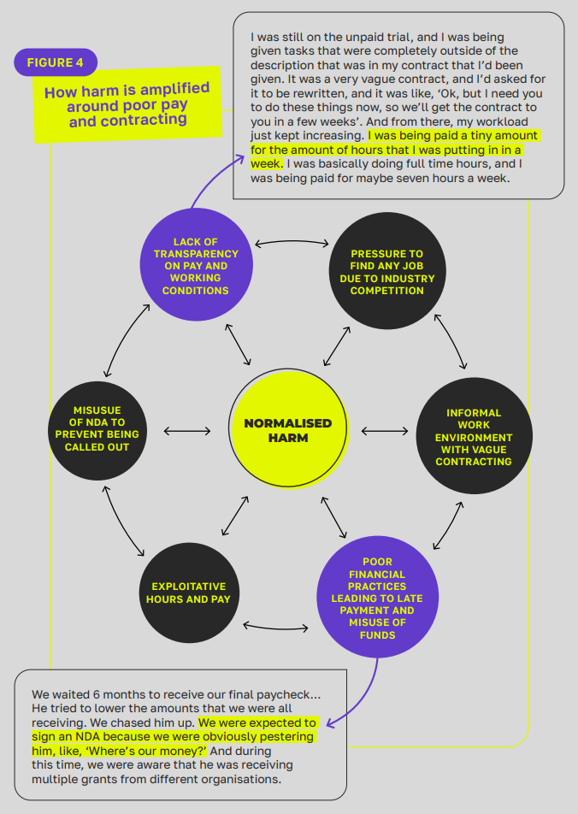

Figure 4: How harm is amplified around poor pay and contracting.

Description: the figure shows the following factors surrounding and connecting to “normalised harm” 2 factors have larger descriptions. The factors are:
- Lack of transparency on pay and working conditions
  - “I was still on the unpaid trial, and I was being given tasks that were completely outside of the description that was in my contract that I’d been given. It was a very vague contract, and I’d asked for it to be rewritten, and it was like, ‘Ok, but I need you to do these things now, so we’ll get the contract to you in a few weeks’. And from there, my workload just kept increasing. I was being paid a tiny amount for the amount of hours that I was putting in in a week. I was basically doing full time hours, and I was being paid for maybe seven hours a week.”
- Pressure to find any job due to industry competition
- Informal work environment with vague contracting
- Poor financial practices leading to late payment and misuse of funds
  - “We waited 6 months to receive our final paycheck… He tried to lower the amounts that we were all receiving. We chased him up. We were expected to sign an NDA because we were obviously pestering him, like, ‘Where’s our money?’ And during this time, we were aware that he was receiving multiple grants from different organisations.”
- Exploitative hours and pay
- Misuse of NDAs to prevent being called out

Unsafe Work Environments

The music industries present specific work environments that bring safety risks for young creatives. In music studios, artists and producers often do one-to-one work in soundproofed spaces. This means there’s more opportunity for inappropriate behaviour to happen, and it’s harder to raise the alarm if it happens. Festivals carry specific safety risks around safe accommodation. Inaccessible spaces, and the presence of alcohol and drugs, present additional safety concerns.

Physical Health And Safety

Physical health and safety within workspaces, particularly in performance spaces, is poor. Young creatives report a lack of regard for their safety, including risk assessments not being done and lone working being common-place.

“Backstage, there are a lot of work hazards that don’t really get to be looked at, because I think that they spend a lot of time looking at the people that they think matter – the people that the audience get to see. But there are a lot of work hazards with lighting and cables and a lot of things with the costumes. The safety does not really get to the people that work in the back.”

“Particularly in gigs, they don’t think about wires, so wires will be strewn all over the place, and that’s a massive health risk when it comes to wheelchairs.”

Inaccessible Workplaces

Disabled young creatives, and those with access requirements, experience health and safety issues due to workplaces and venues being inaccessible. It’s rare for access requirements to be taken seriously. One young creative told us about the aesthetics of a venue being prioritised over their needs.

“The option of playing at a festival exhausted – because you’re on the last day and you’ve been sleeping in a tent the whole time, and you’re not getting paid anything so you couldn’t even get hotel if you wanted to – just feels really difficult. And that’s the reality for a lot of these festivals.”

“I’ve had people say that they won’t put a ramp out because it looks ugly… also, sometimes the ramp is way too steep, and so I’m nearly falling out my chair… Often there is no disabled toilet which means that I’ve had to leave venues early because I need a toilet but I can’t get in there.”

Travel And Accommodation

The nature of touring, gigging and working late means that it can be hard to access safe travel and accommodation, with high rates of lone working.

“Sometimes I’m going to these gigs by myself, and people will shout from outside or wolf whistle from outside the bars when I’m walking down towards the venue and they’ll shout things like, ‘sing us a tune’. It’s quite dark in the night time, and so I’m quite scared so I pick up the pace to try and get in the venue a bit quicker.”

“[When I performed at a festival] I tied the zip together in my tent and slept with my rape alarm in hand. I don’t think we should be at a state where people feel like they should have to do that…When I was doing pub gigs a lot more and would travel and get the cheapest hotel that I could, because you don’t get paid enough. There were some hotels I really didn’t feel safe in, and you come back really late at night… Having to have my rape alarm is a constant.

“Often when you got a press pass, you’d only get one, so you have to go to these gigs alone. Usually, it would be assumed I was the girlfriend or something… I look back and I never felt really felt safe. I would keep myself to myself and just kind of pray for the best. Even getting to and getting away from work [late at night]. People never think about how you are safe getting home. You’re just expected to get on with it and sort yourself out.”

Informal And Inappropriate Work Environments

At their best, the music industries offer fun and social work environments. But blurred lines between personal and professional can be problematic. Based on the accounts we heard, it’s normal to do business in pubs and bars. Alcohol and power hierarchies are often at play, leading to harassment, discrimination, and abuses of power.

“I was in the studio space with some of the youth workers that I’d known for a couple of years, and I trusted them as we were all hanging out and making music. They were like, ‘Okay, it’s late, we need to shut up.’ And this rapper was like, ‘Oh, well, I live around the corner. You can come to mine.’ And I was like to my friend, ‘What do we do? Do we go?’ It very much felt like your opportunity to make music with this man is now: if you don’t go back now, it’s not going to happen in the future, sort of thing. So we went.”

“I was 19 – drugs and alcohol were about freely and I was quite compromised in that sense. At some point in the evening he left the living room where we were all hanging out, and went into his room. I was walking past, going to the bathroom, and he was like, ‘come in here. I want to show you something that no one has heard. It’s completely unreleased.’ And it was like a song that he’d made with another artist that I really admire. I sat down on his bed, and then I just had this moment where I looked around and I just had alarm bells in my head. I went to the bathroom and I looked a mirror, and I was like, ‘You’re not safe. You need to get out.’ So I told my friend and we left. But years later, I had a friend who fell for his thing, made an album with him, and it was being sniffed out by majors and stuff. And then he said, if she didn’t sleep with him that she couldn’t release her music. And this person just kind of gets away with it.”

“A really big record label got in touch, and I went to a meeting in London. The meeting was in a pub, which I thought was a bit random, but [it’s the] music industry, a nighttime industry. So I went and the A&R guy was really drunk that he nearly fell on top of me and crushed me... So I was quite alarmed. And then the first question he asked me was how long I’d been single for.”

“I had a meeting with [a potential manager] and it was at a shisha lounge. And I’d never been to a shisha lounge before, I’d barely been to the pub at that age. And I thought it was really unprofessional. But he’d be like, ‘this is just how the industry is. We do meetings that happen at the pub, or restaurants that aren’t really restaurants, like shisha lounges and stuff.’ And so I went anyway, and it was fine, luckily, but it just didn’t feel right. Just kind of felt unsafe. I didn’t tell my parents. I told my friends about it, and they were like, ‘this doesn’t sound right. I don’t think you should work with this person.’ And so I stopped working with him after.”

“He gave me the address, and I was very sceptical, but I went to the place, and it was like an abandoned building... I went and I brought in some breath spray that was my weapon of defence. Fortunately, it was okay, he was just there in the room and just saying a lot of uncomfortable things, and it felt very like grooming, in a way. I’m glad that I’m okay. That it was okay. I don’t know, something could have happened, but it didn’t.”

Discrimination And Harassment

Young creatives commonly experience discrimination and harassment. These behaviours take many different forms and affect people in intersectional ways. They are enabled by informal and unsafe work environments, lone working being normalised, and more senior collaborators or colleagues abusing their power.

Discrimination

Some situations are hard to prove and pinpoint, which makes the behaviour difficult to challenge.

“There’s two main areas which I think I notice feeling unsafe, or feeling unwelcome perhaps is a better term for it: and that’s in relation to disability, and then in relation to being a female.”

“There’s two main areas which I think I notice feeling unsafe, or feeling unwelcome perhaps is a better term for it: and that’s in relation to disability, and then in relation to being a female.”

“It’s difficult because sometimes when you’re being discriminated against, you don’t have hard evidence that these things happened because of discrimination.”

Specific types of discrimination are also normalised.

“I just felt like I had to make myself look less good to the male gaze, to like, protect myself. And I think that’s a thing that a lot of women experience.”

“The person running the program came in and told me I had to take my shirt off and then proceeded to only take photos of my paralysed arm side and then use that as all their promo. I was never asked my permission if that was okay… there was nothing signed, nothing, anything like that.”

In the context of being a wheelchair user:

“Very often, people will speak to my PA and not to me. And I find that very frustrating. She’ll be like, ‘You should speak to the musician who is right, right there’. And they still don’t…I get assumptions that I’m a participant, not the [music] facilitator.”

“I’m Muslim, and I’ve told [my boss] on numerous occasions that I don’t drink, it’s not something I do. And she likes to drink and [there’s been] numerous occasions where she’s drank out of work events and just gotten bare drunk and just been standing way too close, and comments like, ‘Oh, want some wine? Want some wine?’ Or, ‘Are you gonna have some wine? Or, do you want some wine?’ And I’m like, I told you bare times, like, I don’t drink.”

“The manager at the venue [where our band was performing] was just really, really inappropriate. He was an older man. Just made loads of really inappropriate comments towards myself and my band. He misgendered us on stage and my bassist went and said, ‘Actually, I use the pronouns they/ them, next time you introduce us on stage, can you make sure that you use that, that would be great’, – whatever, super nice. And he just said all of the wrong things and refused to use the right pronouns and was objectifying female audience members.”

Tokenism

Tokenism is a common thread across different instances of discrimination. Young creatives are aware of being exploited based on their protected characteristics. Organisations and people in positions of power use this to excuse unfair and exploitative working conditions and arrangements. All while benefitting from the image of employing or collaborating with marginalised young creatives.

“I very often also see things that are tokenistic in nature… Whether this has been the truth or not is another matter, but I’ve felt often that I’ve been approved onto certain things, or I’ve got a job at certain things only because I’m a wheelchair user and it looks really good for them, rather than I’m genuinely good at music.”

“I was offered by a really big platform to perform next month, and I was really excited about it. And then they were like, ‘The deal is that you come and perform for us and we give you social media content. We need to market this event as a women and LGBTQ+ event so you’re going to need to market it that way as well.’ And I was just straight up you can’t market it that way and not pay underrepresented artists for their work. I’m from a working class background, and it’s not possible to play for exposure.”

“I also think for a lot of organizations, they kind of hire [an accessibility coordinator] just to look good, as opposed to actually really caring about accessibility.”

Sexism And Sexual Harassment

Sexist behaviour, ranging from ‘mansplaining’ to sexual harassment, is normalised in many settings. Young creatives can feel powerless due to their age, gender or position to challenge this behaviour. Often, this behaviour comes from cis men, directed at women and people of marginalised genders.

“I started helping out venues when I was 16, and especially being a woman as well, I think people don’t really expect you to know things. I once had this guy try and teach me how to coil a cable. He just went up to me and was like, ‘Oh, let me teach you how to coil a cable, sweetheart.’ And when we first met, he kissed me on the cheek, but he didn’t do it with the other student who was there, because he was male… It was just a really horrible experience. And because I was young, I just didn’t know what to do in that situation.”

“I’ve been in band meetings, which are mainly men in educational settings, and I’ve had all sorts of odd requests of, ‘Hey, would you like to sit on my knee?’”

“It’s quite normal to be groped by men. It’s pretty normal and usually I’m shoving people off.”

Ageism And Abuse Of Power

A common feature of working environments is that that managers and others with more power are unprofessional in their conduct. People take advantage of young people’s relative inexperience and lack of bargaining power.

Those in charge set up or allow other lapses in professionalism to occur.

“I was offered £100 a day to come into the studio and record as many songs as possible. And at the time, I hadn’t earned anything from music. So that felt like a really generous offer, but it would turn into 12 hour days, recording three songs in one day, not taking enough vocal rest. I chose one of the songs that I made with him [a producer], and I said, ‘Look, I really want to release this’ and then he got me into conversations with a publisher. I signed a contract, and then I was under obligation from the publishers to release music using this funding. And then the week of the release, he just ghosted me, and he stopped replying, and he never responded. And I... lost my entire catalogue of music pretty much overnight. In hindsight, like that was my lyrics, my intellectual property. I should have just taken them and worked with a different producer. I reported it to Musicians’ Union, and I spoke to some other people in the industry, and it turned out he was notorious for, like, not paying his rent for a studio on time.”

“[I had] quite a volatile line manager within a role I was in. There was just a lack of boundaries around things, improper topics to be discussing in a workplace, particularly when there’s an imbalance of power and age. Just a lack of formality, ranging from inappropriate sometimes sexual topics to things like drug use. Things at the time that are quite normalised because of the industry, that you look back on and you’re like, ‘Oh, no. That was a direct report. That was really not appropriate.’”

Informal And Exploitative Cultures

Unprofessional behaviour, informal approaches to recruitment, and a lack of contracts are common. Working relationships are often also social relationships, built on good faith and lacking any formal agreement. The friendship element of such relationships makes it difficult for young people to report issues. Moving with colleagues from the office to the pub to the club can often be part of the working culture, creating blurred boundaries around appropriate behaviour. In addition, a culture of ‘we’re all pals so it’s fine’ [12] means background checks about employees and contractors are rarely undertaken, and behaviour expectations not made clear.

Poor Contracting Practices

It’s normal to not have a contract, particularly in the realm of freelance work. Where contracts or terms and conditions are stipulated, these are often unfair or exploitative. This leads to young creatives being disempowered and undervalued for their work. There were several instances where this had happened with promoters and producers. But issues also happen in office settings where people are technically doing employee roles:

“The promoter suddenly said ‘Oh, actually we have this £50 fee if you drop out of the gig.’ I’d never even signed a contract or agreed to this, but they were like ‘Oh, well, it’s on our Instagram highlights.’”

“I was doing a three day week contract, which I was being paid £1,000 a month for, I think. And I was regularly working within two or three months until 9 or 10 o’clock at night multiple days a week. Didn’t even know what TOIL was until a new CEO came in about a year and a half later.”

“I was told that there would be a job available for me at the end of this contract I had, which was a fixed six months term… I remember even writing it down, because this person used to say it, and I was like, I’m never getting this in writing. But this person kept saying to me, ‘don’t worry, there’ll be a job for you at the end of this six months.’ Obviously at the end of six months, there was no job.”

NDAs And Legal Action

Formal agreements and contracts are rare. Yet, Non Disclosure Agreements (NDAs) are commonplace. They are misused to silence young creatives from calling out bad practices, including harassment.

Threats of legal action are also used to exploit young people’s rights and entitlements as workers and creatives.

“I’ve never received any pay slips or anything for my work regarding the musical stuff. I’ve never received any contracts in place and I’ve done performances where we’ve performed on stages, on TV and radio and stuff, and never got any contracts. Our music has been used in songs that have done very well – no contracts, royalties, no anything. The only thing we’ve ever signed is an NDA and a medical form.”

“I tried to leave [my last manager]. I didn’t have a contract with him, we were on a trial period of six months. And he tried to make me pay a termination fee of thousands of pounds, and copied my solicitor into the communication to try and formalise it. He said that we had the verbal agreement, which we didn’t. Essentially, he bullied me into trying to pay this money with the threat of court. Obviously a sunset clause is something that is in a lot of contracts. But I didn’t sign a contract.”

“[I connected with a potential manager online.] He had some famous people on his profile. So I thought, okay let me try this out. There’s no harm. But he made us sign an NDA. I was really sceptical about it, because I was like ‘why is there an NDA for something that I don’t even know what it is yet? I will need to check this with my parents’. Obviously being young and impressionable, I kind of accepted like whatever he said. And he was like, ‘it’s an NDA. You can’t show your parents this.’… And so I signed this NDA and we were added to this group, and it was all girls that were working under him. It sounds so weird, but I didn’t know how to say no, and kind of get out of this group. I still hadn’t done anything – but luckily, a few months later, someone outed him on social media. It was an influencer, and then everyone started reposting, saying ‘I’d experienced the same thing’. And I was like, ‘Oh, damn. So I’m not the only person that’s felt like this’, and it had happened to multiple people, and other people’s stories were way worse.”

Musical Rights And Ownership

Young people’s intellectual and creative copyrights become jeopardized due to a lack of contracting and formal agreements. When young people work without formal agreements, or even with friends, this means they can lose access to their material if relationships breakdown.

“My music and my lyrics have been copied and taken as someone else’s… When it’s something that you’ve created yourself and someone is taking it away from you, I don’t even feel safe to put out my own original music anymore, because I’m scared that people are going to copy it.”

“Any music that we made, we were never given a contract of the rights of the music. It was like, ‘Oh, it may be yours’ and then when we try and get stems, they would be like, ‘Oh, we’re not available today’ and stuff like that. So even now, we have an album that we’re still trying to get off them”.

“There was a situation where I was working with a producer for a year and a half, and we became super, super close, became like family. And then he started making up scenarios. For example, he was like, ‘Oh, you don’t appreciate me. You didn’t even mention me on this radio show that you were on’. And I go back and I check to the recording, and I literally hear me mention him multiple times… That situation eventually ended in him never sharing the stems to a year and a half’s worth of work of music that we’d created.”

“One band I worked for, they wrote the songs and I recorded them, produced them, mixed them, mastered them. I sent them the songs, and they put it on Spotify and there’s no credit to my name whatsoever on their side of things.”

Case Study: Unprofessional working conditions, poor pay and harassment

“It was meant to be an artist management assistant role. I interviewed for it in one 15-minute interview and then got the offer within like two hours. So it all felt kind of sketchy, because I was like, ‘why would they pick me so quickly?’ In the interview, they told me that I’d be working with a team of four. They weren’t telling me who the artist was until I got there, which also was a bit of a red flag. But I went anyway, because I was just desperate for any work, even though it was also really badly paid.”

It was advertised as £50 for 4 hours of work. I was like, that’s fine for where I’m at right now. And then, after the interview, they said they’d expect 8 hours of work a week.” They sent me the address the evening before, and it was the address of an apartment building, which also felt really sketchy. But they said it would be in the co-working space of the building, and it wouldn’t be in this person’s apartment. I showed up and it was just one man. I would never agree to just work with one man if they’d told me that beforehand. This guy was the project manager, and he said that the artist would be showing up. But then he plays the music video, and it’s him in the music video, and he’s like, ‘Oh, surprise, I’m the artist. You’re just working one on one with me’. This was just completely falsely advertised – like, how I’d be working with this whole team.

He’d recorded all of these shirtless videos and he was doing lots of inappropriate stuff in the videos. He was showing them to me and being like, ‘Oh, do you think this is, like, too dirty to post?’ Which obviously is super uncomfortable, especially working one on one with a man.

I was like, ‘I’ve just got to get through these few hours and then I can just quit’. I didn’t feel comfortable quitting in person. I didn’t go back, but the guy was saying, ‘In a couple weeks, we’ll go up to my apartment and we can film content, because I’ve got a recording studio in my apartment’. I don’t know if he did or not, but I would never want to go up to an apartment by myself with a man.

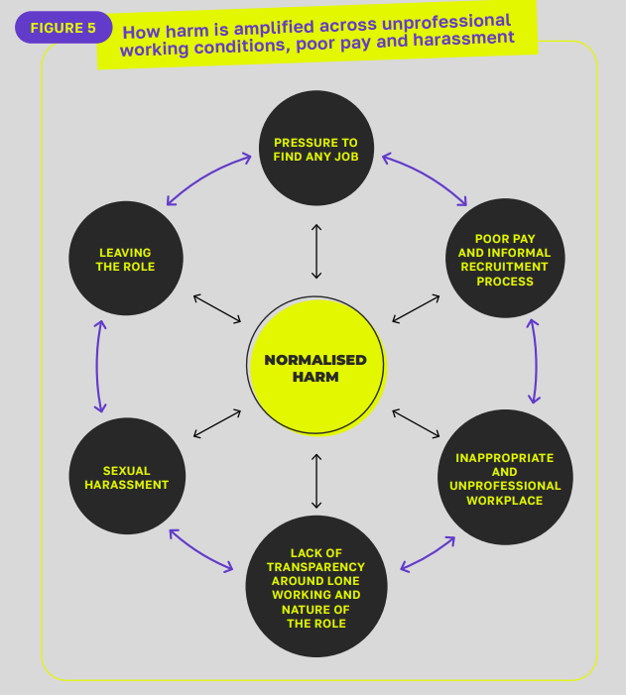

Figure 5: How harm is amplified across unprofessional working conditions, poor pay and harassment.

A circle of factors all connecting to “normalised harm”. The factors are:
- Pressure to find any job
- Poor pay and informal recruitment process
- Inappropriate and unprofessional workplace
- Lack of transparency around lone working and nature of the role
- Sexual harassment
- Leaving the role

Barriers To Reporting

We know that incidents of harm in the music industries are hugely underreported. 77% of music industry workers haven’t reported incidents officially. “The most common reasons for not reporting were ‘it’s just the culture’ in the music sector (55%), followed by ‘no one to report to’ (48%) and ‘fear of losing work’ (45%).” [5]

As The Misogyny in Music report highlights, reporting ‘is particularly problematic for younger people in the industry who are more likely to be on the wrong side of power imbalances.’ [13] The fewer protections a worker has, the harder it is for them to report. 88% of freelancers haven’t reported incidents. [5] Freelancers lack the support from HR managers and internal reporting systems that employees can often access. This also works the other way. If freelancers are perpetrators of poor behaviour, it’s easier for their crimes to go unchecked.

Barriers To Reporting

The young creatives we spoke to paint a picture where safety procedures and reporting mechanisms are often non-existent or not fit for purpose. There is often a lack of explicit behaviour expectations for staff, freelancers or audience members. In some cases, organisations use their power to threaten and dissuade young creatives from taking reports further.

“I remember performing three times at a massive festival, never paid, in a heat wave and almost passing out. They didn’t even bring me water. And they would like make comments saying, ‘don’t talk about your disability on stage anymore’ or make comments about black members of the artist development program about the colour of their skin compared to others and how it’s better to be a certain colour and all this sort of stuff. When I tried to get safeguarding involved, I was taken into a room and told ‘You’re being a rat. What happens in house, stays in house’. So that’s why I eventually reported them and got help”.

First time event organiser:

“This venue said in their terms and conditions of hire that they did provide security, and then on the night there actually wasn’t a security guard. I had to deal with [a problem] by myself with the help of the bar staff, which then put them in an uncomfortable position.”

An artist doing a gig where a queer fan was harassed by another audience member:

“I reported it to the venue when we were still there, and they didn’t even have the person leave the venue. So that was very stressful and obviously difficult to put people who are fans, people who I’m bringing to a space, putting them in a vulnerable situation.”

In this case, a person was working as a Studio Manager. A producer came to them and told them drugs were being brought into the studio and young people were attending the studio intoxicated:

“I wanted to make sure that he felt heard, and I took this to our boss, because I knew that he didn’t feel comfortable to approach him about it. There had been conversations previously, where we were just overlooked, and it was like ‘well, they’re bringing in money if they want to come and record, they can come and record’. This continued, and he would even go as far as lying to the team that nothing had been brought in, even though there would be obvious evidence that that things have been going on. And it really got to me because there was huge emphasis on… giving young people a place to sort of get off the streets and do something positive… behind closed doors he was just letting people get away with anything and everything, no matter how uncomfortable it made his employees feel.”

Strategies For Staying Safe

Amongst the harmful cultures of the music industries, young creatives are left to assume responsibility for their own safety as they are let down by more powerful and experienced employers, collaborators and contacts. When they experience harm, discrimination and exploitation, the expectation is often on them to grow a ‘thicker skin’ or ‘get over it’.

“Over the last few years, there’s been a lot of communities being built around queer, POC, female or non-binary trans communities coming together to make sure that we can support each other where we’re not being supported in other places. It doesn’t even-out what’s going on, but I’ve definitely had a lot of beautiful moments and experiences through these people and the solidarity that all of us have offered each other. I think we do really need to support each other to be able to kind of do anything.”

They risk their own safety and wellbeing when they take up informal, unclear and exploitative opportunities. Or risk their finances and career when they turn them down. In these situations, they’re often left to rely on their gut instinct to know when it’s worth the risk, and when they need to get out.

Young creatives are often having to resort to measures they shouldn’t need to take, for example bringing sprays and alarms to defend themselves against physical harm. People who are marginalised face greater pressure to do this, hiding or diverting attention away from protected characteristics to reduce the risk of harassment or discrimination.

Although they remain the exception, examples of good workplace practices stand out as being a vital lifeline for some. These often come from grassroots organisations and range from providing access support workers, to proper contracts and pay, to workplace cultures that prioritise staff voice and wellbeing. The people we spoke describe how experience good practices – even when they’re the exception – can make a huge difference. They model an alternative to the harm and exploitation that has become normalised, making it easier to recognise and call out.

Young creatives are also building alternative models from themselves, building networks and communities that model safety and inclusion.

Awareness and education enable people to recognise and call out harmful industry cultures. Industry pathway providers, delivering music industry education, and safer networking and progression opportunities, play a vital role in this. Embedding the new CIISA standards will also help increase awareness and set defined standards.

Not everyone has the confidence, experience and stability to risk losing out on opportunities, particularly at the start of their career. Those who stipulate boundaries or turn down unsafe and exploitative opportunities use this agency to support their safety and ally with others.

“I’ve had people who have refused to do certain gigs unless it’s in an accessible venue and have really backed me up… and that’s been really useful.”

“I will collaborate with other producers, but I will go to them and I will say I need stems at the end of every session. If they don’t send me the stems at the end of the session, I don’t do a second session with them. I explain to them why. And like, since then it’s been better.”

The work that young creatives do to keep themselves safe can’t be underestimated. Whether it’s relying on their gut instinct, supporting each other, or connecting with grassroots organisations that model and share good practice. But this responsibility and emotional work is both unfair and unsustainable.

When harm, exploitation and discrimination is so normalised, the power sits with the music industries, government, and other organisations to make the change.

“It’s not even a way to feel safe, because you still don’t feel safe… it’s this extra labour of constantly thinking something might happen.”

A Changing Landscape

There is lots of positive change on the horizon:
- New protections from sexual harassment were introduced in October 2024 that put more onus on employers to take preventative steps and encourage culture change. They must anticipate when sexual harassment may occur, and take reasonable steps to prevent it. And if it happens, to take action to stop it recurring. Note: ‘reasonable steps’ will change to ‘all steps’ under the new Employment Rights Bill.
- The Creative Industries Independent Standards Authority (CIISA) has been established to uphold standards of behaviour across the creative industries and to prevent and tackle bullying and harassment. The CIISA standards set out the minimum behaviour standards expected across the sector, and expectations around reporting concerns. Future services will include a confidential reporting helpline and dispute resolution service.
- The National Living Wage only applies to people aged 21 or over. The Government has committed to phasing out the 18 – 20 age rate so eventually, all over 18s will qualify.
- A new Employment Rights Bill contains a host of positive measures that will increase protections for both employees and freelancers. It is set to complete royal assent in autumn 2025. It includes stronger duties to prevent sexual harassment (including employer liability for harassment by third parties), a ban on the use of Non-Disclosure Agreements where harassment or discrimination has been alleged, and measures for greater pay transparency
- At the time of writing, a call for evidence on unpaid internships is open. Unpaid internships are already largely banned under current law, but protections will be strengthened following the consultation.
- The Music Managers Forum has launched a manager certification. It embeds CIISA guidelines and includes matters of ethics, welfare, safeguarding and professional standards.

But there are also planned changes which could make things harder for young creatives already experiencing marginalisation:
- The recent Supreme Court ruling on the Equality Act 2010 stated that ‘sex’ means ‘’biological’ sex’. Although the ruling reaffirmed that the Equality Act protects trans people from discrimination based on gender reassignment, LGBTQ+ sector leaders are concerned it will have ‘widespread, harmful implications’ for trans people. And while detailed guidance is forthcoming, there’s confusion about what it will mean for young trans people’s access to certain youth spaces and provision. [14] [15]
- Planned cuts to Personal Independence Payments benefits for disabled people have been paused to undertake a consultation. But cuts are still planned, alongside changes to Access to Work funding. All this will make things harder for Disabled people in the workforce. [16]

Recommendations

How do we ensure the current reality isn’t ‘just the way it is’? To create new norms within the music industries, where there’s:
- Fair and transparent pay and contracts
- Inclusive, diverse, equitable and accessible work environments
- No place for discrimination and harassment

Regardless of where we’re positioned, there’s actions we can all take to make positive progress. To create systemic change, all parts of the industries need to work together and play their part.

Government & Policymakers

Close the gap around safety, inclusion and rights of young adult creatives through policy and law.
- Legislate and enforce fair pay and fair hours. Regardless of age, role and industry
  - Minimum wage should be in line with the Real Living Wage.
  - Look to other countries who’ve implemented Universal Basic Income for freelance creatives.
  - Increase protections for freelancers.
- Ensure new protections against the mis-use of NDAs are watertight, particularly for freelancers
- Support CIISA to uphold and improve behaviour in the UK’s creative industries.
- Close the gap on adult safeguarding, so there’s a framework and support for organisations working with young adults over the age of 18.

Funders And Sector Support Organisations

Listen to what grassroots industry organisations and young creatives need to make things safer and fairer. Use your power and influence to promote accountability.
- Support industry organisations to improve their practices, particularly grassroots organisations who have less resources to do this work
  - Funders in particular hold a lot of power. They should learn from the organisations they fund what the barriers are to creating safer, inclusive and fair cultures.
- Improve communication of reporting mechanisms, be clearer about behaviour expectations on grantees and about consequences where they are not met
- Ensure that the process for accessing funding, support or joining as a member is accessible for young creatives
- Campaign for wider change

Industry Employers

Create open and accountable workplace cultures, with fair pay and contracts.
- Proper contracts for staff and freelancers
- Better procedures and practices
  - Risk assessments, safer recruitment, training and induction, code of conducts, reporting mechanisms that work.
- Work in professional spaces and communicate on professional platforms
- Invest properly in access costs
- Pay fairly
  - Commit to Real Living Wage and don’t offer unpaid work. Sign up as an accredited living wage employer to show commitment to fair pay
- Put clear and open mechanisms in place
  - to meaningfully listen and have dialogue with staff and freelancers.

Advice For Young Creatives

The primary change needs to come from organisations who hold power and influence. The current culture expects young creatives to look out for their own safety and ‘get over it’ when things go wrong. It’s important to emphasise that it’s not fair or acceptable to put the burden on young people to keep themselves safe.

However, young creatives are already doing a lot to promote their own and others’ safety and rights. Although we shouldn’t have to, it feels necessary to share these things.
- Know your rights and what good practice looks like
  - You can use resources and templates from trusted organisations to create access riders, contracts, and terms and conditions for your work. These can help to lay out your expectations and hold people accountable when your rights aren’t respected.
- Know how to report bad behaviour
  - Knowing how to report bad behaviour means that you can make an informed decision if you experience this. As well as reporting concerns internally, there are different external organisations that you can report to depending on the issue. Often, you can report to external organisations anonymously.
- Model good practice and allyship with other young creatives
  - Collaborating with others is often central to being a creative. By starting strong – modelling working in safer, fairer and more inclusive ways with others – you are part of setting better norms for the new generation of creatives.
- Access support and opportunities from trusted organisations
  - Grassroots organisations offer pathway programmes for progressing in the music industries. Signing up to newsletters and joining networks can mean you’re aware of these opportunities. Unions such as the Musicians’ Union and the Independent Society of Musicians offer a range of services to members, and their membership costs can often be included in funding applications.
- You’re not overreacting. Trust your gut instinct and the red flags
  - Give yourself permission to leave a situation that doesn’t feel right. You shouldn’t have to be hyper-vigilant and sometimes it’s not obvious that a situation isn’t safe. But if your instinct tells you that something’s not right, then don’t dismiss it.
- Prioritise your own wellbeing
  - It can be exhausting to be working and navigating an industry where harm, unfairness and discrimination is normalised. Especially when there’s pressure to always be working and getting ahead. Amongst this, it’s important to look after yourself and prioritise your wellbeing. There are also free support lines and resources for young people and people working in music.

Signposting And Resources

Access Riders

Unlimited’s guide to Creating your own access rider

Musicians’ Union guidance on Access Riders for Musicians

Contracts

Musicians’ Union template Standard Contracts

Reporting

Crimestoppers is an independent UK charity that allows you to report a crime anonymously.

The Musicians’ Union Safe Space scheme provides an opportunity for musicians to share instances of sexism, sexual harassment and sexual abuse in the music industry. They have a range of other useful resources and members can access free legal advice.

Anyone can report a concern to Arts Council about an organisation that has applied to them or receives funding from them. If you make a report, you can ask to remain anonymous.

Youth Music has a procedure to raise a concern about a funded partner. If you make a report, you can ask to remain anonymous.

Protect is the UK’s leading whistleblowing charity and they provide free and confidential whistleblowing advice.

The Creative Industries Independent Standards Authority will soon be launching a new reporting line that will provide a safe, impartial place where individuals and organisations can seek confidential advice, report concerns and access support.

Opportunities And Funding

Youth Music’s newsletter contains information about opportunities and funding for young creatives, sector news, insights and updated about our work.

Youth Music’s opportunities board contains opportunities from different organisations, such as training, workshops and job openings.

Attitude is Everything’s Next Stage initiative supports artists with access requirements to thrive within the music industry.

Musicians Union has different rates of membership, including reduced rates for Disabled musicians and musicians in education.

Independent Society of Musicians has different rates of membership, including reduced rates for early career and student membership.

Wellbeing Resources

British Association for Performing Arts Medicine health resources and healthy practice training for creative professionals.

Musicians’ Union “A Young Freelancers Guide” covering mental health in the music industries

Musicians’ Union Mental Health Support resources

Mind’s ‘music sector guides’, for organisations, managers, employees and freelancers, give information on how those working in the electronic music industry can be supported to have good mental health at work.

Support Lines

Samaritans – To talk about anything that is upsetting you, you can contact Samaritans 24 hours a day, 365 days a year. You can call 116 123.

If you work in music and are concerned about a bullying or harassment situation, call Help Musicians confidentially for free support and advice on 0800 088 2045.

Music Minds Matter on 0808 802 8008 (24 hours a day, 365 days a year) which is run by Help Musicians, a UK based charity.

Music Support Helpline – 0800 030 6789 (9am-5pm, Monday-Friday) managed by mental health-trained peers with lived experience, for anyone working within music and live events.

Shout Messaging Service – Text the word ‘Shout’ to 85258 for free urgent mental health support, 24 hours a day, 365 days a year.

Papyrus HOPELINEUK If you’re under 35 and struggling, you can call Papyrus HOPELINEUK on 0800 068 4141 (24 hours a day, 365 days a year).

Rape Crisis – If something sexual happened to you without your consent – or you’re not sure – you can talk to Rape Crisis. Call 0808 500 2222 or Live Chat on the website (24 hours a day, 365 days a year).

References

[1] | L. G. a. D. O. Heather Carey, “Job Quality in the Creative Industries: The final report from the Creative PEC’s Good Work Review,” Creative Industries Policy and Evidence Centre, 2023.
[2] | “Women Musicians Insight Report,” Musicians’ Census, 2024.
[3] | Attitude is Everything, Black Lives In Music, “Unseen Unheard: Race and Disability – Black disabled experience in the UK’s music industry,” Attitude is Everything, Black Lives In Music, 2023.
[4] | Musicians’ Census, “Disabled Musicians Insight Report,” Musicians’ Census, 2024.
[5] | V. B. Kathryn Williams, “Dignity at work 2: Discrimination in the music sector,” Independent Society of Musicians, 2023.
[6] | Musicians’ Census, “LGBTQ+ Musicians Insight Report,” Musicians’ Census, 2024.
[7] | Health and Safety Executive, “Working days lost in Great Britain,” Health and Safety Executive, 2025.
[8] | UK Music, “Diversity Report 2024,” UK Music, 2024.
[9] | D. O. M. T. Orian Brook, “'There’s no way that you get paid to do the arts’: unpaid labour across the cultural and creative life course,” Sociological Research Online, vol. 25, pp. 571-588, 2020.
[10] | Musicians’ Union, “Financial Insight report,” Musicians’ Union, 2024.
[11] | Youth Music and Livity, “A Blueprint for the Future,” Youth Music and Livity, 2020.
[12] | L. B. M. M. Dr Diljeet Kaur Bhachu, “Safeguarding Young People in Traditional Music,” The BIT Collective, 2025.
[13] | Women and Equalities Committee, “Misogyny in music,” Women and Equalities Committee, 2024.
[14] | Consortium.lgbt, “LGBT+ Sector Leaders Statement on Supreme Court Ruling,” 2025. [Online]. Available: https://www.consortium.lgbt/lgbt-sector-leaders-statement-on-supreme-court-ruling/.
[15] | Frontline, “How the Supreme Court’s decision will impact young people in the social work system,” 25 April 2025. [Online]. Available: https://thefrontline.org.uk/blog-post/how-the-supreme-courts-decision-will-impact-young-people-in-the-social-work-system/.
[16] | Benefits and Work, “What's changing, when,” 21 July 2025. [Online]. Available: https://www.benefitsandwork.co.uk/personal-independence-payment-pip/pip-uc-changes/whats-changing-when.

