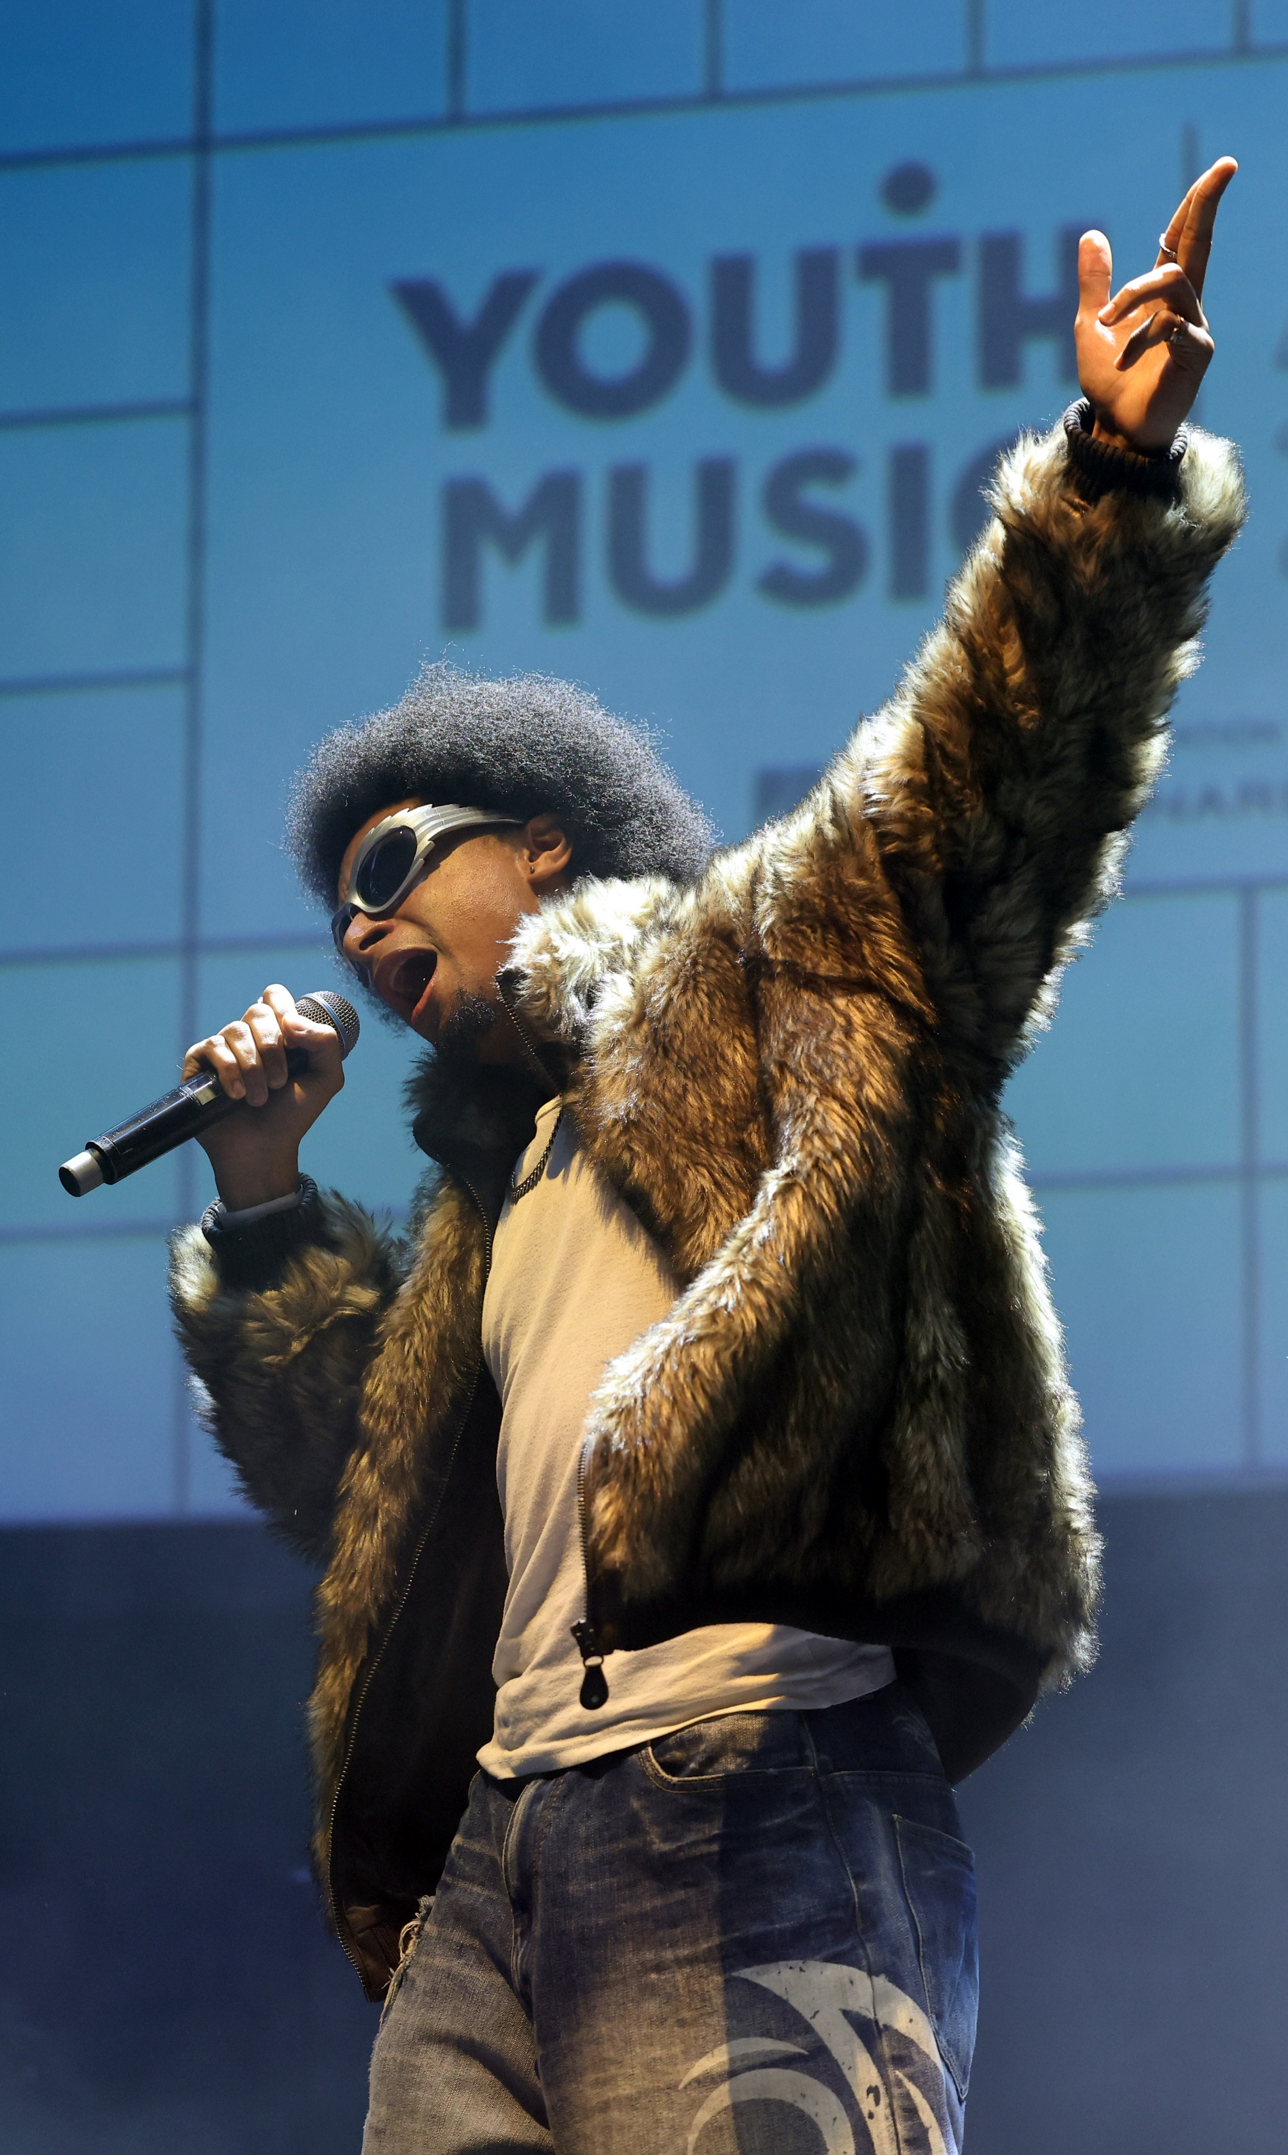
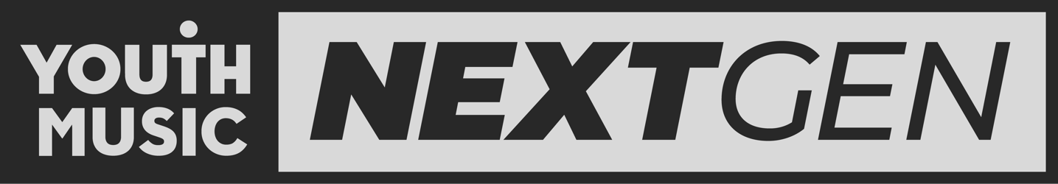
Photo by Tim Whitby

NEXTGEN
FEEDBACK
SURVEY
2024
Contents

Introduction 3
Respondent Information 4
Youth Music’s Impact 5
Accessibility and Inclusion 6
NextGen Fund Feedback 7
Collaboration 8
NextGen Views 8
Final Thoughts 9
Case Study: Charity, West Midlands 10
Case Study: Charlie, London 11
Case Study: Jazmine, North West 12
Case Study: Jenni, North West 13
Case Study: Sarah, London 14
Case Study: Tobi, Yorkshire & the Humber 15

Introduction

The NextGen Feedback Survey is an annual survey to explore how much impact we are having and what more we could do to facilitate the development of young creatives’ careers. The survey was live in October-November 2024. Respondents can then opt-in for a follow-up interview with our Insights team.
Interviewees included NextGen that have received the NextGen Fund, had a freelance opportunity, or have taken part in a Youth Music funded project. There were also young people who are part of the NextGen Community but were yet to have an opportunity with Youth Music.
The interviews were conducted in December 2024.
The case studies from these interviews can be found at the end of the report.

Respondent Information

Total responses: 100 (37% increase from 2023)
57 respondents have had an opportunity with Youth Music
16 respondents have had more than one opportunity

Engagement with a Youth Music opportunity (100)



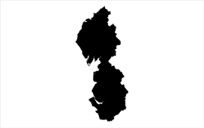






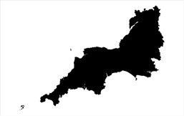

N. Ireland
0%
Scotland
4%
North East
6%
North West
14%
Wales
3%
West Mids
3%
East Mids
7%
Yorkshire
7%
South West
3%
South East
5%
London
28%
East of Eng.
2%
What region do you currently live in? (100)
18% responded ‘England’

Youth Music’s Impact
To what extent do you find the opportunities Youth Music offer impact your career progression? (2024: 42 / 2023: 36)
Most respondents found Youth Music’s opportunities to be valuable for career progression, offering skills, connections, and industry insights.
When asked to explain their selection, some provided examples of how it had impacted their career:
“I feel like working for an established music industry company was beneficial to my CV, and sharing content I made on a platform with an existing audience allowed it to flourish more than it typically would on my own social media channels”
“With Youth Music funding I was able to put out an EP that massively progressed my career. One of these tracks were then chosen and nominated for a youth music award where my band performed.”

Accessibility and Inclusion

To what extent do you find the opportunities Youth Music offer to be accessible? (2024: 42 / 2023: 35)
When asked to expand on their answers, the responses were largely positive. There were still some suggestions for improving our accessibility and inclusion, including an increased regional spread of opportunities and changes to the application process.

NextGen Fund Feedback

 | Not at all | To little extent | To moderate extent | To good extent | To great extent |  | To a good/ great extent | Change from 2023
Application form | 0% | 0% | 8% | 19% | 73% |  | 92% | +5%
Application guidance | 0% | 0% | 4% | 33% | 63% |  | 96% | +9%
1-1 support from Youth Music | 0% | 7% | 7% | 30% | 56% |  | 85% | +13%
To what extent were the following resources useful for you when applying to the NextGen fund? (2024: 27 / 2023: 31)
 | Not at all | To little extent | To moderate extent | To good extent | To great extent |  | To a good/ great extent | Change from 2023
Application form | 0% | 4% | 7% | 19% | 70% |  | 89% | -11%
Application guidance | 0% | 0% | 19% | 22% | 59% |  | 81% | -6%
1-1 support from Youth Music | 0% | 7% | 11% | 22% | 59% |  | 81% | +5%
To what extent were the following resources accessible for you when applying to the NextGen fund? (2024: 27 / 2023: 31)
We asked successful NextGen Fund respondents if they had any feedback on our grant management. The feedback was largely positive, with many respondents praising the friendly, supportive, and approachable communication from their grant managers. Grant managers were appreciated for their understanding of challenges such as project delays and personal issues, as well as their flexibility with timelines.
“My experience with my grant manager has been great, they have been understanding of any changes and struggles I have come across and helped me get them approved so I could move forward with my project in a way that made sense for me given certain circumstances.”
“Amazing communications with my grant manager. Responds quite quickly and is so nice and enjoy chatting to my grant manager”

Collaboration
2024
2023
What could Youth Music do to help you collaborate with others involved with Youth Music? (Select all that apply) (2024: 91 / 2023: 66)

NextGen Views

What interests you about the music industries at the moment? Select all that apply. (92)

Final Thoughts

To gain more insight into how Youth Music can best support young people, we asked respondents what further opportunities Youth Music could provide to help them reach their career goal. Suggestions were broad, including the following:
Networking and Industry Access:

“Networking support, building a team. Connecting artists to managers, booking agents, lawyers, creative directors, labels etc.”

“More chances to network with other musicians and creatives, further support for independent musicians not fortunate enough to advertise.”

Mentoring and Guidance:

“Mentors - having someone who has loads of experience to speak to and hear how they have done it. Having that person to ask questions who understands the industry. Takes away from feeling like you need loads of contacts to be able to make it”

“Mentorship, a placement to develop my artist development and guidance for that, also to help me develop my skills, both music and production, or connect me with those who can help me turn my ideas into reality”

Live Performance opportunities:

“More live performances and alumni styled programmes for continuing support for previous recipients.”

“More investment in offering opportunities for live performance”

Funding and Grants:

“Smaller micro-grants. Lots of small artists just want £200 to help with marketing, or a small cash injection to buy some equipment. Lots of the grants available are for larger chunks of money that can feel inaccessible.”

Case Study: Charity, West Midlands

Charity is a 24-year-old musician from Lincolnshire. She recently moved back home after spending the last five years in Nottingham. Having previously worked in hospitality and the charity sector, she is currently on a career break, allowing her to dedicate her time entirely to their musical pursuits.
A singer-songwriter, Charity received NextGen Funding in 2021. The funding not only enabled the production of a song but also the creation of a music video shot on Super 8 film, which is something Charity had long held ambition to do. "It was really lovely to kind of finally got the vision that we wanted," Charity shared. Additionally, the funding allowed Charity to compensate friends and family who contributed to the project and to produce T-shirts and CDs.
The opportunities provided by Youth Music have had a profound impact on Charity’s musical journey. "This funding kind of reignited a passion," Charity notes, emphasising how the support helped them fall back in love with music after a period of professional burnout. The exposure from the NextGen Fund project also helped Charity expand their supporter base and establish valuable connections within the music industry. "I definitely, at the very least, met a lot of interesting people through Youth Music".
Charity envisions a hybrid career that combines her passion for music with an interest in working with children. Recent work experience at a primary school revealed a newfound joy in sharing music with young learners. "I just really enjoyed the simplicity of that. I thought it was really beautiful how excited they were to see a musician."

Case Study: Charlie, London

Charlie is a 26-year-old freelancer, primarily working as a DJ and Event Producer. She is Executive Producer for Ori Community and a Creative Collaborator for Jazz on Wick, amongst DJ residencies with Nightales and Jumbi, and hosts shows on Sister Midnight FM, The Boat Pod, and Back 2 Back DJ Battle.
Despite studying English literature at university and considering a career in Law, the COVID-19 pandemic prompted Charlie to reassess her goals and pursue music full-time. Over time, Charlie built valuable connections in the music industry, working at
various roles, including marketing, studio production, and promotion. It was through this experience that she was able to contribute to building Orii Community, a hub for musicians to perform and connect.
Charlie also worked at the Youth Music Awards 2023, where she was part of the PR team. “It was an amazing opportunity. I was able to meet a lot of different people and get vital skills in PR which I've taken back into my freelance career and offered back to grassroots organisations that don't have the money to hire a PR agency.”
Additionally, the networking opportunities at the Awards helped Charlie expand her professional connections. "I was able to meet so many people there, like other female DJs, female artists, photographers - people who I'm still in touch with now."
Charlie's future plans involve continuing to develop her artist career as both a DJ and producer, and expand her reach within large-scale event production. She aims to secure an agent to manage bookings, allowing her to focus more on the creative aspects of her work.
Shealso plans to release two EP's in 2026, furthering her artist portfolio and identity.

Case Study: Jazmine, North West

Jazmine is a 24-year-old musician based in Manchester. Initially starting as a guitarist and session musician, she transitioned to audio engineering and production after sustaining an injury that limited her ability to perform live. Alongside, she has focussed on solo studio work, while continuing to teach and facilitate music.
This facilitation work has led Jazmine to work with Youth Music funded partners, including Create Define Release (CDR) and Brighter Sound. Originally self-taught, after receiving some tutoring, she released the impact that kind of support can have so wanted to do that herself. Initially supporting young people with instruments, she has since moved to teaching music technology and DAW software.
Looking ahead, Jazmine aims to expand their role in music education and pursue solo artistic endeavours. "I want to do more facilitation and find something studio-based, which is really competitive." They are also focused on completing their degree, which will provide a strong foundation for their future projects. "I'm doing my dissertation on creativity and creative workflows for solo artists, so I'll probably just be following that and trying to become a solo artist."

Case Study: Jenni, North West

Jenni, a 23-year-old musician based in Manchester, has been releasing her music since late 2021. Releasing music in a pop/alt-rock genre, she’s been performing at various gigs around Manchester, including the Euros Fan Village. In 2023, she graduated from university after studying for a Business degree, securing a job in marketing.
Jenni received NextGen funding, which she put towards releasing music. "I used the NextGen fund to release one of my singles, which then kind of geared me up to release the EP that I've just put out". The grant allowed her to produce a song and run a marketing campaign, significantly boosting her music's reach and professionalism. Jenni also had some studio time at Levi’s, which came about from conversations she had at the Youth Music Awards.
The NextGen Fund has had a big impact on Jenni's career, beyond supporting her to release music. "The main thing that I actually got from the grant, aside from obviously the funding, was the confidence boost," she explained. This newfound confidence led Jenni to release additional singles, perform at larger events, and secure further funding from Help Musicians for her EP. "It's becoming easier to get performances, and I've built a bit more of a network where I am now."
Jenni aims to continue growing her music career, focusing on live performances and larger projects. Jenni is actively applying for festival spots and support slots, hoping to expand her reach and build a stronger community around her music. Additionally, she plans to promote her recently released EP and explore new projects.

Case Study: Sarah, London

Sarah is a 26-year-old singer-songwriter based in Essex and London. She started singing and writing music at a young age before going to music college, where she spent three years honing her craft.
After college, Sarah began gigging and releasing music, initially experimenting with her style. In the last two to three years, she’s started to get momentum, performing at better stages and gigs, gradually building a sustainable music career.
Sarah received the NextGen Fund to create her first EP, covering mixing costs, studio fees, mastering, and even a live session recording. "It really gave me something to use to build the EP, which I had no idea how I was going to bring out without that funding," she said.
A single from the EP, “Intuition”, went on to win the Best Original Track (Solo) at the Youth Music Awards 2024. This recognition has opened up numerous publicity and networking opportunities for her, including radio play and press coverage. "Being involved with Youth Music has helped me with my progression […] [Winning the award] has already opened up so much publicity opportunities".
As well as this, she feels going through the NextGen Fund application process has been really beneficial in supporting and preparing her for further funding, discovering how best to portray herself in applications.
Sarah is focused on maintaining consistency in her music releases and live performances. Her ultimate goal is to make music her sole profession and sustain a career without needing to work alongside it.

Case Study: Tobi, Yorkshire & the Humber

Tobi, a 21-year-old musician based in Leeds, England. As well as music, Tobi is currently studying for a Law degree at university.
Tobi is a former participant in the LEVEL Incubator Fund project at Young Thugs in York. The project involved a six-month placement at their music studio, along with a career development programme.
While on the project, they learned how to produce music, make their own beat and released one of their songs. “I didn't even try and make a beat or anything like that. But then one of the people who worked there helped me so much. They helped me get over the initial fear of starting and then gave me a lot of confidence to be able to do it. Within three months, I was just making beat flows throughout that summer.” Reflecting on the project, Tobi said it was the best time of her life.
The programme also facilitated networking opportunities, allowing Tobi to connect with other musicians and industry professionals. "I met this girl, and she produces. So it was nice to be able to share ideas and have her opinion on stuff […] because I don't really know that many people who do music.”
Tobi is determined to continue pursuing her music career while completing her Law degree, aiming to release more music and push herself creatively. Tobi is also considering further education in music and management to enhance their music career, with the ultimate goal of making music her primary progression.

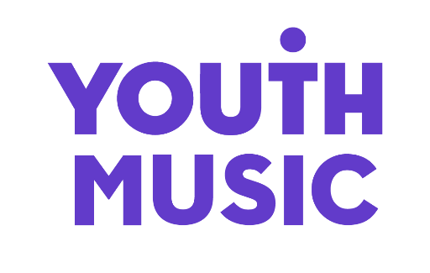

THE NATIONAL FOUNDATION FOR YOUTH MUSIC
STUDIO LG01, THE PRINT ROOMS
164-180 UNION STREET, LONDON, SE1 0LH
REGISTERED CHARITY NUMBER: 1075032
LIMITED COMPANY NUMBER: 03750674

