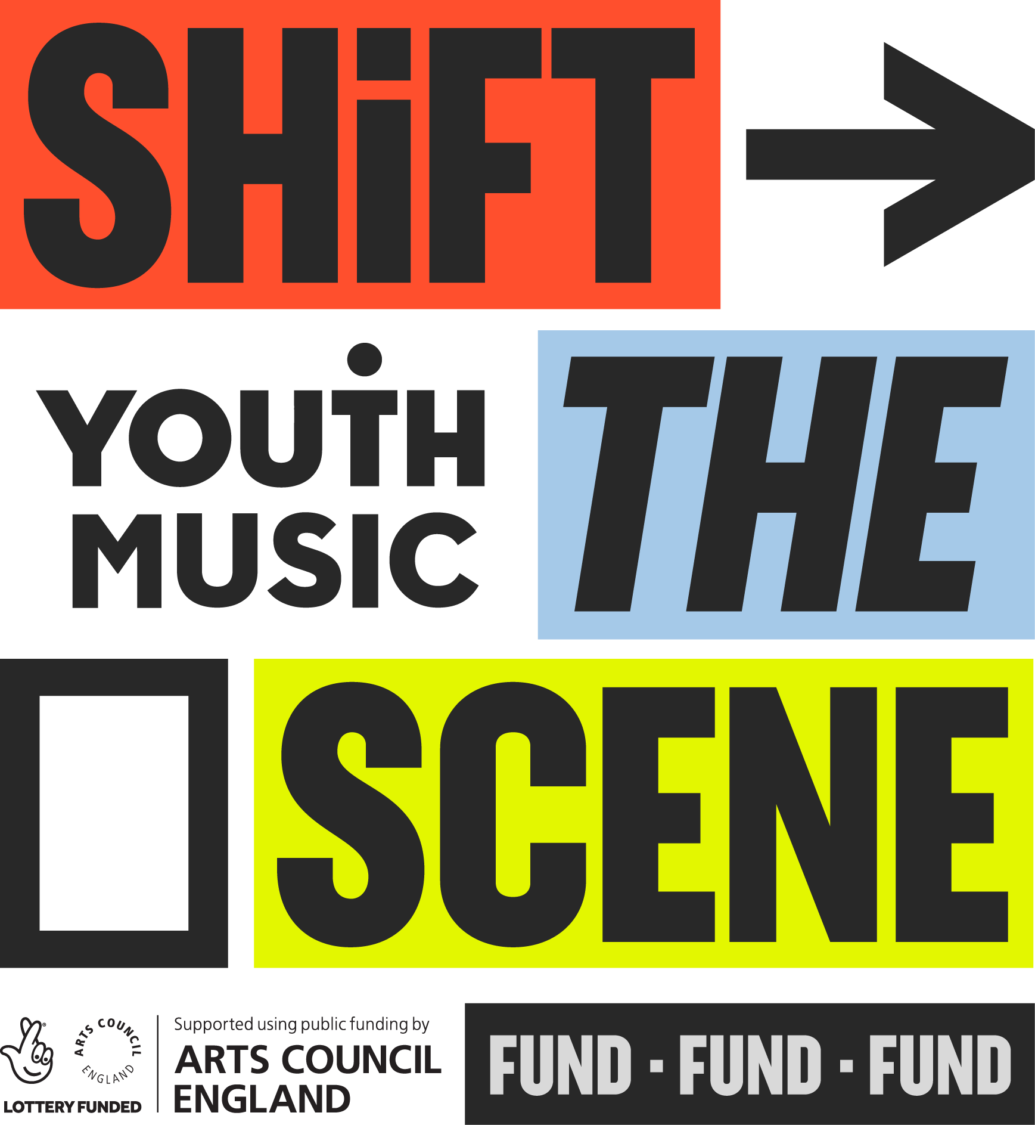

# Youth Music Shift the Scene Fund Application Guidance

## Table of Contents

**Page 2:** Section one: Shift the Scene overview

**Page 8:** Section two: Why we decided to create this fund

**Page 10:** Section three: Our fund principles  
**Page 16:** Section four: Am I eligible?   
**Page 22:** Section five: Programme fit  
**Page 28:** Section six: Budget planning    
**Page 34:** Section seven: Next steps  
**Page 37:** Section eight: How we make decisions  
**Page 40:** Section nine:What happens next?

**Page 43:** Application checklist

## About Youth Music

We’re a national charity. We help marginalised young people to make and monetise music.

Every year, we raise £10 million to fund inspirational grassroots music projects and support aspiring young creatives up and down the UK.

We’re campaigning to break down barriers for young people facing inequity, exclusion and discrimination.

Together with our partners, we’re helping the next generation to transform their lives through music. Join Us.

### Youth Music funding

Youth Music runs several grant programmes. Read more about them on the [Youth Music website.](https://www.youthmusic.org.uk)

Youth Music’s Shift the Scene fund works across the arts, and is financed with National Lottery funding, which we receive through Arts Council England.

## Section one: Shift the Scene overview

### Overview

**Shift the Scene** will fund creative opportunities for **Disabled children and young people**. Driving genuine inclusion, ambition and accessibility. Through advocacy, creativity, and community, we want organisations to ‘shift the scene’ and create spaces where Disabled voices lead.

In this one-off fund, grants of up to **£200,000** will be made to organisations for work that is sustained over a **4 year period**.

Opportunities will be funded **across all art forms**, not just music, for children and young people **aged 9 to 30.**

#### Beyond Music

This is Youth Music’s second fund investing in more than music. This is in response to Arts Council England’s Let’s Create Strategy, and the requirements of our National Lottery funding.

#### What will a Shift the Scene Funded Partner get?

* A 4.5 year grant.
* A facilitated learning and networking programme with other funded partners – the Shift the Scene community.
* Communications and advocacy strategy and support from Youth Music.

#### What does Youth Music want to achieve?

Ultimately, we want to bring about equality of creative outcomes for Disabled young people. To change how creative programmes are designed and delivered, and how young Disabled creatives are perceived.

When?Funding will be for four and a half years.

* Set-up: May 2026 - August 2026 (delivery can start within this timeframe if you are ready)
* Year 1: Sept 2026 - August 2027 (12 months)
* Year 2: Sept 2027 - August 2028 (12 months)
* Year 3: Sept 2028 - August 2029 (12 months)
* Year 4: Sept 2029 - August 2030 (12 months)
* Final reporting: Sept 2030

#### Application process

A two-stage application process. Stage one is an application form. Shortlisted applicants will then be invited to stage two. This is an online interview with Youth Music.

#### Target organisations

* Constituted UK based organisations who have been set up for at least a year. See Section 4 for full criteria.
* Those experienced at working creatively with Disabled children and young people, who align with our fund principles and where co-design is core to their practice.
* The fund will bring together different organisations – with a diversity of organisation type and size, geographic spread, and creative practices.
* There will be a very high demand for music focussed projects. We anticipate that we will only fund one or two music-based projects.
* Schools are not eligible to apply to this fund. However, schools can be partners on a Shift the Scene programme.

#### A Shift the Scene funded partner could be:

* A museum or library that programmes literature and art activities for 9 to 12 year olds.
* A theatre company that specialises in work with Disabled young people.
* A small CIC comprising freelancers delivering music and movement projects with Disabled young people in a variety of community settings.
* A visual arts charity creating pathways for young Disabled artists.

#### What does a Shift the Scene Fund programme look like?

At its heart, a Shift the Scene Fund programme is about delivering creative activities for Disabled young people that have been co-designed with them, and delivered by organisations that want to explore and develop their practice and help us Shift the Scene.

[Take a look at the Shift the Scene project examples on our website](https://www.youthmusic.org.uk/funding/shift-scene-project-examples).

#### Timeline

The [Grants Portal](https://grants.youthmusic.org.uk/) opens for applications on Friday **31 October 2025**. The deadline for applications is **Friday 28 November 2025 at 5pm**. You’ll find out if you have been invited to interview at the start of **February 2026.** Interviews are currently scheduled to take place between Monday 23 February and Friday 6 March.

A note on language

We use the term ‘Disabled’ rather than ‘SEN/D’ or ‘person with disabilities’ in line with the [social model of disability](https://www.sense.org.uk/about-us/the-social-model-of-disability/). The social model, developed by Disabled people, reframes disability as an issue of rights. It says that people are disabled by features of society and the environment, not by their impairment. The social model therefore puts the onus on society to provide the right support to overcome disabling barriers.

We use the term ‘Disabled people’ to encompass the terms d/Deaf, Disabled and Neurodivergent. We have made this choice to help with readability. We use the term ‘Disabled person’, rather than ‘person with disabilities’, in line with the social model. We capitalise the D to emphasise the term’s political significance.

We know that not all people with neurodivergence, long-term health conditions, impairments or access needs consider themselves to be Disabled. And that others might self-identify. We want to recognise at the outset that language and labels used around disability have, and will continue to, evolve. And that whilst collective definitions and labels can be helpful, they can also be imperfect and reductive.

Disabled access supportIf you identify as Disabled and require additional support to make an application to Youth Music, you can [apply to our Access Fund](https://www.youthmusic.org.uk/funding/i-need-funding/access-fund). We offer funding of up to £900 for the application stage. You should apply for this money before you start your application.

#### Use of Artificial Intelligence (AI) in applications

If you use AI to help you draft your application, your answers must be an honest and accurate reflection of your work and plans. We often find AI answers aren’t specific enough, and this can have a negative impact on your assessment.

## Section two: Why we decided to create this fund.

#### Why the focus on Disabled children and young people?

Disabled children, young people, and adults still face disproportionate barriers when accessing the arts, creative education, and employment. In our latest research, [**Excluded by Design**](https://www.youthmusic.org.uk/excluded-by-design), we found that:

* Their participation in the arts is lower, shorter-term, and more likely to be home-based.
* They frequently encounter discrimination, fear of judgement, lack of youth voice and agency, limiting expectations, and tokenism.
* Representation remains scarce. Just 9% of the workforce of regularly funded arts organisations are disabled, compared with 16% of all people in employment in the UK.

In recent years, we’ve seen some exciting **innovation and progress** when it comes to access and inclusion in the arts. But change hasn’t come fast enough.  
  
There needs to be a shift in **how creative programmes are designed for young Disabled people**. They should be long-term, sustained and progressive. With more youth voice and agency, 1:1 mentoring and support, better representation and more progression options. Underpinned by the social model of disability.  
  
The research charts good practice from across the sector and provides a **series of recommendations**. We urge you to read the findings and take action to improve parity of creative outcomes for Disabled people.

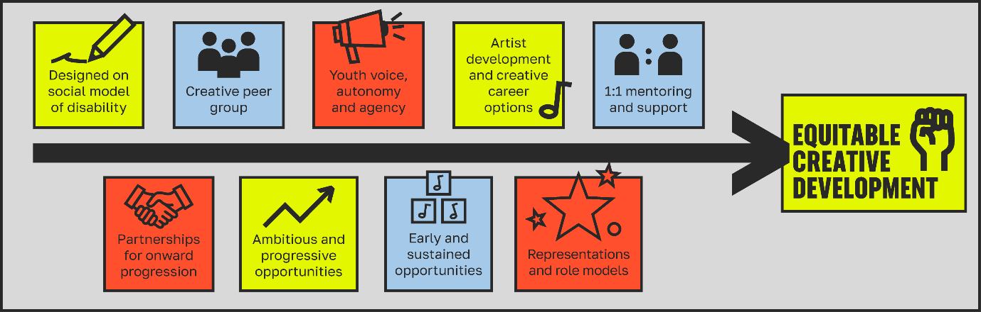

## Section three: Our Shift the Scene principles

**Shift the Scene** is a fund for Disabled children and young people, pushing for genuine inclusion, ambition and accessibility across all art forms. Through advocacy, creativity, and community, we want organisations to shift the scene and create spaces where Disabled voices lead.

Below are the beliefs and principles that have guided the development of this fund. To apply to the Shift the Scene Fund, you must align with them. We have designed them in response to the Excluded by Design report findings, working with our [**Shift the Scene steering group**](http://www.youthmusic.org.uk/funding/shift-scene-steering-group)**.**

We don’t expect you to have it all sorted across all of these areas. But we do expect and value your honesty about where you need to develop.

### Shift the Scene principles

**1. Trust**

It is clear from our conversations with young Disabled people that they’ve been let down many times and for some, the trust is gone. For us, the most important thing is to ‘do no further harm’. Therefore, it is essential that one of our principles is to build back that trust. We want to fund authentic and genuine organisations who provide safe and supportive opportunities for Disabled children and young people.

2. Learn and developYouth Music’s practice is constantly developing, and we’re still learning – we want to partner with organisations who do this too. This means evaluating and reflecting on what you do, refining, and trialling. Also, being open and honest about what is and isn’t working.

3. Amplify Disabled voices and representation

Young Disabled voices must play a central role in shaping your programme. By ‘voice’, we mean the various ways that young Disabled people articulate their opinions, insights, passions and needs. Having Disabled people actively involved throughout the organisation—in both delivery and leadership—is crucial. Lived experience brings invaluable insight, and meaningful representation makes a real difference.

**4. Anti ableist**

We believe every organisation should be actively anti-ableist, advocate for the rights of Disabled people, platform disability arts, and operate in line with the social model of disability.

5. Inclusion, Diversity, Equity and Accessibility (IDEA)Your organisation should strive to be **I**nclusive, **D**iverse, **E**quitable, and **A**ccessible. In this fund, there’s particular importance and focus on:

* Access from the start
  + We believe true accessibility means building access and inclusion into every project from the very start — it should never be treated as an afterthought.
* Addressing Intersectionality
  + We recognise that supporting Disabled children and young people requires an understanding of how [intersectionality](https://www.disabilityrightsuk.org/resources/inclusion-and-intersectionality-online-resource-support-disabled-people%E2%80%99s-organisations#_Toc155189267) significantly shapes experiences within the disabled community.

6. Creative ambitions We believe that Disabled children and young people’s creative ambitions should be at the heart of creative practice. This should take priority, and organisations should provide genuine pathways to facilitate this. Organisations should be ambitious and want to push boundaries within their creative practice.

7. Wellbeing and safety

Participant and staff wellbeing is a critical aspect of this fund. This extends beyond physical safety to include mental, emotional, and social support. Organisations are responsible for creating an environment that protects people’s health, wellbeing, and human rights, ensuring they can participate without fear of harm, abuse or neglect. Access to the resources and care needed to support safety and wellbeing should be prioritised at every stage of the process for participants *and* staff.

8. Partnership workingWe believe that working in partnership with other organisations, adults, and young people is key to enabling deeper learning, development, and a better creative world for young people

**You should be able to answer yes to all these questions to apply:**

* Are you genuinely committed to providing safe and supportive opportunities for Disabled children and young people?
* Are you committed to learning and developing as an organisation?
* Do you recognise and value the voices and lived experiences of Disabled people within your organisation as essential, and an example of good practice?
* Are you committed to improving Inclusion, Diversity, Equity, and Accessibility in your work and organisation?
* Do you understand that intersectionality is important to address within the disabled community?
* Is access at the forefront, when planning your programmes?
* Are you committed to being an anti-ableist organisation?
* Are Disabled children’s and young people’s wellbeing and creative ambitions the primary driver of your practice?
* Do you value partnership working?

**Additionally, you must be committed to (and budget for):**

* **Being part of the Shift the Scene Community.** We anticipate bringing funded partners together for 4 x 90 minute online sessions per year. In addition, there will be one in-person meeting per year that 2 people from your organisation should attend.
* **Engaging with evaluation and data collection.** We anticipate commissioning some research, or participatory evaluation of the programme. We’d expect organisations to support this, in addition to any self-evaluation. In the first year, we’d work with funded partners to agree an area of focus.
* **Advocating and Communicating:** We want to work with organisations who are happy to support us in celebrating, and campaigning. This could involve being interviewed by the Youth Music communications team or for mainstream media, submitting human interest stories for PR, taking part in filming, or sharing content with your networks. We will provide support with how to communicate and advocate about the fund and your work, but in return we expect our partners to be proactive and engaged.

## Section four: Am I eligible?

### Who can apply?

You must be able to answer yes to **all the statements in bold** in this section, before you make an application.

#### You are a constituted UK based organisation

* Sole traders and individuals can’t apply to this fund.
* If you are a voluntary group not registered with Companies House or the Charity Commission, you must have a constitution and management committee.
* You must be legally constituted and providing activity for at least one year before you apply to this fund.

**You are not a school or academy**

* Schools and academies can’t be lead applicants. This includes primary, secondary, PRUs, and special schools.
* Organisations that do apply, can partner or deliver in a school setting.

#### You have a set of recent accounts

We expect to see accounts that:

* Show your total income and expenditure for the last financial year (often called a profit and loss or a statement of financial activities); and
* A summary of your assets and liabilities at the end of the year (often called a balance sheet).
* These should be less than 18 months old.
* You’ll need to upload these with your application.

#### You have the correct insurance in place and comply with all relevant statutory legislation

* Correct insurance includes employers’ and public liability as a minimum. Copies of your insurance must be available on request.
* Statutory legislation includes things such as company and charity law, the Data Protection Act, and the Equality Act.

#### Safeguarding is an essential part of your culture and ways of working, and you meet our minimum safeguarding standards

* Safeguarding practices are well understood, always developing, and they inform your ethos and behaviours.
* You’ll need to evidence that you meet our **minimum safeguarding standards:**
  + A safeguarding policy in the name of your organisation, updated in the last three years.
  + A person with overall responsibility for safeguarding (your designated safeguarding lead).
    - Their name and contact details are in your safeguarding policy.
  + Safer recruitment practices, including DBS checks for those working with children and young people (at the highest level permitted, re-checked at least every three years).
  + A procedure for reporting concerns, incidents, or allegations (including those against staff/volunteers) that says who to inform and how to contact them.
  + Regular safeguarding training for staff and volunteers who work with children and young people (this can include in-house sessions) and induction into safeguarding for new starters.

If you don’t have all these things in place, please contact us before you apply. Visit our [safeguarding hub](https://www.youthmusic.org.uk/resources/safeguarding-hub) for further guidance and support.

#### You have a track record in delivering creative work with Disabled young people.

* You must be experienced in delivering creative work with Disabled young people with the age group/s you are proposing to work with.
* You might have experience working with a particular art form, or you could have experience in multiple areas. Either is fine.

#### Co-design is central to your practice

* As stated in our values, we believe that young people should be able to influence how the activities and organisations they are involved in are run.
* Therefore, we want to fund organisations who place disabled young people at the heart of their delivery.

You should have experience of co-designing with Disabled children and young people and want to develop your practice in this area.

* + What do we mean by co-design?We don’t have a fixed definition of what co-design is or should look like. Co-design can happen in different ways – it can involve observation, talking, reflection, creative activities, movement, and connecting with children, young people, adults, and families. Our [Youth Voice hub](https://new.express.adobe.com/webpage/uRF3ZaNeXWOUp?page-mode=static) can provide further ideas.

#### You are experienced at working in partnership with other organisations

* Your experience of partnership working could be with arts organisations, local authorities, charities, venues, or others (this is not an exhaustive list).
* You don’t need to have partnered with huge numbers of organisations in the past, but we do want to see that you have some understanding of what it means to collaborate with others.

### Current funded partners

#### If you already have a grant from us:

* You must be up to date with all your grant requirements.
* You must have capacity to deliver on multiple grants at the same time.
* You should have a conversation with Youth Music before applying – please contact your Grants & Learning Officer in the first instance.
* We anticipate that whilst some music-making activities will be supported by the fund, these will represent a low proportion of overall numbers funded.

## Section five: Programme fit

**Your programme will be informed by your location, your organisation, the creative forms you work within, and most importantly, the young people you work with. But there are some things your programme must do:**

The programme should:

1. Deliver a long-term creative programme for d/Deaf, Disabled, or Neurodivergent young people aged between 9 to 30 years old. The programme can either target a specific age group or include different strands to engage various age ranges.
   * We anticipate a high number of applications for programmes for young adults, so success rates for these projects will be lower. If you already work with younger ages, we encourage you to think about how you can close the creative opportunities gap before children become adults.
2. Ensure the safety, wellbeing, and accessibility needs of both staff and participants are fully supported. This need to be reflected and demonstrable in your actual day to day practices, as well as in organisational policies.
3. Provide a broad range of opportunities that:
   1. Are tailored to individual need.
   2. Provide various ways for participants to get involved, allowing for adaptable and flexible participation.
   3. Provide pathways into creative careers if desired (while recognising that not everyone aspires to this, it’s important that everyone has the chance to explore and understand these opportunities from an early age).
   4. Include 1:1 support and mentoring for those who want it.
4. Be co-produced in genuine partnership with children and young people, ensuring they have real power, choice, and agency throughout the process. This includes involving them in decision-making, budgeting discussions, design, and delivery, so that their voices shape the programme in meaningful and impactful ways.
5. Where programmes are working with Disabled people aged 18–30, consider providing financial support through meaningful opportunities such as paid employment, bursaries, or micro-grants. This support should recognise the value of their time, skills, and contributions, and aim to reduce barriers to their participation and leadership within the programme.
   * We acknowledge the complexities around payment and benefits, and appreciate that support and recompense might need to be tailored to an individual’s circumstances.
6. Ensure representation of Disabled people within the delivery team, and create opportunities for participants to act as role models for other young people.
7. Have at least two partnerships in place that support young people’s creative progression and integration to create genuine impact. Each organisation should have a clear, defined role in the project. The organisations you partner with must align with the fund principles as well. Types of partnerships could include:
   * Partnering with other organisations on delivery (i.e. workshops or visits)
   * Organisations you can signpost a young person to, and be confident that the organisation will work with them in an inclusive way. This may also involve initial work to improve knowledge, understanding and practices in your chosen partner.
8. Include training for organisation and staff development throughout the programme.

#### Timeline

* Grants will last 4.5 years, from May 2026 to September 2030. You’ll find out if you’ve been successful in March 2026.
* Between May 2026 and August 2026, you can take time to plan and set up your programme. This might include initial co-design or consultation, staff recruitment, developing partnership agreements, finalising delivery plans, booking venues, and recruiting participants.
* The creative programme delivery should start by 30 September 2026 (but you are welcome to start before if you are ready to go). Detailed delivery plans for years two, three and four will be developed in response to your year one delivery.
* We are unable to offer any further flexibility with this programme timeline.

#### Location of your delivery

* This is up to you! You might be working in theatres, in libraries, community centres, museums, art galleries or parks. You may be working in one or multiple locations. Schools cannot be lead applicants – but we recognise that they might be a good venue for project delivery.

#### Activity

* At the core of your programme are regular activities with children and young people. You might work with one core group, or activity might be spread across multiple groups or locations. Ideally, we want continuity of provision. So, if a young person wanted to, they could have access for up to 4 years. However, we recognise that the participant group is likely to be dynamic and change, for a number of reasons. We understand that children (and their carers or families) may join and leave at unexpected times.
* One-off activities or events are fine, but they shouldn’t be the sole focus of your programme.
* You should have an overall plan for all four years of the programme. However, at application stage we only expect detailed plans for year one.

#### Evaluation, learning and advocacy

* You should know what you specifically want to learn from your own programme and how you’ll reflect.
* You should also have built in time to reflect on how the programme is going and how to adapt your delivery.
* You should build in time to report back to Youth Music.
* You’ll need to complete annual reports to Youth Music – updating on delivery progress and budget spend.
* Remember to budget for attendance at the Shift the Scene Community, and time for advocacy, marketing and comms.

**Monitoring**

For this fund, it’s really important to us that young people get a good experience. If we find this is not the case, we reserve the right to withdraw funding or require improvements. In addition to submitting annual monitoring reports to Youth Music, we will undertake project visits each year as part of our monitoring.

## Section six: Budget planning

You can request up to £200,000 from Youth Music, for a programme that runs between May 2026 and September 2030.

The Youth Music Shift the Scene grant can fund a mix of:

* **Delivery costs:** This is funding to deliver your programme.
* **Core costs:** This is funding to run your organisation.

### Budget rules

* Make sure your budget covers all the activities in your programme.
* Usually, no more than 20% of the Youth Music grant can be spent on capital costs (items that have a use which extends beyond the grant or that could be sold on once the grant has been completed). However, there is some flexibility for projects that have a technology focus or use lots of assistive technologies.
* All staff working on the programme must be paid at the [Real Living Wage](https://www.livingwage.org.uk/what-real-living-wage) rate or above.
* You must commit to raising at least 20% match funding, with a minimum of 10% in cash match funding. Match funding is additional income to your Youth Music grant that allows your programme to happen. You can’t use Arts Council England or National Lottery sources towards the minimum cash match.

### Eligible costs

Please consider the following costs when planning your budget:

#### Delivery costs

* Planning and project management.
* Salaries or freelance fees of staff working directly on the programme (e.g. Creative Practitioners, Project Manager, access workers).
* Personal access costs for staff working on the programme – e.g. travel, PAs, interpreters.
* Staff induction and training.
* Participation in the Shift the Scene Community (attendance at 4 online meetings and the annual face to face event) – **don’t forget to budget for this!**
* Co-design activities.
* Marketing.
* Monitoring, reflection, and evaluation.
* Computer equipment.
* Assistive technologies - software, hardware and/or digital development that supports access.
* Room, venue and professional spaces hire.
* Food, travel, and other access related costs.
* Hire of accessible toilets or other items required to make venues accessible.
* Visits to partner organisations.
* Shows, exhibitions and/or performance costs.

You can include contingency costs of up to 10% of your Youth Music grant to cover unexpected events or activities.

#### Core costs

* Salaries (staff who aren’t working directly on the programme).
* Organisational development (e.g. to develop your approach to safeguarding; inclusion, diversity, equity and access; and/or environmental responsibility).
* Fundraising and communications.
* Operations (e.g. rent and utilities).
* Governance (e.g. audit, legal advice, preparation of annual accounts).
* Income generation.
* Training.
* IT costs.
* Health and wellbeing-related activity for staff and volunteers.
* Access improvements.

Our [finance and fundraising](https://network.youthmusic.org.uk/finance-and-budget) hub provides further information and support.

### Ineligible costs

The following are ineligible:

* Activities taking place in school curriculum time.
* Profit-making programmes.
* Costs incurred before we made you a grant offer.
* The purchase of land or buildings.
* Reclaimable VAT.
* Reserves, loans, or interest payments.
* Activity that promotes party political or religious beliefs.
* Activities that are a statutory responsibility.
* Costs incurred in making your application (if you identify as Disabled you can [apply to our Access Fund](https://www.youthmusic.org.uk/funding/i-need-funding/access-fund) to help you write your application).

### Match funding

We ask all funded partners to commit to bringing in match funding. You don’t need to have this funding secured at the point of application. This is additional money, on top of your Youth Music grant, to support your project.

There are two types of match funding:

* **Cash match funding.** This is where there is money exchange involved. For example, a grant from another funder.
* **In-kind match funding.** This is non-cash support that you or your partners make towards the project. For example, free venue hire, or volunteer support.

For the Shift the Scene Fund, you will need 20% total match funding or higher (at least 10% must be cash match funding). This means for every pound you request from Youth Music you must raise at least 10p match funding, of which at least 5p must be cash match funding.

|  |  |  |
| --- | --- | --- |
| **Amount requested from Youth Music** | **Minimum total match funding required** | **Minimum cash match funding required** |
| £200,000 | £40,000 | £20,000 |

Whilst Arts Council England or National Lottery sources can’t be used towards the minimum match funding amount, it can be used as an additional contribution.

If you get a grant, we may ask for evidence of your cash match funding. This would not need to be secured at the start of the grant.

## **Section seven: Next steps**

Have you read the guidance and think you’re eligible? You should now:

1. Download and read the example [[application form](https://www.youthmusic.org.uk/funding/shift-scene-fund).](https://youthmusic.org.uk/energiser-fund)
2. Plan your programme and gather the information you’ll need to complete your online application form.
3. Double-check the [application deadline.](https://network.youthmusic.org.uk/i-need-funding)
4. Create an account on the Youth Music [grants portal](https://grants.youthmusic.org.uk/Login.aspx?ReturnUrl=%2f) and bookmark the URL.

There is an application checklist at the end of this document listing the steps you’ll need to go through to submit your form.

### What support is available?

You can ask the Youth Music team for advice or support. We’re a friendly group of people and are here to help!

There will be a Shift the Scene Fund online question and answer session for organisations who are new to us on Friday 17October at 11am. [Sign up to the online Q&A through Eventbrite](https://www.eventbrite.co.uk/e/shift-the-scene-qa-tickets-1745971982199?aff=oddtdtcreator). If you are an existing Youth Music Funded Partner, there is a session on Monday 20 October 2025 at 11am. [Sign up to the funded partner Q&A session through Eventbrite](https://www.eventbrite.co.uk/e/shift-the-scene-qa-for-funded-partners-tickets-1746107507559?aff=oddtdtcreator).

There’s a list of [Shift the Scene Fund FAQs](https://www.youthmusic.org.uk/funding/shift-scene-FAQ) and some [programme examples](https://www.youthmusic.org.uk/funding/shift-scene-project-examples) on our website. Check out our [resource hub](https://www.youthmusic.org.uk/community/resource-hub) for additional information and support.

Otherwise, you can email [grants@youthmusic.org.uk](mailto:grants@youthmusic.org.uk) with any questions or to schedule a call. The email will come through to a member of our Grants and Learning Team.

### Access support to make an application

Youth Music is committed to offering a clear and accessible grant-making process that is open to everyone.

We use an online application system. This system does not currently meet Web Accessibility Guidelines to the level we’d like. We know that the system may be inaccessible to some people. It is not optimised for use with accessible technologies such as screen readers. We’re working to address this in the future.

If you face any difficulties making an application, please contact us to discuss how we can help. Please email us on [grants@youthmusic.org.uk](mailto:grants@youthmusic.org.uk) or call 020 7902 1060.

If you identify as Disabled and require additional support to make an application to Youth Music, you can apply to our [Application Access Fund](https://www.youthmusic.org.uk/funding/i-need-funding/access-support).

## Section eight: How we make decisions

At Youth Music, we believe that a greater diversity of views, skills, and lived experience leads to better decisions.

That’s why we appoint a unique group of decision-makers for every funding round. Each group comprises internal and external experts with lived experience relevant to applicants, the organisations they’re from, and the young people they support. Applications are reviewed by multiple people, and decisions are always made collectively. Disabled people will be core to Shift the Scene decision-making, across all stages.

We assess all eligible applications. We then use our assessments and other data to help us make final decisions.

### Assessment

The Shift the Scene Fund has a two-stage application process. At each stage we will assess your proposal and your organisation.

* We will look at your Shift the Scene proposal and assess if your programme is a good fit for the fund.
* We will review whether your organisation meets all the eligibility criteria, and how well you match the Shift the Scene principles.
  + Remember, you don’t have to have it all sorted, but we do expect and value your honesty about where you need to develop.

Following assessment of application forms, shortlisted applicants will be invited to an online interview with Youth Music – we will tell you in advance what you need to do to prepare for this.

### Decision-making

When it comes to final decisions, assessment and interview is only one part of the picture. As we only have a small number of grants to award, we won’t be able to fund all the applications we receive, even though most of them will meet our criteria. We want to ensure we are bringing together a range of organisations from across the country and working across a range of creative areas. We also try to be equitable in our decision-making. This means targeting our investment towards the people or places that need it the most.

Some of the factors we will consider are:

* Young people reached (e.g. barriers, ethnicity).
* Location.
* Type of programme (e.g. setting, creative approaches, art forms).
* Organisation type (e.g. turnover, leadership, set-up).
* Risk levels (e.g. financial, safeguarding).

## Section nine: What happens next?

You’ll find out if you’ve been invited through to interview by the start of February 2026, with interviews taking place between Monday 23 February – Friday 06 March 2026.

You’ll then find out if you’ve been awarded a grant or not by 27 March.

### Unsuccessful applicants

If your application is unsuccessful, you will receive an email notification. We’ll endeavour to outline the key reasons behind this decision and provide some support and guidance about potential next steps for your organisation. Depending on the number of applications received, we reserve the right to provide collective feedback.

### Successful applicants

You’ll be assigned a member of the Youth Music team to support you throughout your grant. We are friendly people who are looking forward to getting to know you.

#### We’ll issue a funding agreement and an online form where we’ll ask you to upload:

* your funding agreement (signed by two people in your organisation)
* evidence of bank details
* authorised signatories’ mandate
* any other specific information we require from you

It takes up to 30 days from submitting these requirements to get your first payment.

#### Initial Planning

We may provide some feedback about your planned programme and budget, and we might need to work with you to shape these a little further.

InductionYou’ll receive a funded partner welcome pack and there will be an online induction session for all successful applicants. These will also help you understand your responsibilities as a funded partner and the support and opportunities Youth Music will offer you.

#### Monitoring and reporting

You’ll complete annual interim reports throughout your programme and a final report at the end of your programme. Templates for these will be available at the start of your grant – so you know exactly what data and information you need to prepare for your reports.

Making changesYou may need to make changes to your original plans. These should be approved by your Youth Music contact. You’ll have their email and phone number so you can always contact them directly to discuss. We’ll always try to approve the changes you request, so long as they meet the aims of the Fund.

## Application checklist

|  |  |
| --- | --- |
| **Have you…** | **✓** |
| Before you decide to apply | |
| Checked that your organisation aligns with all the Shift the Scene Fund principles? |  |
| Responded yes to all the statements in the ‘Am I eligible?’ section in the guidance? |  |
| Want to deliver a programme that aligns with the ‘Programme fit’ section in the guidance? |  |
| Read the Shift the Scene Fund guidance in full? |  |
| Applied to the Access Fund if you need support? |  |
| Contacted Youth Music with any questions? |  |
| Before starting your application | |
| Downloaded a copy of the application form questions? |  |
| Created an account on the Youth Music Grants Portal? |  |
| Checked:   * the date you were legally constituted * your charity/company number (if applicable) * your annual turnover |  |
| Got the information you need to answer all the questions on the application form – including a copy of your accounts and safeguarding policy (and constitution if you are a voluntary group not registered with the charity commission), and copies of letters/emails from your key partners |  |
| Got the required diversity monitoring information about your leadership team? |  |
| Before submitting your application | |
| Ensured your application form has been checked through by the appropriate people in your organisation, that they have completed the declaration and data protection section, and signed their name, position, and the date |  |
| Checked the validation page on the Youth Music Grants Portal for errors? |  |
| After you’ve submitted your application | |
| Received a confirmation email from Youth Music? |  |
| Downloaded and saved a copy of your application form for your records? |  |

The National Foundation for Youth Music

Studio LG01, The Print Rooms, 164-180 Union Street, London, SE1 0LH

Registered charity number: 1075032

Limited company number: 03750674

