# Youth Music logo

# Excluded by design? Mapping inequalities in the arts for Disabled children and young people

Large Print version

September 2025

## Contents

Foreword

Summary

Methodology

**Detailed findings**

1. The social model of disability
2. Disability rights
3. Structural and discriminatory barriers in the arts and cultural sector
4. Excluded by design? Access practices on creative programmes
5. Participation and progression
6. Barriers to creative employment
7. A time to act. Inclusive design to equalise outcomes
8. Youth Music’s commitments

Thanks and acknowledgements

References

# 

# Foreword

We want to ensure that young Disabled people are not denied their rights to a rich creative education from birth.

How do we make that happen? What needs to change to equalise access? What can be done to improve parity of creative outcomes?

In this report, we explore how accessible the arts are to Disabled young people. With a particular focus on community and group based activity that typically happens outside of the home.

In 2024, the Government was accused by the [UN Committee on the Rights of Persons with Disabilities (sic) of ‘failing’ Disabled people](https://tbinternet.ohchr.org/_layouts/15/treatybodyexternal/Download.aspx?symbolno=CRPD%2FC%2FGBR%2FFUIR%2F1&Lang=en) [1]. Their hard-won rights are being eroded on multiple fronts. With planned reform to Personal Independent Payments (PIP), Access to Work, and Education and Health Care Plans.

During such times, matters of arts access can take a back seat. As Disabled people and their families are forced into battle for their basic human rights. The arts and cultural sector has an opportunity to step up. To help protect Disabled peoples’ rights, and to equalise access from within. We want to help make this happen, to highlight the injustices in the current system, and be clear about what needs to change.

In recent years, we’ve seen some exciting innovation and progress when it comes to Disabled young people’s access and inclusion in the arts. But change hasn’t come fast enough.

We’re frustrated. On the one hand, the UK’s leading the way internationally when it comes to inclusive creative practices. On the other, much of our reputation relates to a minority of progressive, radical (and often Disabled-led) people and organisations. These are relatively few in number. And they’re at risk, during this time of financial precarity.

Too many arts programmes for young Disabled people start from a place of pity. What Disabled people can’t do, not what they can. The social model of disability is still not widely understood or adopted, despite having been around for 40 years. Lots of barriers to access remain. Which prevents young Disabled people from taking part in opportunities that can literally be life-changing. This inhibits their creative progression, leading to more employment barriers later down the line.

As we undertook this work, we were shocked at the lack of research about Disabled people and the arts. Rather like parts in a jigsaw, we’ve had to piece together the puzzle. But gaps remain.

We’ve tried hard to centre the views and voices of Disabled people, as writers, peer reviewers and interviewees. We’d like to thank everyone who took part for their generous contributions. We hope we’ve done you justice.

Sadly, this research isn’t saying anything new. But that speaks to a lack of progress, and the urgent need for change. Let’s work together to make it happen. In the final section, we’ve outlined our commitments. We urge others to do the same.

# Summary

If young Disabled people are ‘excluded by design’, the problem does not start or end in the arts sector. It stems from society itself. In the early chapters of this report, we discuss the social model of disability, and why it was so important in the fight for Disabled people’s rights. We chart the success of the disability rights and disability arts movements in changing legislation. These powerful accounts show what can be achieved when people unite for change.

As we spoke to Disabled people who participate or work in the arts, we heard lots of examples of structural discrimination. Despite Disabled people’s rights being enshrined in law, in practice they’re not being met. Too often, efforts to platform Disabled people are tokenistic. Creative programmes for Disabled young people are often held back by assumptions and limiting beliefs. Creative progression, leadership, agency and autonomy are sidelined.

In a section on access practices, we ask whether young people are ‘excluded by design?’. There are lots of brilliant pockets of good practice, but it’s not consistent or widespread. This means that Disabled young people’s progression options are limited, and they risk being siloed. We outline how the concept of access can be broadened to better meet young people’s needs, and spotlight good practice.

Young Disabled people participate less in the arts than their non-disabled peers. They have shorter term engagement, and are less likely to be involved with community-based activity. Yet, there’s demand for more opportunities.

There’s an employment gap too. Disabled people in creative employment face persistent barriers. Despite rising representation, progress is threatened by low pay, high living costs, and upcoming welfare reforms.

The barriers Disabled young people and adults face in accessing the creative arts, and building sustainable careers, are not inevitable. The arts have the power to educate, inform, and create dialogue. Organisations have the power to bring more equity into the way they work. To design inclusion in. To learn from Disabled people. And from the truly excellent work of Disabled artists and specialist organisations who are leading the way.

The report concludes with 6 recommendations focussed on inclusive design to equalise outcomes. These are underpinned by practical actions we can all take.

# Methodology

The findings in this report are a triangulation from a range of different sources, namely:

* Semi-structured interviews with 31 adults working in the sphere of arts, culture and creativity with Disabled adults and/or children. This included CEOs, artists, programme managers, inclusion and diversity leads, fundraisers, and policy makers.
  + 59% of interviewees identified as Disabled.
  + 41% of interviewees consider themselves to be Neurodivergent.
  + 33% of interviewees were aged between 18 and 35.
* Findings from a separate piece of Youth Music research (in progress) into the safety and rights issues facing young creatives entering the music industries.
* A consultation with children and their usual adults through [Attenborough Arts Centre](https://attenborougharts.com/) – a contemporary arts centre in Leicester with a mission to make culture and creativity accessible to all. This included 27 adults and 32 children and young people with complex needs and disabilities.
* Research to develop a set of access principles through national charity [Soundabout](https://www.soundabout.org.uk/). They use music, sound, and silence to create opportunities where Learning Disabled people with complex support needs thrive. They drew on a wealth of feedback data from parents, carers, participants and practitioners across different mediums.

All the quotes you read in the report (unless otherwise stated) have come from these sources.

To help inform the wider context, we’ve also reviewed published evaluations, research reports, videos, websites, toolkits, datasets, statistical reports and articles.

To ensure that lived experience informed the final report, the initial draft was peer-reviewed by three Disabled people. All of whom have experience in disability arts and working with young people.

All contributors were offered a fee to cover their time and access costs.

Note. For readability, we have used ‘young people’ as a catch-all term to describe those aged between 0 and 25.

# 1. The social model of disability

**Quick summary**

When the social model of disability was introduced, it reframed disability. It politicised it, made it a matter of rights, and re-imagined it as something more than a medical identity. It was developed by Disabled people. This model underpins Youth Music’s approach and is why we use the term ‘Disabled people’ in this report.

“In our view, it is society which disables physically impaired people. Disability is something which is imposed on top of our impairments, by the way we are unnecessarily isolated and excluded from full participation in society. Disabled people are therefore an oppressed group in society” [2].

This statement, outlined in a 1976 pamphlet on the ‘Fundamental Principles of Disability’, marked a turning point in the way that disability identity was constructed.

The thinking that it’s not someone’s impairment that disables them but the way that society treats them, became central to the ‘social model of disability’ (social model). This term was coined in 1983 by the Disabled academic Mike Oliver.

The social model was a fundamental shift from the previous models that had existed. It was integral to the disability rights movements and had massive cultural and political significance.

## What’s wrong with the other models?

The prevailing view of Disabled people is seen through a medical lens – the ‘medical model’. It equates disability with someone’s medical condition. It locates the problem with the individual and what is ‘wrong’ with them. When addressing barriers, this model looks at ‘fixing’ the problem by finding treatment for the person, or by looking for a cure. Sometimes called the ‘tragedy model’, it says that someone’s impairment is the barrier to participation, and leads to professionals making decisions on behalf of Disabled people.

The ‘charity model’, like the medical model, shares the view that Disabled people have an impairment that needs fixing. It informs how Disabled people are treated by society. It is a patronising model. Disabled people are not seen as contributors to society but as victims, and recipients of charitable services (mostly delivered by non-Disabled people). Lacking in genuine empathy, it mirrors the medical model in how it dehumanises people, and undermines their rights, autonomy, and agency.

“Every day we are told we have to celebrate medical interventions that ‘cure’ us of disability … they use the Medical Model to eradicate Deaf culture … Through medical interventions like cochlear implants, we diminish the impact of human or community responses like sign language… and we reinforce the idea that Deafness is something to be ashamed of”.

## Why is the social model so important?

The social model, developed by Disabled people, reframes disability as an issue of rights. It politicises disability and is a powerful way of re-imagining it as something more than a medical identity.

It says that people are Disabled by features of society and the environment, not by their impairment. The structural barriers in society are the things that disables people. These barriers come in many forms. Physical, like buildings without step-free access, or ideological, based on people’s attitudes. They might be digital, cultural, communication-based, or economic. Many of these barriers are systemic and structural. They result in exclusion and discrimination. According to the social model, removing these barriers is the collective responsibility of society at large.

The social model turned the understanding of disability on its head. gave ownership and strength of identity to Disabled people by making it a matter of discrimination and oppression. It evolved from people’s lived experience and was central to the disability rights campaigns of the 1980s and 1990s. These fought for the recognition of Disabled people’s rights through legislative change.

The social model was never intended as a rigid theory – it was designed to bring about change. Mike Oliver wrote that its endorsement didn’t mean that individual support for Disabled people, for example medical interventions, were of no use. But some would say it [overlooks the disabling impairments connected with people’s bodies](https://www.muchtabooaboutnothing.com/models-of-disability) [3]. For example, structural changes in society won’t help aching joints or chronic fatigue.

In more recent years, the [radical model](https://www.drakemusic.org/blog/nim-ralph/understanding-disability-part-6-the-radical-model/) [4] has emerged. Whilst still in its infancy, it builds on the social model and places disability as a matter of justice.

Youth Music sees disability as a matter of rights and justice. We align with the models and activists who are working to shift the onus of responsibility onto society. We want an approach that gives Disabled people ownership and agency. This means that arts and other organisations should embed the social model of disability into their organisations, and work through what that means in practical terms. Many will say they adopt the model. Which sounds great on paper, but what does it mean in practice?

### A note on language

Our [favoured approach](https://www.youthmusic.org.uk/resources/how-and-why-you-should-update-language-your-organisation) [5] to describe a person is to use the same terms they would use to describe themselves. However, collective terms have been used in the writing of this report. We do not use them to ascribe identity to individuals, to replace how individuals identify themselves, or to suggest that all Disabled people are the same.

Throughout this report we use the term ‘Disabled people’ to encompass the terms d/Deaf, Disabled and Neurodivergent. We have made this choice to help with readability. We use the term ‘Disabled person’, rather than ‘person with disabilities’, in line with the social model. We capitalise the D to emphasise the term’s political significance. We write ‘sic’ after phrases like ‘person with disabilities’ to show that’s the original language used, not our own.

We know that not all people with neurodivergence, long-term health conditions, impairments or access needs consider themselves to be Disabled. And that others might self-identify. We want to recognise at the outset that language and labels used around disability have, and will continue to, evolve. And that whilst collective definitions and labels can be helpful, they can also be imperfect and reductive.

# 2. Disability rights

**Quick summary**

The Disability Rights Movement in the UK has evolved through activism, legislation, and cultural expression. Legislation changes, including the landmark Disability Discrimination Act of 1995, were driven by Disabled people demanding rights and representation. The Disability Arts Movement were a powerful part of the wider movement. They fought for dignity and inclusion, challenged stereotypes, and pity narratives.

“We have to wave the flag of d/Deaf and Disabled culture, and make people understand what it is to be part of this community. We are the people *of* the people, and we need to carry on as who we are and bring society along with us.”

There are examples of [disability activism in Victorian times](https://www.historyworkshop.org.uk/disability-history/disabled-peoples-activism-in-victorian-britain/) [6]. These were tied up with labour movements, as people became disabled as a result of poor working conditions. The first employability legislation for Disabled people was introduced in 1944, after many servicemen became disabled during the war.

However, it took until the 1990s until a law was introduced to protect Disabled people from discrimination. This was credited to the campaigning and lobbying of the disability rights movement, of which the Disabled People’s Direct Action Network (DAN) played a key part.

## “Piss on Pity”

One of the key campaigning moments was the [Block Telethon protests of 1990 and 1992](https://the-ndaca.org/the-story/the-archivists-corner/on-the-block-telethon-protest/) [7]. People involved in the demonstrations campaigned against a marathon ITV show aimed at raising money for disability charities. Disabled people fought for control over how they were viewed by the UK media and wider society. They highlighted that the charity campaigns patronised and disempowered the people they claimed to support. The main slogan of these campaigns was the powerful message “Piss on Pity”.

### Key Legislation Milestones

**Chronically Sick and Disabled Persons Act 1970:** Required local authorities for the first time to provide certain services to disabled people. This included practical assistance, home adaptations and access to activities.

**Education Act 1981:** Introduced the concept of Special Educational Needs (SEN) and placed a duty on local authorities to identify, assess and provide support. [The previous 1944 Education Act considered many children to be ‘uneducable’ or ‘educationally sub-normal’](https://publications.parliament.uk/pa/cm200506/cmselect/cmeduski/478/47805.htm) [8].

**UN Convention on the Rights of the Child:** Ratified by the UK in 1991. Enshrines the right of all children (without discrimination) to take part in a wide range of cultural and artistic activities. It asserts the rights of Disabled children to live a full life with dignity, independence and to play a part in their community.

**Disability Discrimination Act (DDA) 1995:** A landmark moment, [the first of its kind to protect Disabled people from discrimination in areas such as employment, the provision of goods and services, education and transport](https://lordslibrary.parliament.uk/disability-discrimination-act-1995-and-now/) [9]. Won through lobbying and activism.

**Education Act 1996:** Introduced requirement to educate children with Special Educational Needs (sic) in mainstream schools, unless incompatible with parents’ wishes or ‘the provision of efficient education for other children’ [10].

**UN Convention on the Rights of Persons with Disabilities (sic):** Ratified by the UK in 2009, but without a statutory requirement to embed it into law. Has 8 guiding principles including full and effective participation and inclusion in society.

**Equality Act (2010):** Replaced the DDA. Included disability under broader equality law. Many Disabled people considered their rights were better protected under the DDA, also a conclusion of a [House of Lords Select Committee review](https://lordslibrary.parliament.uk/the-equality-act-2010-impact-on-disabled-people/) [11]. As this falls under civil law, the money involved to take a discrimination case to court poses significant barriers for many Disabled people.

## The Disability Arts Movement (DAM)

The [[DAM](https://macbirmingham.co.uk/exhibition-archive/art-and-social-change-the-disability-arts-movement)](https://the-ndaca.org/the-story/) [12] is one of the most successful art activism movements in the world. Their work is ongoing today. Considered the artistic branch of the wider Disability Rights Movement, the group fights for civil rights.

Organisations like [Shape Arts](https://www.shapearts.org.uk/), (founded in 1976) and [Graeae Theatre Company](https://graeae.org/) (which opened in 1980) have been at the forefront of the disability arts movement since their inception. Other significant moments were the formation of the London Disability Arts Forum in 1986 and the same year publication of ‘Disability Arts in London’.

“The visibility, humour, originality and creative quality of the DAM was an integral part of campaigning for rights and power for Disabled people. It showed that Disabled people weren't lesser, inert, poor cripples to be pitied, but instead creatives who could create dynamically, originally, and with great purpose, just as well as anyone non-Disabled” [13].

# 3. Structural and discriminatory barriers in the arts and cultural sector

**Quick summary**

Disabled people face systemic discrimination in the arts, including disablism, ableism, and “othering.” Legal protections like the Equality Act are often ignored. Intersectional barriers intensify marginalisation. Disabled young people face limited access to arts education, fear of judgement, and low expectations, which stifle their creative development. Representation is lacking. Inclusion efforts are often tokenistic, and reinforce stereotypes. Disabled people want genuine inclusion and respect, not tokenism.

“The starting point should be what Disabled young people bring to the table, not what we are told we lack”.

This section draws heavily on the research interviews we undertook with artists, producers, and policy-makers (see methodology for more information). This is what they told us about the structural and discriminatory barriers they faced, or had witnessed, in their life and work.

### Disablism, ableism and ‘othering’

‘Disablism’ is discrimination or prejudice against disabled people. ‘Ableism’ is discrimination in favour of non-disabled people. ‘Othering’ is where people or groups are labelled as not fitting in. These all act as barriers from people accessing certain types of spaces.

We heard from many people about how prejudice and discrimination impact their experiences in creative spaces and in society at large. People talked of being excluded and patronised. Many do not disclose being Disabled, for fear of it being used against them.

“The word [disability] is like, ‘you’re not one of us’... I feel like Disabled people get their humanity stripped away from them, like we deserve to be stared at because we’re different, and that makes me not even want to leave the house sometimes”.

“Young Disabled people are still fearful of identifying as Disabled because it might have a negative impact on their career”.

“Because I often talk about accessibility … that was used against me to say that I should be costing less, because it's not accessible if you're charging”.

“They're not flexible about their perceptions of what quality is. And by people, I mean audiences, directors, makers, reviewers. I mean, I think that is shifting very, very slowly within theatre, certainly, but … all of it fundamentally comes down to othering and ableism. We're essentially an ableist sector.”

### Equality legislation not met

The Equality Act 2010 requires organisations to make adjustments to ensure equal access for Disabled people. However, the law is often disregarded or misunderstood.

“Right now it’s normal … to not follow the Equality Act. [Organisation said] ‘As a private company we’re not obligated to be accessible to Disabled people’”.

“I've had people say that they won't put a ramp out because it looks ugly”.

### The magnifying effect of intersectionality

Whilst we didn’t ask specific questions about intersectionality in our interviews, the topic came up a lot. The overriding theme was that discrimination was intensified by those facing intersectional barriers. For example, people from lower socioeconomic backgrounds lack access to resources or advocacy, compared to those with financial privilege. Often compounding their negative experiences of disability.

“When you are marginalised it’s even more difficult - and for every intersectionality there is another barrier.”

“As a young black woman, I felt I couldn’t add another thing that would mean people shut me down.”

“The intersection of disability and class often goes unaddressed.”

### Marginalisation within education

School can play an important access route in arts education, because its free, and most children attend school. The majority of interviewees were concerned by the clear decline in the arts offer within schools over the last decade.

This lack of access is compounded for Disabled young people who are already marginalised within education.

“[the focus was on] on English and Maths because that’s where they think we [the d/Deaf community] are weakest. This means that music and arts for d/Deaf children are forgotten about”.

### Fear of judgement

One facilitator told us how a parent had been asked to leave a session they’d attended because the staff didn’t know how to respond to her daughter who had additional needs. Fear of judgement came up a lot in the consultations with parents. Being judged leads them to disengage from activity. It also makes them more hesitant to attend ‘mainstream’ sessions, reducing opportunity.

“People judging because they aren't acting in the normal way - we get looks and that can be off putting.”

“I’ve been to stay and play groups with my son and felt a fear of being judged, and a fear of being stared at because we are different”.

### Limiting expectations and assumptions

Creative programmes for Disabled young people are often designed around therapeutic or social outcomes. This means creative progression, leadership and autonomy are sidelined. Disabled young people were faced with assumptions about their abilities. These assumptions can become internalised, leading to a lack of confidence or belief in their own abilities. Even parents and carers sometimes underestimate the abilities of their children.

These limiting expectations aren’t just present on young people’s creative programmes. They pertain to disabled people in the workforce and disability arts more generally.

“[There’s a perception that] if you’re Disabled then the work will have a lesser quality … it gives the vibe of ‘aw bless they’re giving it a go’”.

“[My daughter] has been involved in the emerging leaders program too. I initially thought this would be beyond her, but I was wrong.”

### Lack of youth voice and agency

Given the ‘nothing about us without us’ slogan’s strong ties with disability rights, we might expect more youth voice within creative programmes. Our two consultation partners have creative and participatory ways to build youth voice into their work, but this is not the norm. There can be a tendency from well-meaning but uninformed organisations to wrap young people up in cotton wool. Parents and organisations are often fearful of giving ‘constructive criticism’ to support people’s creative development. This takes away people’s agency and limits their ability to learn.

“People often think that Disabled people shouldn’t be allowed to fail. But is that really just to protect other people from having to deal with us?”

### Tokenism

Many efforts to platform more Disabled people are tokenistic. They lack full organisational commitment and are designed to make organisations look good. One interviewee was labelled as an organisation’s “poster-girl for disability”. Another told us they felt the need to “perform their disability”. Tokenism is often tied to ‘inspiration porn’. Inspiration porn overly praises Disabled people for their efforts regardless of the quality of the creative output. It risks perpetuating people’s limited assumptions of Disabled people. Disabled people want to be there on their own merit, not to make up a quota. People are frustrated at being labelled a ‘Disabled artist’, rather than an artist in their own right.

“I very often see things that are tokenistic in nature … I've felt often that I've been approved onto certain things, or I've got a job at certain things only because I'm a wheelchair user and it looks really good for them, rather than I'm genuinely good”.

### Role models and representation

The creative industries are not representative of Disabled people. As there are fewer Disabled people in arts and creative professions, young people are less likely to think, “I can do that too”. As Disabled people in the workforce are a minority, they continue to be faced with incorrect assumptions.

“Young people don’t see themselves on the stage, so they don’t think that making art is something they can do.”

“There’s something really important about young Disabled people getting to know older, more established Disabled people working in the arts, to see the possibilities, to see the trajectory”.

“I think like when people see themselves represented, they're going to gain that confidence, and they're going to work through that imposter syndrome”.

“I do a lot of community work, I get assumptions that I'm a participant, not the facilitator. So a lot of people are like, 'Oh, well, why don't you go sit over there and I'm sure the facilitator will come soon.' And I'm like, I know. I’m here, and I am paid to be here. Please let me in.”

# 4. Excluded by design? Access practices on creative programmes

**Quick summary**

In 1985, the SAD code access guide was created to help feminist organisers identify barriers for Disabled people. Forty years on, while creative access has improved, good practice remains inconsistent. Access work prioritises audiences over artists or young people. The concept of access can be broadened to bring more consistency. Re-framing it as a creative process can help it to become embedded in programme design, rather than an ‘add on’.

Sisters Against Disabledment (SAD) published ‘The SAD code’ in 1985. This was a step-by-step guide to evaluating access. It had 18 access features. Parking, public transport, entrances, doors, inside building, lift, toilets, dimensions of premises, floor surfaces, lighting, seating, heating, participation, helpers, creche, food and drink, smoking, structure of activities.

Its aim was to equip feminist organisers with the knowledge to know how environmental barriers serve to disable certain people. Although not labelled as such, it speaks to an intersectional approach to access. [At the time, it was met with a mixed response](https://www.historyworkshop.org.uk/disability-history/reimagining-disability/) [14]. As we write this report 40 years later, we ask the question: has anything really changed?

## Access 40 years on – what’s changed?

The UK is revered internationally for leading the way in its creative access and inclusion practices. In some ways, lots of progress has been made. But this is still being led by a relatively small number of specialist organisations. We’ve got a long way to go before good access becomes ‘the norm’.

The social model of disability has been an important construct in changing the design of creative programmes for Disabled people. But many organisations who espouse the social model don’t embed it in practice. And lots don’t know about it at all.

### Access hierarchies

In general, there’s much more focus on access work that supports audiences, rather than artists. An access hierarchy.

Visit the website of any large venue and you’re likely to find access information about things like the building, parking, assistance dogs, BSL interpretation. But this speaks to audiences, not artists. If you’re the performer, access information is much more opaque. And if you’re a parent searching for a creative opportunity in your local area, it’s even harder to find. If audiences come first in the access hierarchy, children and young people come last.

The other hierarchy at play is that of physical space. Often the default response to a question about access will be to talk about toilets, lifts or ramps. The concept of ‘access’ needs to be broadened far beyond this. [The Sensory Trust recommends planning around the ‘access chain’](https://www.sensorytrust.org.uk/resources/guidance/access-chain-an-inclusive-design-tool) [15]. This has four elements: decision to visit, journey and arrival, onsite experience, return home.

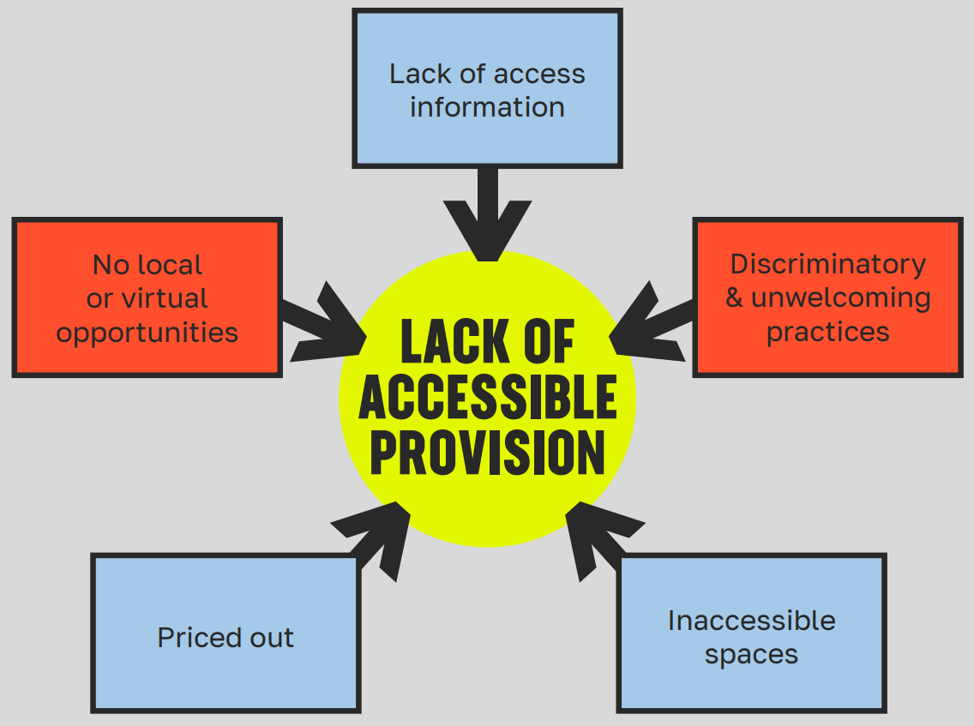

**Figure 1: Summary of access barriers**

### Importance of accessible access information

Young people access creative arts provision in all sorts of locations. Locally based youth centres, community centres, or small arts venues. It’s rare for these places to have explicit access information available. Many don’t even have websites – and where they do, ‘Accessibility’ is not a common menu option. This presents an immediate barrier. [[Ewan’s Guide’s 2024 access survey](https://www.euansguide.com/get-involved/access-survey/)](https://www.euansguide.com/get-involved/access-survey/) [16] found that 62% of respondents avoid going to a venue if it hasn’t shared access information.

### Pre-information

Best practice is to ensure that relevant information is sent ahead of time, so people know what to expect. As one parent told us, “It’s a lot to think about. The more you can take someone’s mind off having to think of all these things, the better.”

### A whole organisation approach

People’s experiences don’t start and end in an arts session, so the whole organisation needs to know about access, including front of house and security staff.

### No common standards

There’s no set of common access standards that are applicable across the arts, other than [Attitude is Everything’s Live Access Charter](https://attitudeiseverything.org.uk/industry/live-events-access-charter/) [17] which is designed for venues and live events. Visit a large theatre with good access practices and you can expect a range of assisted performances (relaxed, captioned, audio-described, signed, or sensory-adapted). That’s alongside all the standard access information about the building and physical space. Art galleries might have visual stories available, dedicated quiet spaces, and cards to help people communicate their needs to staff. In music there’s been much recent innovation in adapted, assistive and digital instruments. The musician Lewis Capaldi has gig buddies, trained mental health professionals, help desks and quiet spaces at gigs, to help fans who experience panic attacks and social anxiety.

Each art form has built up their own access expertise. A lot could be learned by greater sharing within and across art forms. This would also provide more consistency for Disabled people.

### No access without inclusion

The concepts of access and inclusion are different, but interrelated. If access asks the questions, “Do I know something exists? Can I engage with it?”, inclusion would say, “Am I welcome here? Is it for me?”. Given the discrimination faced by Disabled young people, inclusion must be central to any discussion of access.

In 2023, Youth Music consulted with young people about what made spaces inclusive, diverse, equitable and accessible. They told us about the importance of making people feel seen and heard, allowing for different communication needs, being aware of the sensory environment, avoiding assumptions, and not pricing people out.

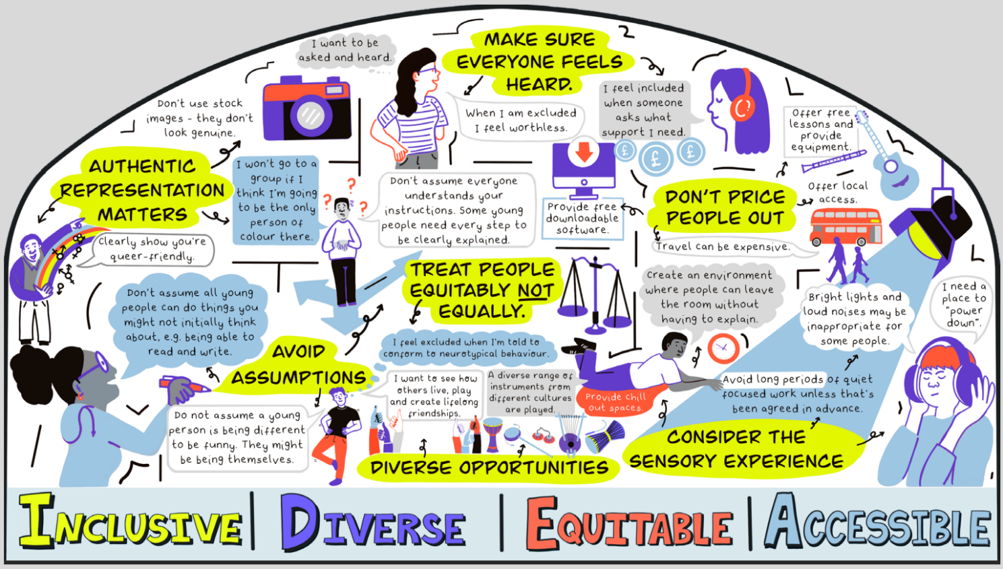

**Figure 2: Visual summary of young people’s views on how to make a music project inclusive**

### Getting places, and virtual spaces

We heard about the importance of straightforward access measures like accessible parking, venues, and toilets. Travel is a significant barrier for Disabled people, especially in rural areas or for those who don’t have access to their own vehicle. Young artists told us about challenges to travelling independently, significantly adding to their costs if they need to rely on taxis or support workers.

In 2021, the Audience Agency wrote [about how the pandemic online content boom had “[given rise to revolutionary opportunities that could improve access for good](https://theaudienceagency.org/en/news/win-win-disabled-arts-lovers-and-sector)](https://theaudienceagency.org/en/news/win-win-disabled-arts-lovers-and-sector)” [18]. But this prevalence of online opportunity did not endure. Our consultations reinforced the importance of virtual and digital options, especially for those with very complex medical needs or living in rural areas.

### Why is all this important?

As good access and inclusion is not yet widespread, “there’s a massive barrier around onward ‘holding’. People get their foot in the door and then there’s no onward progression”. In Attenborough Arts Centre’s consultation, the majority of parents and carers called for specialist provision. Whilst this ensures people’s needs are met, it leads to young Disabled people being siloed. Plus, it narrows their range of experiences.

Get access right, and the results can be truly life changing for young people.

“It's the best thing that ever happened to her and to us … it's completely life changing. I'm gonna get emotional now. You know, you see the young people that aren't out in the community and don't have necessarily a peer group outside of their home, because of their medical needs and the connections … It's a very special thing because otherwise their world would be very, very lonely”.

Aesthetics of access

Graeae Theatre Company coined the term ‘aesthetics of access’ to describe creative ways of meeting access needs. For example, making British Sign Language and audio description a central creative force to a performance. Seeing access as a creative and participatory process can help it become embedded from the start, rather than being an add on.

**Attenborough Arts Centre** creates **‘Sensory Suitcases’** for visitors to explore the exhibitions in a sensory way. These curated cases offer tactile engagement with individual artworks. Objects and materials are tailored to each show, some sourced directly from the exhibiting artists. The suitcases are fun, and child-centred. They enable sensory processing, stimming and play, so everyone can interpret the exhibitions in their own way.

**[The Whitworth Gallery](https://www.whitworth.manchester.ac.uk/)** in Manchester works in partnership with [**Venture Arts**](https://venturearts.org/) to improve opportunities for learning disabled artists. Through the partnership, they host an artist in residence, Sally Hirst. Part of Sally’s role is to provide **tours and ‘easy read’ interpretation** to help communicate information about the exhibitions.

**Soundabout** produces an **accessible booklet** that they send to people before their events. It contains information about the location and travel, has pictures of the venue and quiet spaces, details of the schedule, and photos of the staff who’ll be present.

When a young person joins, they work with them to develop a **1-page profile.** This outlines their likes and dislikes, their access and sensory needs, any previous experience with music, and things that help when they’re unhappy. The profile is shared with staff and used in session planning.

# 5. Participation and progression

Quick summary  
The data in existence suggests that young Disabled people participate less in the arts than their non-disabled peers. They have shorter term participation, are less likely to be involved with community-based activities outside of the home. Progression options are limited, which create siloes and limit choice. The proportion of Disabled people employed in the arts is much lower than the proportion of Disabled people in overall employment. Low participation and low workforce representation creates a vicious cycle that needs to be broken. There is demand from young Disabled people for more opportunities.

It’s not easy to get an accurate picture of participation rates amongst young Disabled people in arts and culture. The available research needs to be pieced together to draw conclusions. In this report, we’ve reviewed several reports and datasets to try to get a sense of the big picture.

## Lower participation

The most comprehensive dataset tracking participation over time is the DCMS [Taking Part survey](https://www.gov.uk/guidance/taking-part-survey) [19], which ran until 2020. Taking Part’s [annual child release](https://www.gov.uk/government/statistics/taking-part-201920-annual-child-release) [20] allows us to monitor the 10 year period from 2010.

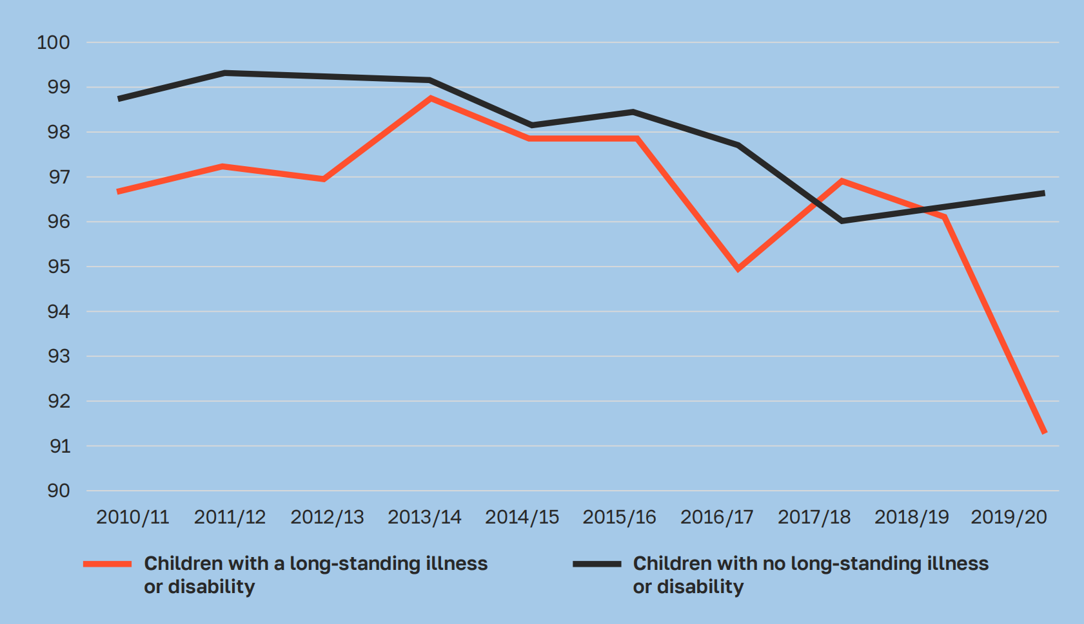

**Figure 3: Proportion of children who have engaged with the arts in the last 12 months, between 2010 and 2020 (%).**

**Source:** DCMS Taking Part Survey

Disabled young people are represented by the red line. It’s clear that their engagement is lower than non-disabled children. But perhaps not as low as we might expect. On average, it’s 1.5% lower across the whole period. The data is not broken down to know what type of activity Disabled people were engaged with. This means we can’t tell differences by age or gender, or (importantly), whether it was in or out of school.

We suspect that many people tracked by the survey were taking part in activity at home. This is based on conversations and other research, namely:

* In [Arts Council’s (2015)](https://www.artscouncil.org.uk/sites/default/files/download-file/FINAL%20report%20web%20ready.pdf) research [21], it states that “Non-Disabled children and young people aged 11-15 are twice as likely to visit a museum with their school than their Disabled peers, with special schools less likely to visit cultural venues”.
* In Youth Music’s [Reshape Music (2020)](https://www.youthmusic.org.uk/resources/reshape-music) [22], most Disabled people were making music at home or in school, with significant barriers to accessing music groups and performance opportunities.

We think the biggest disparity is not about the proportion who participate, but where and how they take part.

## Less community involvement, shorter engagement

Recent [DCMS (2024) [23] research](https://assets.publishing.service.gov.uk/media/672b4bcdfbd69e1861921bff/DCMS_Pilot_Youth_Participation_Survey_Findings_Report_final_accessible.pdf) shows lower participation in community-based activity, and shorter-term engagement for Disabled young people (see Figure 4).

This is backed up by [Music Education Hubs data](https://www.artscouncil.org.uk/MusicHubs/music-hubs-survey-and-data#t-in-page-nav-2) [35]. We compared 2023/24 participation numbers to Department for Education [school census data](https://explore-education-statistics.service.gov.uk/find-statistics/school-pupils-and-their-characteristics/2024-25) [24] to see what proportion of young people are being engaged in regular group music-making. This means attending a weekly group, for a minimum of a term.

In 2024, just 0.50% of all children with Special Educational Needs took part in a regular ongoing music group, compared with 1.81% of all school-aged children.

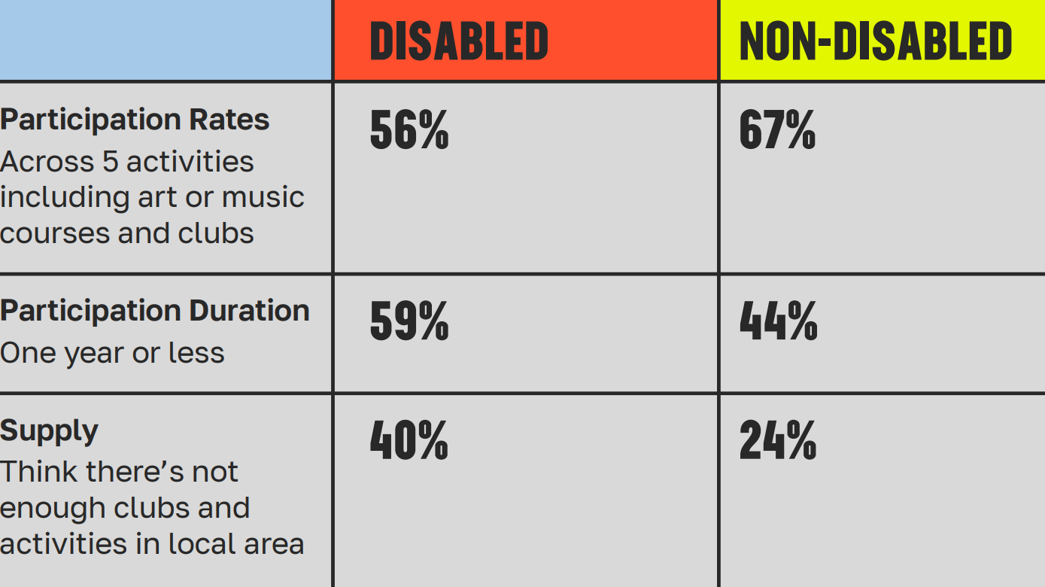

**Figure 4: Out-of-school participation rates for young people aged 10 to 19**

**Source:** DCMS Youth Survey Pilot Report 2024

## Demand for more

Attenborough Arts Centre’s consultation asked children and families about the types of programme they want:

* 70% wanted more performing arts such as dance, music and theatre, the most popular being music.
* Over 60% wanted more visual art/craft, social activities, sensory play and outdoor events and activities.

Youth Music’s [Sound of the Next Generation 2024](https://www.youthmusic.org.uk/resources/sound-next-generation-2024) [25] research found 60% of Disabled young people want more music in their lives (versus 49% of non-disabled young people).

Most research points to a drop off in participation from 16 years and over, and our consultations highlighted the need for more opportunities for tweens (10-12) and young adults.

## Impact of unequal participation

Low participation affects young Disabled people’s creative development. Too many miss out on the opportunity to be inspired by real-life artists, to tap into industry expertise, to access professional equipment and spaces, and to find their creative peer group.

Underestimation and limiting beliefs means that they aren’t given the same opportunity to build foundational skills and experiences as their non-Disabled peers. There aren’t enough chances to explore, and to fail. Youth voice is lacking, which means less chance to develop agency and be autonomous.

This creates a progression gap, where young people aren’t getting the right experiences earlier down the chain. Interviewees called for more 1:1 mentoring, and sustained creative opportunities that start from an early age.

As good access and inclusion practice is still the preserve of a few specialist organisations, progression options are limited. Organisations, parents or carers are wary of signposting to places where young people’s needs may not be met. Which limits choice and creates siloes.

The low numbers of Disabled people in the workforce means young Disabled people can’t see themselves represented, which impacts their creative ambition.

There are few programmes for young Disabled people that encourage creative careers. Those that do exist tend to focus on the 18-25 age brackets. By this point, many Disabled young people have already had big gaps in their creative education which leaves them further from the labour market. This creates a vicious cycle that needs to be broken.

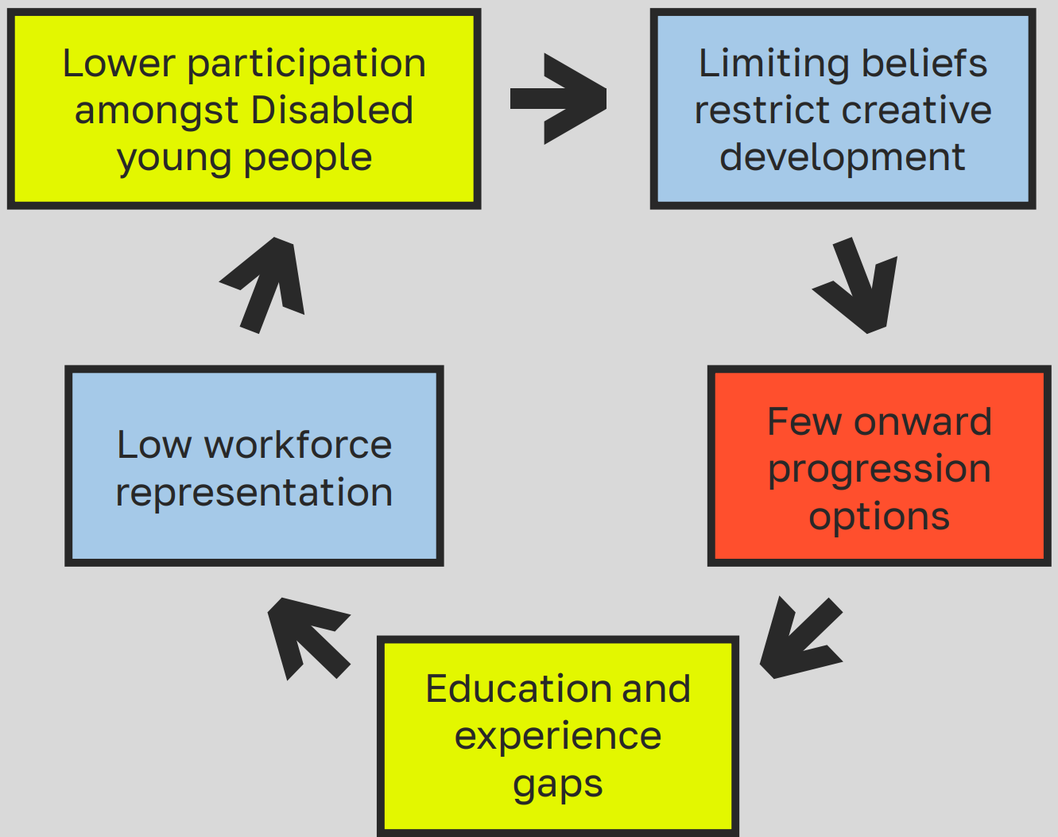

**Figure 5: The participation and progression cycle**

## Do young Disabled people progress to creative employment?

The proportion of Disabled people working in the arts is very low. Much lower than the rest of the economy. In 2022/23, Disabled people made up 16% of people in employment the UK. In the same year, they made up just 9% of the National Portfolio Organisation workforce.

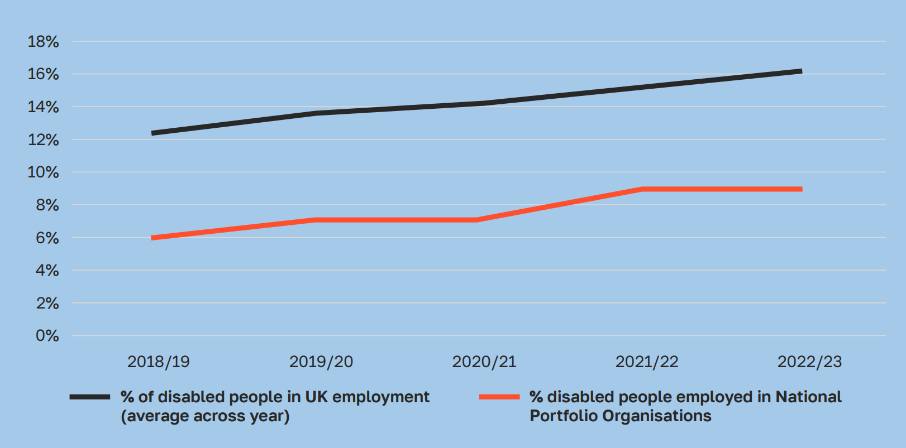

**Figure 6: Proportion of Disabled people employed by National Portfolio Organisations versus proportion of Disabled people in UK employment 2018 – 2023 (%)**

**Sources:** ONS [26]; Arts Council England [27]

Progress has been slow but steady. In addition, the proportion of Disabled people in senior positions in the National Portfolio Organisation workforce is higher than shown on the chart. 15% of Chairs and 13% of Chief Executives identify as Disabled.

# 6. Barriers to creative employment

**Quick summary**

Disabled people in the creative sector face persistent barriers to employment, including inaccessible work practices, limited support, and systemic discrimination. Despite rising representation, progress is threatened by low pay, high living costs, and reduced support through benefits like Access to Work and PIP. Freelancers, who make up a significant part of the workforce, are especially vulnerable. With government support shrinking, the arts sector must take greater responsibility to fund access and ensure sustainable careers for Disabled professionals.

“Disabled people in the sector reported barriers in accessing employment, which were felt to be linked to their disability status. They also highlighted a number of working practice barriers including attitudes towards people with disabilities, the culture of long hours, lack of part time senior roles, high levels of travelling, a narrow view of reasonable adjustments, under-representation of Disabled people on boards and a negative impact of changes to support funding and benefits”. Arts Council England  [Equality Analysis](https://www.artscouncil.org.uk/sites/default/files/download-file/Equality%20Analysis_Arts%20Council%20England_Strategy%202020-2030.pdf) [28]

The proportion of Disabled people in UK employment overall (including self-employment) is rising. So is the proportion of Disabled people in the arts workforce. But this progress is in danger of reverse. Issues of low pay, combined with upcoming changes to benefits, pose real risks.

## Low pay

Disabled people earn less (‘the disability pay gap’), and face increased living costs compared to non Disabled people (‘disability price tag’). Scope calculates the ‘disability price tag’ as £1,095 per month. £13,140 per year.

[In 2023, the disability pay gap was 13%](https://www.ons.gov.uk/peoplepopulationandcommunity/healthandsocialcare/disability/articles/disabilitypaygapsintheuk/2014to2023) [29]. This means that on average, Disabled people will earn £3,848 less per year than non-Disabled people.

There are issues with low pay across the creative workforce, but especially for freelancers. Just under [one-third of the Creative Industries workforce is self-employed](https://pec.ac.uk/blog_entries/creative-self-employed-workforce-in-england-and-wales/) [30].

[The Big Freelancer Survey (2025)](https://freelancersmaketheatrework.com/bigfreelancersurvey/2025report/) [31] study showed that 44% of respondents earned less than the national living wage. In the Musician’s Union [Disabled musicians Insight Report](https://mcusercontent.com/f8a7f535676e150d1ccb6a790/files/26eda189-360f-69ef-5ad6-8becbb7fadbf/Disabled_Musicians_Insight_Report_Sml.5cs.pdf) [32], the most reported career barrier (51%) is not being able to make a sustainable income.

## Precarious freelance careers

Being self-employed has many benefits for Disabled people. The flexibility, and ability to be your own boss, can make for an inclusive working environment that can flex around people’s needs. That is, unless people become too ill to work. Prolonged absences can lead to loss of freelance work. That’s in addition to the financial implications if people don’t receive sick pay.

## Benefit barriers to work

The loss of existing benefits is a hidden barrier for many Disabled people to enter and stay in work. We heard worries about the risks associated with moving from benefits and into work. “[they] have to fight for what they need monetarily, but immediately when they try to become part of the workforce they lose it and can’t earn enough to replace it.”

Payment and benefits are a talking point for arts organisations who help Disabled people into the workforce. How can they reward people for their time fairly, within the law and without risk to their benefits?

The Government’s [Access to Work](https://www.gov.uk/access-to-work) scheme is vital for the careers of many creatives. It funds things like support workers, transport costs, or specialist equipment – the things that Disabled people need to be able to work. It is still widely underused.

Yet, it’s becoming less and less accessible to Disabled people. Currently, there is a backlog that results in very long waiting times (with one interviewee waiting over 12 months for their decision). In May this year a [a whistleblower outlined ‘operational changes’](https://www.thecanary.co/uk/analysis/2025/05/06/dwp-access-to-work-changes/) [33], driven by budget savings, that makes it harder for Disabled people to access the help they need. [Artist and co-founder of Touretteshero has posted about the ‘devastating’ decision to cut their access to work by 60%, in a potentially career ending decision](https://www.touretteshero.com/safe/2025/05/23/a-career-ending-decision/) [34]. This cut has happened despite their access needs and job remaining unchanged. “I desperately want to concentrate on doing my job, on growing my company and supporting other disabled people. Instead, I’m having to use all the time and energy I have battling for the basic support I need to work”.

## Are things getting worse?

Earlier in 2025, intense lobbying and activism by Disabled people and Disabled People’s Organisations led to the Government pausing planned cuts to Personal Independence Payments (PIP).

Whilst PIP isn’t a work benefit, it provides vital support for Disabled people to live independent lives, which in turn supports their employment. Planned future cuts to both PIP and Access to Work are a real threat. They risk reversing the recent progress in closing the Disability employment gap.

In the face of increasingly restricted Government funding, it seems likely that the arts sector will need to step up its funding of access costs if we want to improve Disabled representation. “Unless the creative sector engages with the reality of how difficult and long Access to Work is, it means they aren’t supporting Disabled people”.

# 7. A time to act. Inclusive design to equalise outcomes

The picture painted here isn’t an easy one to look at — but that’s exactly why we can’t turn away. The barriers Disabled young people and adults face in accessing the creative arts, and building sustainable careers, are not inevitable. They are the result of choices, systems, and inaction. And that means they can be changed.

The arts have always had the power to connect, to transcend, to reimagine what’s possible. Art shapes culture. It connects cultures. But its power is wasted if it’s not open to all, or reflective of the true human experience.

We may not be in direct control of Government policy. But we do have the power to end discrimination and bring more equity into the way we work. We are employers, we are producers, we are creators, we are facilitators, we are teachers, we are governors, we are funders. We can use our structures, our knowledge, our art, our networks, our audiences and our wider assets to help create change. If not us, then who? And if not now, when?

What actions can we take to get creative parity for young Disabled people, and for Disabled professionals?

## 1. Equitable funding for Disabled people

Funders should take an equitable approach to funding work for Disabled people, with ringfenced or targeted funds. Guidance and application processes should be accessible. And decisions informed by lived experience.

Organisations should build access costs in their budgets so Disabled people can be paid fairly and have their access needs met. Employers can signal their commitment to fair pay by becoming real [Living Wage Employers](https://www.livingwage.org.uk/what-real-living-wage) [35].

## 2. Accessible access

The inability to find information is often the first barrier to engagement. Access information for participants, artists, staff and audiences should be accessible and easy-to-find. Re-framing access as an aesthetic and creative pursuit can help embed it in programme design from the outset, and avoid it being a ‘add on’.

## 3. Improved knowledge and understanding

Organisations should create opportunities for training and dialogue, to upskill teams and improve understanding. Social model of disability training is a good starting point. More experienced and Disabled-led organisations can help educate others – but they must be adequately resourced to do this.

## 4. The development of IDEA cultures in organisations

Inclusion, diversity, equity and access (IDEA) practices should cut across all areas of an organisation’s operations, to support young people, staff and audiences.

Diversity aims should be intersectional. Wellbeing and safe environments should be core to organisational culture. People and organisations should have a genuine openness to sustained action, learning and evolution. Employers can signal their commitment to employing Disabled people through the [Disability Confident Scheme](https://www.gov.uk/government/collections/disability-confident-campaign) [36].

Note: Youth Music uses the acronym IDEA rather than EDI or DEI. This is to ensure that **A**ccess remains central in our practices. If you want to improve your IDEA practices, [visit our IDEA resource hub](https://www.youthmusic.org.uk/community/resource-hub/idea-hub) [37].

## 5. Individual advocacy and allyship

Advocacy and allyship can help challenge discrimination and protect Disabled people’s rights. This is something that we can all do as individuals. Whether that’s by educating ourselves, challenging discriminatory practice, asking questions, using our platforms, or taking positive action. Now is the time to act.

## 6. Inclusive programme design

There needs to be a shift in how creative programmes are designed for young Disabled people. They should be long-term, sustained and progressive. With more youth voice and agency, 1:1 mentoring and support, better representation and more progression options. Underpinned by the social model of disability.

Disabled young people should be able to have a good experience on any creative programme, not just ‘Disabled-led’ or targeted disability programmes. For this to happen, there needs to be dedicated partnerships for progression between Disabled and non-disabled people’s organisations.

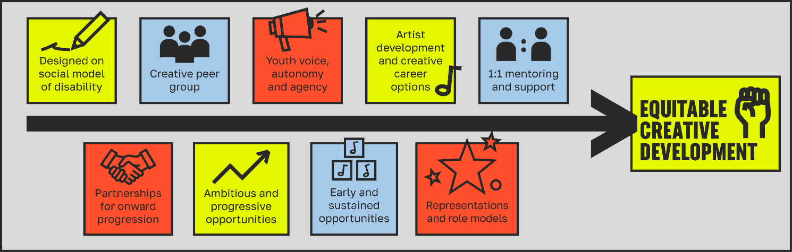

**Figure 7: A framework for inclusive programme design**

# 8. Youth Music’s commitments

We don’t pretend that we’ve got it all sorted. But we’re committed to constant improvement. Some steps we’ve already taken:

* We’re a [Disability Confident Employer](https://www.gov.uk/guidance/disability-confident-how-to-sign-up-to-the-employer-scheme#sign-up-to-the-disability-confident-scheme), a [Living Wage Funder, and a Living Wage Employer](https://www.livingwage.org.uk/what-real-living-wage).
* We’ve embedded [application access costs, and personal access costs](https://www.youthmusic.org.uk/funding/i-need-funding/access-support), into our funding programmes.
* We’ve [improved Disabled representation on our staff team](https://www.youthmusic.org.uk/about/IDEA) and amongst our freelancers and [funding advisors](https://www.youthmusic.org.uk/youth-music-funding-advisors).
* We’ve developed an [IDEA resource hub](https://www.youthmusic.org.uk/community/resource-hub/idea-hub) to help others on their journey.
* IDEA topics are embedded into our [Exchanging Notes online learning programme](https://www.youthmusic.org.uk/community/opportunities/exchanging-notes). This included a session on [Access to Work](https://youtu.be/7FzKkXfrscg?list=PLVU57s6Q-XySD_b_0tcLkE4srfQMiaJpg).
* We’re working on a set of access principles to roll out across all our work.

## Coming next: 'Shift the Scene'

On an average year, Youth Music invests around £1.5 million into music projects for Disabled children, young people and adults. This investment is ongoing.

Alongside the publication of this research, we’ve committed to doing more. We’ve created a one-off, £2.25 million fund designed to ‘Shift the Scene’. This is in addition to our music funds, and will work across the arts. We want to help catalyse change and give this work a real boost.

This fund will make long-term investment into equitable creative programmes for Disabled young people. We’ll work alongside our Shift the Scene funded partners to explore, learn, and share good practice. We’ll bring this learning back to our own organisation, and to the wider sector.

## 

## Keep in touch

There are lots of ways to stay connected with us.

**Join our community**

[Visit the Youth Music website](https://www.youthmusic.org.uk/)

[Apply for funding](https://www.youthmusic.org.uk/funding)

[Sign up to our newsletter](https://youthmusic.us2.list-manage.com/subscribe?u=33203ddba089565c1d2e6b37a&id=c9da7d78ed)

[Attend a free, online Exchanging Notes session](https://www.youthmusic.org.uk/community/opportunities/exchanging-notes)

[Browse or submit a job, event or training on our opportunity board](https://www.youthmusic.org.uk/community/opportunities)

**Follow us on socials**

[Youth Music Instagram](https://www.instagram.com/youthmusicuk/)

[Youth Music TikTok](https://www.tiktok.com/@youthmusic)

[Youth Music LinkedIn](https://www.linkedin.com/company/national-foundation-for-youth-music/)

[Youth Music Facebook](https://www.facebook.com/youthmusiccharity)

[Youth Music Threads](https://www.threads.com/@youthmusicuk)

**Call us**

Our telephone number is 020 7902 1060

**Email us**

Email [grants@youthmusic.org.uk](mailto:grants@youthmusic.org.uk)

# Thanks and acknowledgements

Thanks to all the people who helped us with this research. To those who shared their stories and experiences, to our critical friends, our consultation partners, and the team at Youth Music. We hope we’ve managed to represent you in the most accurate way possible.

Alison Maxhuni – Open Up Music

Alix Apples – Freelance, The Holywood Trust, D&G Council

Aslan Herzen Kenwood – Freelance Assessor and Creative Professional

Andrew Fletcher – Attenborough Arts Centre

Andrew Lansley – Very Good Solutions Company

Bal Cooke & Ewan Sinclair – Soundplay Projects

Ben Evans – Europe Beyond Access

Caitlin Brown – Musician and NextGen Fund recipient

Tina Smith – Bamboozle Theatre

Dan Tsu – Lyrix Organix

Elizabeth J Birch – Music artist and facilitator

Emma Sen-Isard – Westwick Management

Esther Gagne – Heart n Soul

Fiona Cariss – Whitworth Art Gallery

Gareth Evans – Carousel

Holly Radford-James – Soundabout

Ian Thomas – The British Council

Jay Pocknell – RNIB

Jenni Waugh – Jenni Waugh Consulting Ltd

Lucy Crisp – Musician

Maddie Morris – Freelance Musician

Martin Swan – Creative Director, Prism; and freelance artist

Mary-Alice Stack – Creative United

Meg Fassam-Wright – Sense

Michèle Taylor – Ramps on the Moon

Nyrobi Beckett-Messam – ALT BLK ERA

Rightkeysonly - Amplifying Accessibility

Troi Lee – Deaf Rave

**Our consultation partners**

Thanks to all the to all the young people, their families and carers who took part in the consultations. And to:

Marianne Scahill-Pape - Attenborough Arts Centre

Hannah Pillai - Attenborough Arts Centre

Rebecca Tunley - Soundabout

Holly Radford-James – Soundabout

**Aesthetics of access**

Katherine Long - Venture Arts

Sally Hirst – Artist

Fiona Cariss - Whitworth Art Gallery

**Shift the Scene Steering Group**

Adrian Dobra

Andy Dawson

Kathryn Sturman

Elizabeth J Birch

Lauren Russell

Lou Pidgeon

Nyrobi Beckett-Messam

Toria Banks

Sanjeev Mann

## Our peer review team

**Michèle Taylor** is Director for Change at Ramps on the Moon supporting arts organisations to embed anti-ableism.

Michèle is an accredited coach, registered psychotherapist, and has an MA in fine art photography.

In January 2022 her work was recognised when she was awarded an MBE in the New Year Honours List for services to disabled people and theatre.

**Sarah Fisher** is a skilled community musician, playing percussion and piano. Her work involves facilitating sessions for underprivileged people and those with additional needs. She delivers inclusion training for organisations and regularly presents at conferences and lectures around community music and inclusion. Notable accomplishments have included her show Twitch, completing an MA in Community Music and being an advocate for those with disabilities in the arts.

**John Kelly** is a professional vocalist, musician, performer and song-writer working in the UK and Internationally with a wide range of arts organisations including Drake Music, Youth Music, Graeae Theatre Company, Access All Areas and Extraordinary Bodies.

John is also a qualified facilitator and coach with over thirty years in the youth and music education sector, and is part of Drake Music’s Think 22 project supporting the sector to develop inclusive practice.

# References

|  |  |
| --- | --- |
| [1] | Committe on the Rights of Persons with Disabilities, *Report on follow-up to the inquiry concerning the United Kingdom of Great Britain and Northern Ireland.,* United Nations, 2024. |
| [2] | The Union of Physically Impaired Against Segregation and The Disability Alliance, “Fundamental Principles of Disability,” 1976. [Online]. Available: https://the-ndaca.org/resources/audio-described-gallery/fundamental-principles-of-disability/. |
| [3] | Much Taboo About Nothing, “Models of Disability,” 2020. [Online]. Available: https://www.muchtabooaboutnothing.com/models-of-disability. |
| [4] | Music, Drake, “Understanding Disability: Part 6 - The Radical Model,” [Online]. Available: https://www.drakemusic.org/blog/nim-ralph/understanding-disability-part-6-the-radical-model/. |
| [5] | Youth Music, “How and why you should update language in your organisation,” 1 April 2022. [Online]. Available: https://www.youthmusic.org.uk/resources/how-and-why-you-should-update-language-your-organisation. |
| [6] | D. Turner, “Disabled People’s Activism in Victorian Britain,” 3 October 2024. [Online]. Available: https://www.historyworkshop.org.uk/disability-history/disabled-peoples-activism-in-victorian-britain/. |
| [7] | National Disability Arts Collection & Archive, “On the Block Telethon Protest,” 2020. [Online]. Available: https://the-ndaca.org/the-story/the-archivists-corner/on-the-block-telethon-protest/. |
| [8] | House of Commons, Education and Skills Committee, “Education and Skills - Third Report,” 21 June 2006. [Online]. Available: https://publications.parliament.uk/pa/cm200506/cmselect/cmeduski/478/47805.htm. |
| [9] | P. Lewis, “Disability Discrimination Act: 1995 and now,” 6 November 2020. [Online]. Available: https://lordslibrary.parliament.uk/disability-discrimination-act-1995-and-now/. |
| [10] | UK Parliament, “Education Act 1996, Section 316,” 24 July 1996. [Online]. Available: https://www.legislation.gov.uk/ukpga/1996/56/section/316. |
| [11] | H. Evennett, “The Equality Act 2010: Impact on disabled people,” 14 June 2022. [Online]. Available: https://lordslibrary.parliament.uk/the-equality-act-2010-impact-on-disabled-people/. |
| [12] | Midlands Arts Centre, “Art and Social Change: The Disability Arts Movement,” 2020. [Online]. Available: https://macbirmingham.co.uk/exhibition-archive/art-and-social-change-the-disability-arts-movement. |
| [13] | *Crip Arte Spazio: The DAM in Venice,* Venice: Exhibition at Attenborough Arts Centre, 2025, 2024. |
| [14] | B. Rutherford, “Reimagining Disability,” 2 May 2024. [Online]. Available: https://www.historyworkshop.org.uk/disability-history/reimagining-disability/. |
| [15] | Trust, The Sensory, “Access chain: an inclusive design tool,” [Online]. Available: https://www.sensorytrust.org.uk/resources/guidance/access-chain-an-inclusive-design-tool. |
| [16] | Euan's Guide, “Euan’s Guide Access Survey 2024,” February 2025. [Online]. Available: https://www.euansguide.com/media/tfsj1rzn/euansguide-accesssurvey-2024results-web.pdf. |
| [17] | Attitude is Everything, “Live Events Access Charter,” 2022. [Online]. Available: https://attitudeiseverything.org.uk/industry/live-events-access-charter/. |
| [18] | O. M. Anne Torreggiani, “Win-win for disabled arts-lovers and the sector,” 23 September 2021. [Online]. Available: https://theaudienceagency.org/en/news/win-win-disabled-arts-lovers-and-sector. |
| [19] | Department for Digital, Culture, Media & Sport, “Taking Part Survey,” 31 August 2016. [Online]. Available: https://www.gov.uk/guidance/taking-part-survey. |
| [20] | Department for Digital, Culture, Media & Sport, “Taking Part 2019/20: annual child release,” 16 September 2020. [Online]. Available: https://www.gov.uk/government/statistics/taking-part-201920-annual-child-release. |
| [21] | Arts Council England, “Every child: equality and diversity in arts and culture with, by and for children and young people,” ewgroup, 2015. |
| [22] | Youth Music, “Reshape Music,” 2020. |
| [23] | Department for Culture, Media & Sport, “DCMS Youth Survey Pilot Report,” 7 November 2024. [Online]. Available: https://assets.publishing.service.gov.uk/media/672b4bcdfbd69e1861921bff/DCMS_Pilot_Youth_Participation_Survey_Findings_Report_final_accessible.pdf. |
| [24] | Gov.uk, “Schools, pupils and their characteristics,” [Online]. Available: https://explore-education-statistics.service.gov.uk/find-statistics/school-pupils-and-their-characteristics/2024-25. |
| [25] | Youth Music, “Sound of The Next Generation 2024,” 2024. [Online]. Available: https://www.youthmusic.org.uk/resources/sound-next-generation-2024. |
| [26] | ONS, “A08: Labour market statuis of Disabled people,” [Online]. Available: https://www.ons.gov.uk/employmentandlabourmarket/peopleinwork/employmentandemployeetypes/datasets/labourmarketstatusofdisabledpeoplea08. |
| [27] | Arts Council England, “Equality, Diversity and Inclusion Review 2018-23,” Arts Council England, 2025. |
| [28] | Arts Council England, “Equality Analysis: Development of Arts Council England’s 10-year strategy, 2020-30”. |
| [29] | Office for National Statistics, “Disability pay gaps in the UK: 2014 to 2023,” 2024. |
| [30] | R. Wang, “Creative self-employed workforce in England and Wales,” 17 3 2025. [Online]. Available: https://pec.ac.uk/blog_entries/creative-self-employed-workforce-in-england-and-wales/. |
| [31] | Freelancers make theatre work, “Big Freelancer survey 2025,” [Online]. Available: https://freelancersmaketheatrework.com/bigfreelancersurvey/2025report/. |
| [32] | Musicians’ Union, “Disabled Musicians Insight Report,” 2024. |
| [33] | Canary, The, “The DWP has tried to hide major changes to a grant scheme for disabled people.,” [Online]. Available: https://www.thecanary.co/uk/analysis/2025/05/06/dwp-access-to-work-changes/. |
| [34] | Tourettes Hero, “A Career-Ending Decision?,” 23 5 2025. [Online]. Available: https://www.touretteshero.com/safe/2025/05/23/a-career-ending-decision/. |
| [35] | Living Wage Foundation, “What is the real Living Wage?,” 2025. [Online]. Available: https://www.livingwage.org.uk/what-real-living-wage. |
| [36] | Gov.uk, “Disability confident employer scheme,” [Online]. Available: https://www.gov.uk/government/collections/disability-confident-campaign. |
| [37] | Music, Youth, “IDEA resource hub,” [Online]. Available: https://www.youthmusic.org.uk/community/resource-hub/idea-hub. |
| [38] | England, Arts Council, “Hub Data Dashboard,” [Online]. Available: https://www.artscouncil.org.uk/MusicHubs/music-hubs-survey-and-data#t-in-page-nav-2. |
| [39] | National Register of Access Consultants, “About,” [Online]. Available: National Register of Access Consultants. |

The National Foundation for Youth Music

Studio LG01, The Print Rooms, 164-180 Union Street, London, SE1 0LH

Registered charity number: 1075032

Limited company number: 03750674

# 