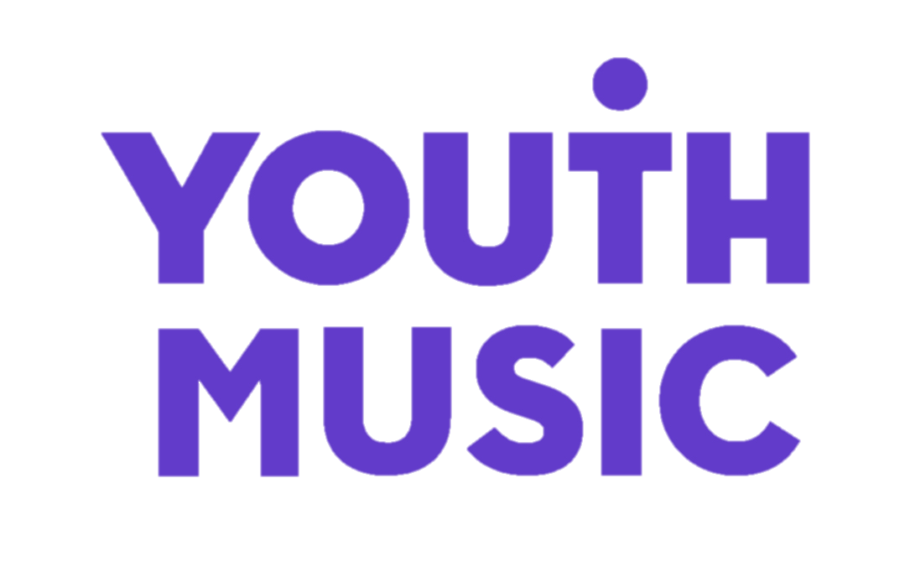

Youth Music NextGen Fund

Sample Application Form

This is a sample NextGen Application Form. You can use this document to draft your answers offline, but your Application Form must be submitted using the online form.

If you need any support with submitting an application online please read the information about Access Support below.

Youth Music NextGen Application Form

Important information before you apply.
The Youth Music NextGen Fund offers young creatives grants of up to £3,000 to make their ideas happen.
The NextGen Fund will help emerging musicians and behind the scenes creatives take a step forward in participating and changing the music industries.
Built for creatives with a stack of ideas but a lack of finance, the fund is open to 18–25-year-olds (and under-30s who identify as d/Deaf, Disabled or Neurodivergent). Successful applicants will use the money to launch a creative project, idea or business.
We want to support the future of the music industries. Singers, Rappers, Songwriters, Producers, DJs, A&Rs, Managers and Agents, right through to roles that have yet to be defined.
We would especially like to hear from people who have never applied for funding before. It is unlikely that we’ll prioritise your application if you’ve already received significant financial support for your work (for example through an Arts Council or a PRS Foundation grant).
We have 2 rounds of funding a year, so if you aren't ready yet, there will be opportunities to apply in the future.

Applicant Guidance
It is essential that you download and read the applicant guidance notes from our website before making your application.
Guidance Documents

Access Support
Youth Music is committed to offering a clear and accessible grant making process that is open to everyone.
If you identify as Disabled, we can provide extra funding to help you make your application and to run your project:

- Access Fund to support applications
We can provide funding to cover additional access costs that might be required for you to make an application to one of our funds. More information is available at: youthmusic.org.uk/access-fund
- Personal Access Budget
If you have any additional personal access costs you need to run your project, you can include these on top of the £3,000 maximum grant. This might include costs for British Sign Language interpreters, personal assistants, support workers or other access costs.
If you want to apply for a personal access budget, and would like to discuss this further with our team, please get in touch in advance of submitting your application.

Youth Music is a Living Wage Funder, which means that we expect all people employed on Youth Music-funded programmes to be paid the Real Living Wage.

If you need any other access support, please get in touch by email at creatives@youthmusic.org.uk or phone us on 020 7902 1060.

Eligibility Criteria

In this section, we are checking to see if you're eligible to apply for the grant. You will only be able to move forward with the application once you have met the criteria.
Criteria | Yes | No
I am aged 18 - 25 (or I am aged 26-30 and identify as d/Deaf, Disabled or Neurodivergent)
I am an emerging creative, and this fund will support me to take my first steps into the music industries
I am based in, and my project will take place in, England, Scotland, Wales or Northern Ireland
I can commit to completing my project in 12 months
I confirm I do not have financial means to invest in this project myself
I have a UK bank account
I confirm I am not signed to a record label, publisher or management company
I confirm I am not already employed full time in the music industries
I feel I have faced barriers to progress my career within the music industries
I confirm I have not previously had a NextGen Fund grant
I can confirm that I am applying to the NextGen Fund as an individual, and not on behalf of a group or collective.

About You

First name

Last name
Preferred pronouns | - He/Him  - She/her  - They/Them  - Other

Other pronouns

Email address

Confirm Email Address

Telephone number
Age Confirmation | - I am aged 18 to 25  - I am aged 18 to 30 and I identify as d/Deaf or Disabled or Neurodivergent  If you would like to apply for a personal access budget, please ensure you select the "I am aged 18-30 and I identify as d/Deaf or Disabled or Neurodivergent" option above.
Date of birth | To be eligible you must be aged 18 to 25 at the point of the application deadline. If you identify as d/Deaf, Disabled or Neurodivergent you can be aged 18 to 30
Are you currently a student with different addresses during term time and vacation? | - No, I only have one address to enter  - Yes, I would like to enter more than one address

Address line 1

City

Postcode

Country

Region

Access Support

Youth Music is committed to offering a clear and accessible grant making process that is open to everyone. If you identify as d/Deaf, Disabled or Neurodivergent, we can provide extra funding to help you make your application and to run your project:

Access Fund to support applications

We can provide funding to cover additional access costs that might be required for you to make an application to one of our funds. More information is available at: youthmusic.org.uk/access-fund

Personal Access Budget

If you have any additional personal access costs you need to run your project, you can include these on top of the £3,000 maximum grant. This might include costs for British Sign Language interpreters, personal assistants, support workers or other access costs. If you have ticked that you identify as d/Deaf, Disabled or Neurodivergent a Personal Access Budget section will appear on your budget page in case you would like to apply for this.

Do you have any access or support needs that you would like us to be aware of? (Max. 200 words)
- Yes
- No
Please provide details below

If you have an artist name, please share it here:
Please provide the strongest recent example of your music or work. | Enter a URL that will take us to this content in one click, and make sure this link stays live!

Social Media Platform

Full URL

You can also upload any document that showcases your strongest work (e.g. A PDF document or EPK).

Please note the combined max size of all uploaded files on this form must be under 20MB

You can upload *.doc, *.docx, *.xls, *.xlsx, *.ppt, *pptx, *.jpg, *.jpeg, *.png, *.bmp, *.tif, *.gif, and *.pdf

Please attach a photo of you that you are happy for us to use

Please note the combined max size of all uploaded files on this form must be under 20MB

You can upload *.jpg, *.jpeg, *.png, *.bmp, *.tif, and *.gif

Please provide a short bio about yourself (Max. 50 words)

Is this the first time you have applied for any funding? | - Yes  - No
If Yes, what other funding have you previously applied for? | - Youth Music  - Arts Council  - Help Musicians  - Princes Trust  - PRS Foundation  - Other (Please Specify)
Are you currently in receipt, or have you previously received any funding above £1000 to support you as a creative or with a creative project? | - Yes  - No

If Yes, please provide details of previous or current funding.

Please select which best represents your current status from below:
- Employed full time
- Employed part time
- Internship
- Freelance
- Unemployed
- Studying at college
- Studying at school
- Studying at University
- Recent graduate
- Other (please specify)

About You and Your Project
In this section, we want to learn more about you, your journey in music so far, and how you hope this funding will benefit you in your career goals. We recognise that people might want to communicate their ideas in different ways, so you can submit your answers using your preferred method out of the options below.

Name of Project

Please provide a short description of your project (Max. 50 words)

Project Start Date | Please provide a rough estimate of when you plan to start your project. You must start within 3 months of being notified of our decision.
Project End Date | This should be no longer than 12 months after the project start date.

Please select up to five genres that apply to your work:
- Pop
- R&B
- Indie
- Hip-Hop
- Folk
- Rock
- Soul
- Electronic
- Alternative
- Jazz
- Singer-songwriter
If you choose to describe, please list these genres separated with a comma, e.g. reggaeton, trance, rumba.

Please choose how you want to respond to the following 3 questions in the “About you and your project section”.
- Respond in text (below)
- Upload documents to support responses
(Please note the combined max size of all uploaded files on this form must be under 20MB)
- Add weblink to audio/videos to support responses
(Please use 'unlisted' rather than private YouTube links, and do not use sites where download links will expire such as WeTransfer.)
Presentation and/or visual documents must not exceed 8 slides or 2 A4 pages and be within 1,000 words. Video applications must not exceed 6 minutes in total

1. Tell us about the last year or two of your progression as an artist/professional (Max. 250 words)

Please include:

What you do and where you are in your career now.

Why is now the right time for you to receive funding.

What you've already been doing to work towards your goal(s). We're most interested in what you've already made happen on your own.

Any challenges you're facing in your journey in music.

2. What you're going to do, and how you're going to do it. (Max. 500 words)

Please include:

A detailed plan of your project including timescales. Be specific and break it down - we want to know how you are going to deliver your project. You can upload a one page timeline or project plan to support this below.

We want to fund people who can deliver strong projects that are:

Interesting, innovative, or original (for you or your audience).

Realistic and deliverable within a year

Well planned, timelined and clearly budgeted

3. Tell us what you’d like to achieve over the next year through your project, and how the funding will make a difference (Max. 250 words)

Please include a list of up to 4 main goals you would like to achieve with this project.
Document Upload | If you would like to upload a visual timeline or project plan (e.g. a spreadsheet or a slide) to support your answer you can attach it here. Please note we will not look at files longer than ONE PAGE.  (The combined max size of all uploaded files on this form must be under 20MB)  You can upload *.doc, *.docx, *.xls, *.xlsx, *.ppt, *pptx, *.jpg, *.jpeg, *.png, *.bmp, *.tif, *.gif, and *.pdf

Budget

Please detail what you’ll spend on your project.

There is space for you to add each area or item of expenditure, as well as a description on each cost and any additional notes. Please see examples below.

Try and include as much detail as possible at this stage of your planning. Consider your network and reaching out to individuals that could support you in planning these costs.

We encourage you to seek value for money and suggest you don't over-budget in areas such as mixing and mastering. We also like to see people being creative with their marketing plans rather than spending high amounts on PR agencies or advertising. The more of the project you can deliver yourself, even if it's something you are doing for the first time, the stronger your application will be and the more you will learn.

You can add a maximum of 10 budget lines. We expect you to have multiple lines so don't spend all your budget on one thing (e.g. all of your budget going towards studio time).

Your total budget must be between £1,000 - £3,000 and there are some limits on how much you can spend on certain items. This is because we’d like you to focus the majority of your grant spend on your creative project and making something happen rather than only using it to buy things.

- Equipment - max £700
- Marketing - max £500
- Training courses - max £200
- Travel - max £200
- Other - any costs associated with delivering your project that aren't covered by the above categories. For example, recording costs, studio time or paying session musicians.
- Time to Create. This is to support your work as a creative. We think it's important to be able to pay yourself during your project. We have therefore already included at least £500 as a wage towards your own time to create, you can add more if needed in the rows below.

When entering your budget, please round up to the nearest pound. Don't use pence or any decimal places in your costs.

Budget – Time to Create
£500 - This is to support your work as a creative.
We think it's important to be able to support yourself during your project.
We have therefore already included at least £500 towards your own time to create, you can add more if needed in the rows below.

Budget - Training

Budget – Marketing

Budget – Equipment

Budget – Travel

Budget – Other

Total Budget Amount

Personal Access Budget for d/Deaf, Disabled or Neurodivergent Applicants
If you identify as d/deaf, Disabled or Neurodivergent and need additional personal access costs to run your project these can be included on top of the £3,000 maximum project budget. This might include costs for British Sign Language interpreters, personal assistants, support workers or other access costs.
Youth Music is a Living Wage Funder, which means that we expect all people employed on Youth Music-funded programmes to be paid the real living wage.

If you are applying for a personal access budget please feel free to get in touch with Youth Music in advance of submitting your application to discuss your requirements with us. This will not have any effect on your application decision.

Please email us at creatives@youthmusic.org.uk or phone on 020 7902 1060.

Please confirm below whether you are applying for a personal access budget?

- Yes, I am applying for a personal access budget
- No, I am not applying for a personal access budget

Access budget - Item & Description

Total Access budget costs

If you are applying for personal access budget to work with a support worker or personal assistant, please provide their details below

Full Name

Link to their website (if applicable)

Referee details
Please provide contact details for your referee. This should be a separate professional connection who knows you and your work as a creative. For example, someone you’ve worked with on a previous project or a Music Leader from a course or programme you’ve participated in.
Please make sure that this is someone who does not stand to benefit financially from this project. For example, please don't choose a producer who you plan to hire to produce your EP.
We will only contact them if your application is successful, but make sure to choose someone reliable who will be available to provide a reference on your behalf. This usually happens around 12 weeks after the application deadline.

First Name

Last Name

Referee relationship to you (e.g. how you know this person, and why you have chosen them as your Referee).

Referee Telephone Number

Referee Email Address

Declaration
You confirm that:
- You (the main contact named in this application form) have read the eligibility criteria and can confirm that you are eligible to apply to this Youth Music fund.
- You understand that if you make any seriously misleading statements (whether deliberate or accidental) at any stage during the application process, or knowingly withhold any information, this could make your application invalid and you could be liable to repay any funds to Youth Music.
- You commit to delivering the project described in the application form.
- You understand and accept Youth Music's obligations under the Data Protection and Freedom of Information Acts as set out in our policy and procedures: network.youthmusic.org.uk/Funding/policy-and-procedures.
- You will take all necessary and reasonable steps to provide a safe and secure place for anyone who takes part in your project.
- You confirm that the activities detailed in your budget are not already paid for by another funder.
- You are aware that Youth Music will use your personal information provided in this application to consider the application and, if successful, administer and monitor the grant, and in accordance with its ‘Grantholder and Applicant Privacy Notice’ which can be found here: https://network.youthmusic.org.uk/funded-partner-applicant-privacy-notice

Please write ‘Yes’ to confirm

Monitoring
We're interested in finding out if you have been involved in any of our work before applying to this fund. Your answers will not affect the outcome of your application.

Youth Music is the UK’s largest young people’s music charity. Since 1999 we have funded around 350 music projects each year, reaching over three million children and young people.

We’d like to know if you have ever taken part in a music project that’s been funded by Youth Music?
- Yes, I have in the past
- Yes, I am currently taking part in one
- No
- I don’t know

Which organisation(s) delivered the project(s) you were involved in?

How did you find out about Youth Music?

Did you access any support from Youth Music when applying for this fund?
Youth Music would like to share with you more creative opportunities that are available for young people across the country. Opportunities can be accessed via our Opportunities board or from receiving our fortnightly NextGen newsletter.

I would like to be added to Youth Music's NextGen mailing list to hear about music-related opportunities and events.
- Yes
- No
- I am already subscribed to the newsletter

Please confirm you understand that Youth Music will only use the information you provide to contact you about Next Gen opportunities, and for evaluation of the NextGen programme.
https://youthmusic.org.uk/privacy-notice

Equal Opportunities
The following equal opportunities monitoring questions are voluntary. We ask them across our application processes as a charity, including for jobs in our team, for Next Gen opportunities and for trustee recruitment. We do so because it's important that we understand who we're reaching, who is within the group that applies for funding and who is eventually funded. This helps us to make sure we consciously work to be equitable and representative in our approach and our funding decisions.

Gender:

Which of the following best describes you? | - Male  - Female  - Non-Binary  - Gender fluid  - Prefer not to say

Prefer to Self Describe Gender
Do you consider yourself Trans? | - Yes  - No  - Prefer not to say

Sexual Orientation:

Which of the following best describes your sexual orientation? | - Asexual  - Bisexual  - Gay  - Heterosexual  - Lesbian  - Pansexual  - Queer  - Prefer not to say

Prefer to Self Describe sexual orientation

Age:

Which age-bracket do you fit in? | - 18-22  - 23-25  - 26-30  - Prefer not to say

Background:
As part of our monitoring we ask about people’s social class background. We have based this question on some existing research about social class in the creative industries.
What type of job did the main income earner in your household work when you were 14 years old? | - Unemployed / Never worked  - Routine manual and service occupation (e.g. van driver, cleaner, porter, waiter/waitress, bar staff)  - Semi-routine manual and service occupation (e.g. postal worker, security guard, machine worker, receptionist, sales assistant)  - Technical and craft occupation (e.g. fitter, plumber, printer, electrician)  - Clerical and intermediate occupation (e.g. secretary, nursery nurse, office clerk, call centre agent)  - Middle or junior manager (e.g. office manager, warehouse manager, restaurant manager)  - Modern professional (e.g. teacher, nurse, social worker, artist, musician, software designer)  - Traditional professional occupation (e.g. accountant, solicitor, scientist, medical practitioner)  - Senior managers and administrators (e.g. finance manager, chief executive)  - Prefer not to say

Ethnicity:
As you make your decision, please think about what ethnic group means to you: that is, how you see yourself. Your ethnicity is a mixture of culture, religion, skin colour, language and the origins of yourself and your family. It is not necessarily the same as nationality.

Please select the ethnicity that best represents you. | - White:  - English/Welsh/Scottish/Northern Irish/British  - Irish  - Gypsy or Irish Traveller  - Other White Background  - Mixed/multiple ethnic groups:  - White and Black Caribbean  - White and Black African  - White and Asian  - Other Mixed / Multiple ethnic background  - Asian/Asian British  - Indian  - Pakistani  - Bangladeshi  - Chinese  - Other Asian background  - Black/African/Caribbean/Black British  - Black African  - Black British  - Black Caribbean  - Other Black / African / Caribbean / Black British  - Other ethnic group  - Arab  - Other ethnic group

Prefer to Self-describe

Religion and Beliefs:

What is your religion/faith, if any? | - Buddhist  - Christian  - Hindu  - Jewish  - Muslim  - Sikh  - Non-religious (Atheist, Humanist, etc.)  - Prefer not to say

Other religion/faith (please specify)

Disability:
The Equality Act 2010 defines a person as disabled if they have a physical or mental impairment, which has substantial and long term (i.e. has lasted or is expected to last at least 12 months) negative effect on their ability to carry out normal daily activities.

Do you consider yourself to have a disability according to this definition? | - Yes  - No  - Prefer not to say
Do you consider yourself to be neurodivergent? (e.g ADHD, Dyslexic)? | - Yes  - No  - Prefer not to say

Caring Responsibilities:

Do you have caring responsibilities? (E.g Children living at home, providing care of a relative, partner or friend)? | - Yes  - No  - Prefer not to say

